**Creating ‘Quick’ Order Entry**

Mascidon LLC

April 2023

Table of Contents

SAP Quick Order Entry Overview 4

Figure 1.1 Quick Order Button on The Customer Master 5

Figure 1.2 Entry of Quantities Required 5

Figure 1.3 Order Created from ‘Quick Entry’ – Logistics tab 6

Figure 1.4 Result of Quick Order Entry – Contents Tab 6

Figure 1.5 Shipping Types 7

Figure 1.6 Item Master Property 10 Setting Options 7

Figure 1.7 Display of Items with Property 10 Set to ‘Y’ 7

Figure 1.8 User Checks the Items that are Available for Quick Order Entry 8

Appendix A – Boyum Functions 9

Boyum Item Placement Tool 9

Figure A-1 ITP for Business Partner Master – Quick Order Button Setup 9

Figure A-2 ITP for Item Master – Property 10 Setup Button 9

Quick Order Boyum Universal Functions and B1 Validations 10

Figure A-3 Execute the ‘Quick Order’ Button 10

Figure A-4 Start the Quick Order Processing 10

Figure A-4 Query to Select Items Available for ‘Quick Order’ 11

Figure A-5 B1 Validation as Item Selections are Made – ‘Close’ 11

Figure A-6 Line Loop Against SQL Query Creates the Sales Order 12

Figure A-7 Open Up the Sales Order and Populate ‘Header’ Information 12

Figure A-8 Check Item Availability Flag 13

Figure A-9 Quick Order Line Item Creation 14

Figure A-10 Set Focus on Sales Order to Ship To – If Needed 14

Figure A-11 Renaming Property 10 For Items 15

Figure A-12 Validation for Click on ‘Set Property’ 15

Figure A-13 Options for Setting Item Property 10 15

Figure A-14 Query to Display Items to Select for ‘Quick Entry’ 16

Figure A-15 Validation after Selecting the Items to Set Property 10 16

Figure A-16 Line Loop to Set the Item Property 10 17

Figure A-17 Set the Item Property 10 17

Figure A-18 Close the Query Form 18

Figure A-19 Reset the Item Property Flag 10 18

# SAP Quick Order Entry Overview

If you are a distributor you may want to implement a ‘quick’ turnaround ordering system for some customers. Let’s say you want to offer 40 items as: 1. Always in stock; 2. Shipped for next day delivery. Within SAP, you could create a ‘Sales Quote’ for a customer with this list of 40 items in the quote. Then when the customer places a sales order you can use the ‘Copy to’ sales order function and selectively choose the 6 of the 40 items they want to order at this time. To implement this within SAP you would need to create as many sales quotes as you have customers, or you would need to alter the customer as you ‘copied’ from a generic customer’s sales quote.

This document explains how to create similar functionality using Boyum B1 Productivity tools. The user interface is much easier to utilize – as we will show.

Let’s review the steps required to develop this Boyum ‘Quick Order Entry’ module. Here are the steps:

1. Identify the items that will be made available to customers as always in stock and available to ship for next day delivery. In our example, property 10 in the item master is checked as the indicator.
2. When the customer is ready to place an order, the sales clerk accesses the Business Partner Master screen and displays this customer.
3. A ‘Quick Order’ button created using Boyum tools is available for the user to create a new sales order for this customer.
4. When the ‘Quick Order’ button is clicked, a query displays the list of ‘n’ item that have property 10 set to ‘Y’.
5. The user enters the quantity required for each of the items. The quantity defaults to zero – meaning those items are not being ordered. Once the user keys in the quantities required for each item being sold to the customer they click the ‘Close’ button.
6. Boyum functions then create the sales order with as many of the non-zero quantity required items as the user has identified.
7. The sales order remains open so the sales clerk can review the order with the customer.

The screens used for this functionality are shown in Figure 1.1 through 1.4. Figure 1.2 is a ‘Query’ of all items that have property 10 in the item master set to ‘Y’. In Figure 1.3 the ‘Focus’ of the order create is at the ‘Ship to’ field on the order screens. If the customer has only 1 ship to location, then the ‘Focus’ of the order create remains on the ‘Content’ tab of the order.

The user clicks the ‘Add’ button after reviewing the order with the customer.

NOTE: Part of the setup involves selecting the correct ‘Shipping type’. The code for this is contained in the Boyum Universal Function LL-02. ‘Set($[$121.0.NUMBER]|2); // UPS Red’. Change the UF LL-02 from ‘2’ to another shipping type as required. Refer to Figure 1.5 to identify the code to use in your SAP implementation (Administration 🡪 Setup 🡪 Inventory 🡪 Shipping Types).

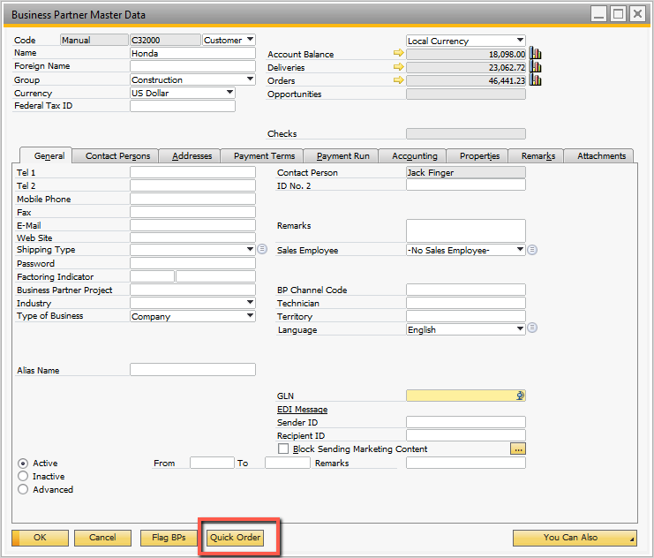

## Figure 1.1 Quick Order Button on The Customer Master

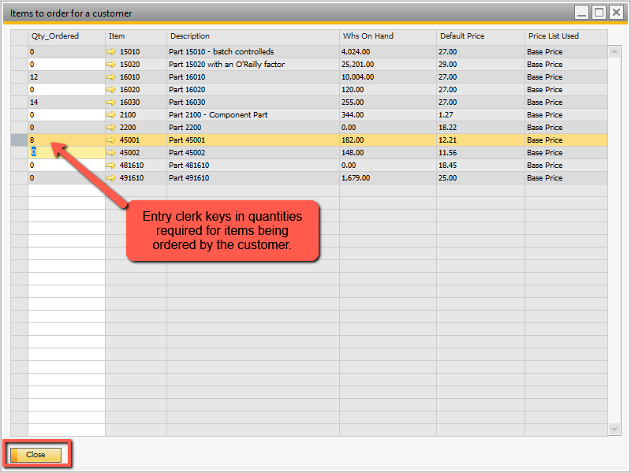

## Figure 1.2 Entry of Quantities Required

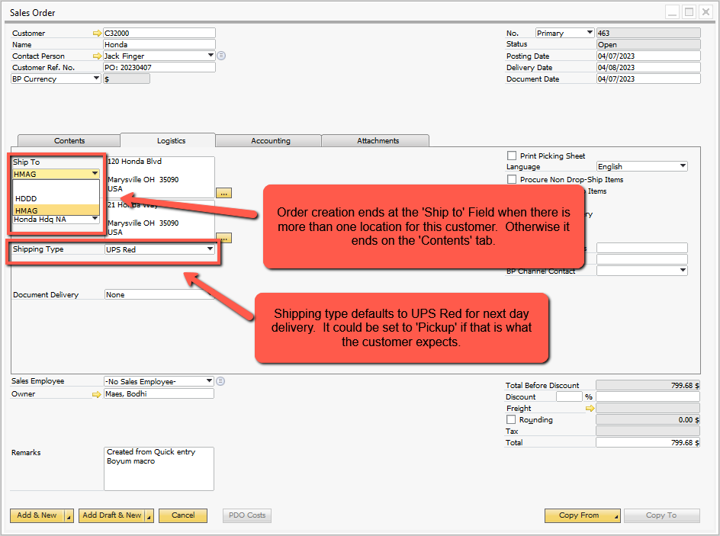

## Figure 1.3 Order Created from ‘Quick Entry’ – Logistics tab

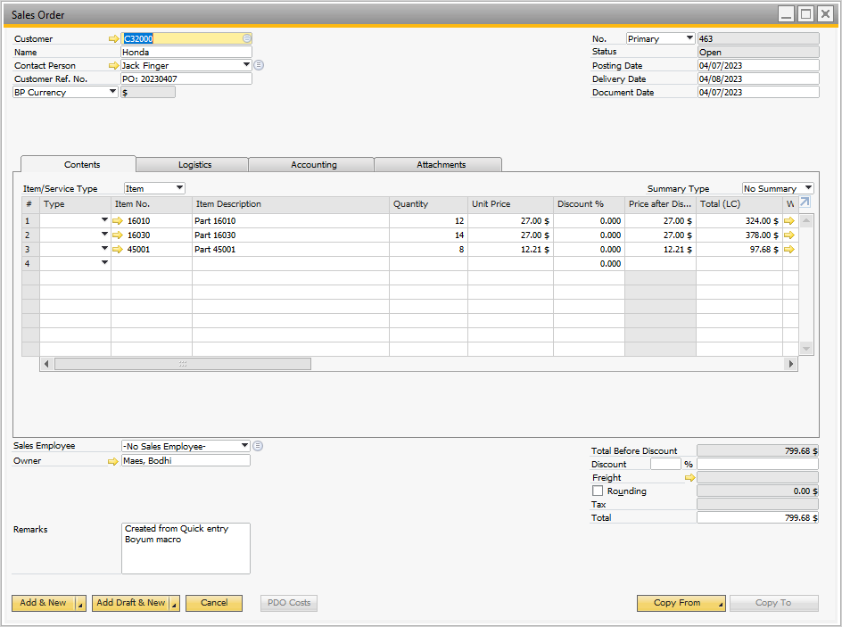

## Figure 1.4 Result of Quick Order Entry – Contents Tab

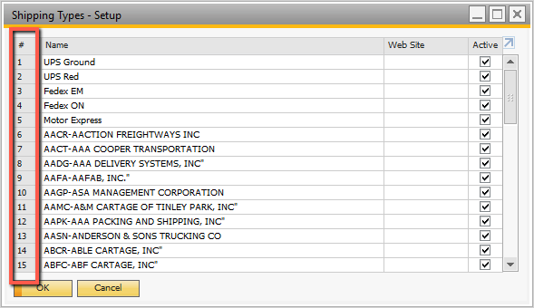

## Figure 1.5 Shipping Types

In addition to the Quick Entry functionality shown above, there are additional Boyum functions to select items to include in the ‘Items available’ for quick sale. On the item master screen there is a button ‘Set Property’. Clicking this button provide the popup selection shown in Figure 1.6.

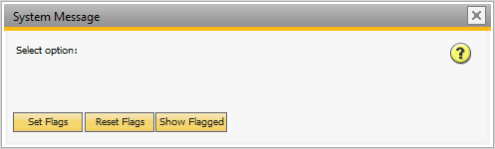

## Figure 1.6 Item Master Property 10 Setting Options

If the user clicks the ‘Show Flagged’ button the report shown in Figure 1.7 displays.

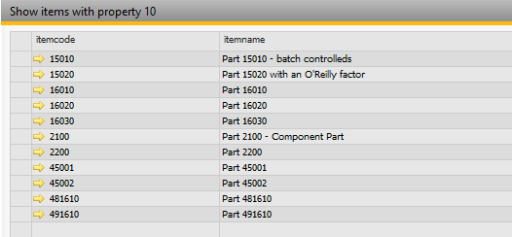

## Figure 1.7 Display of Items with Property 10 Set to ‘Y’

When the user clicks the ‘Reset Flags’ button, Boyum executes a function to set all property 10 flags to ‘N’. The user will see each item currently flagged with property 10 display on the screen and get updated with property 10 set to ‘N’ (unchecked).

When the user clicks the button ‘Set Flags’, the system presents a list of all active items that are ‘saleable’ – as shown in Figure 1.8.

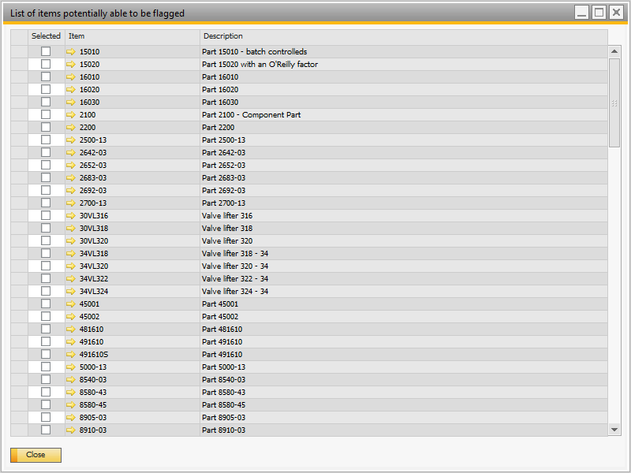

## Figure 1.8 User Checks the Items that are Available for Quick Order Entry

After the user selects the check boxes, they click the ‘Close’ button. At that point the user will see Boyum process each item on the item master screen as it sets the property 10 to ‘Y’ (checked).

You Tube link address: <https://studio.youtube.com/video/Kdig_EBt3nA/edit>

# Appendix A – Boyum Functions

This appendix details the Boyum functionality used. The Boyum functions are all assigned to the ‘Line Loops’ category’.

## Boyum Item Placement Tool

This tool is used twice – to place buttons on the business partner master screen and the item master. These are shown in Figures A-1 and A-2.

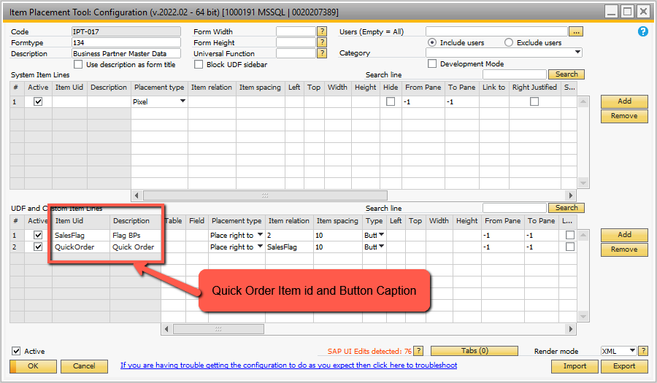

## Figure A-1 ITP for Business Partner Master – Quick Order Button Setup

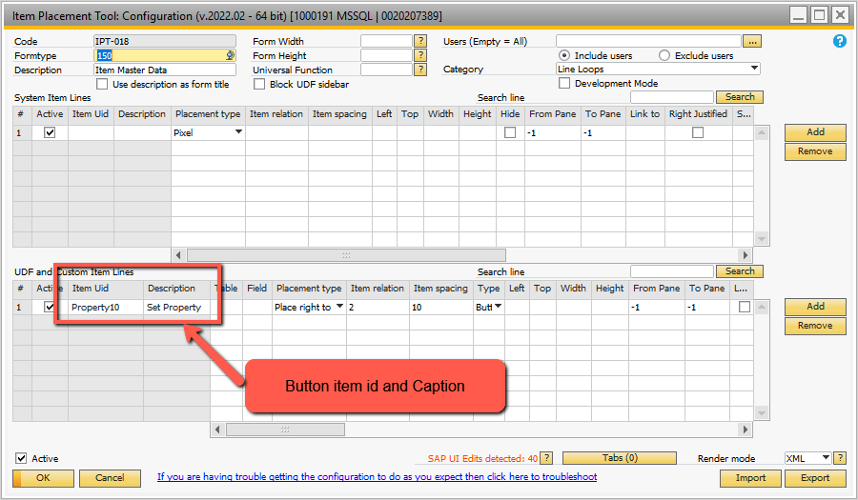

## Figure A-2 ITP for Item Master – Property 10 Setup Button

**Note**: in the ITP for the Business Partner, the ‘Quick Entry’ button is only active in ‘OK’ mode. i.e. a customer must have been selected.

## Quick Order Boyum Universal Functions and B1 Validations

When the ‘Quick Order’ button on the business partner master screen is clicked, the B1 Validation shown in Figure A-3 is executed.

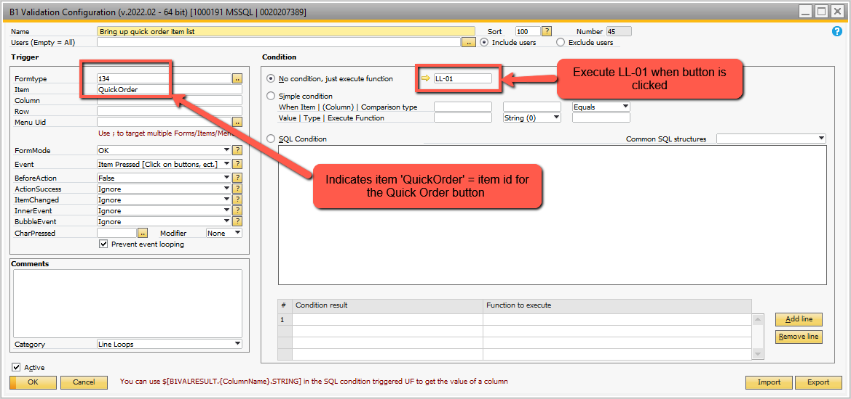

## Figure A-3 Execute the ‘Quick Order’ Button

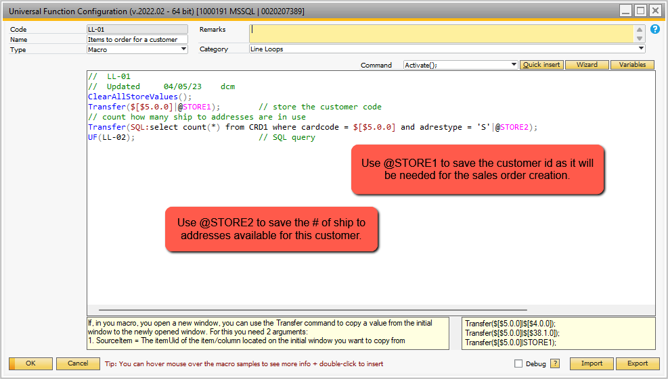

## Figure A-4 Start the Quick Order Processing

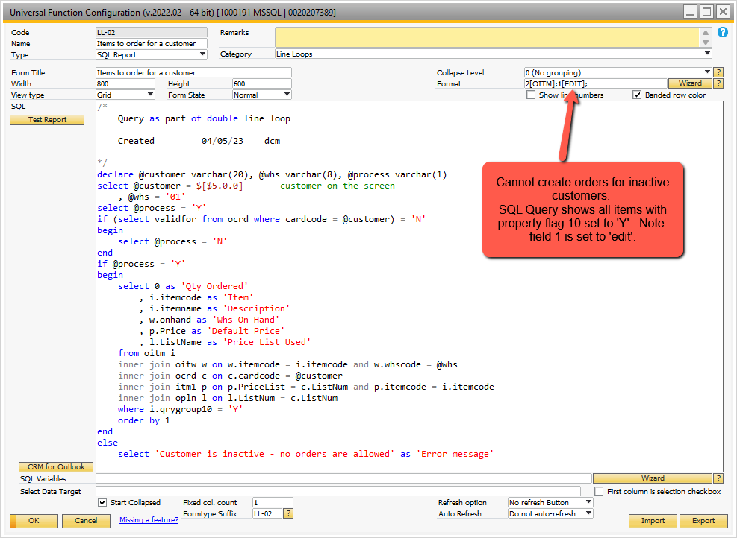

## Figure A-4 Query to Select Items Available for ‘Quick Order’

The SQL query has a button at the bottom ‘Close’. It closes the query screen. Using the Boyum B1 validation we capture when this button is clicked and proceed to create the sales order. The B1 validation is shown in Figure A-5.

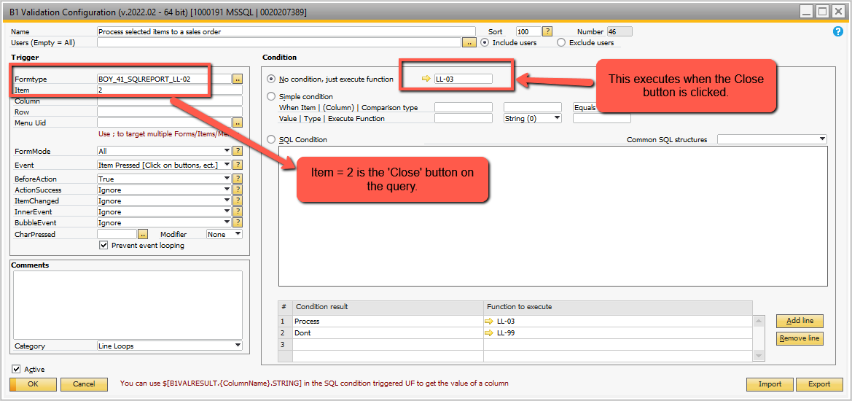

## Figure A-5 B1 Validation as Item Selections are Made – ‘Close’

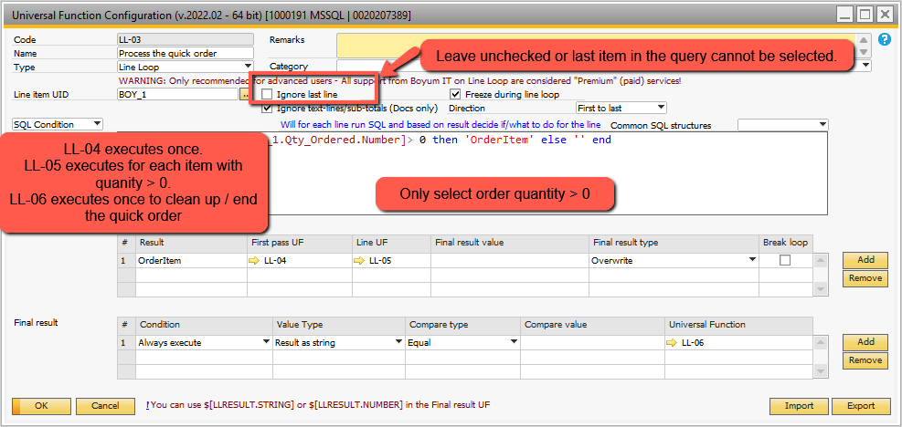

## Figure A-6 Line Loop Against SQL Query Creates the Sales Order

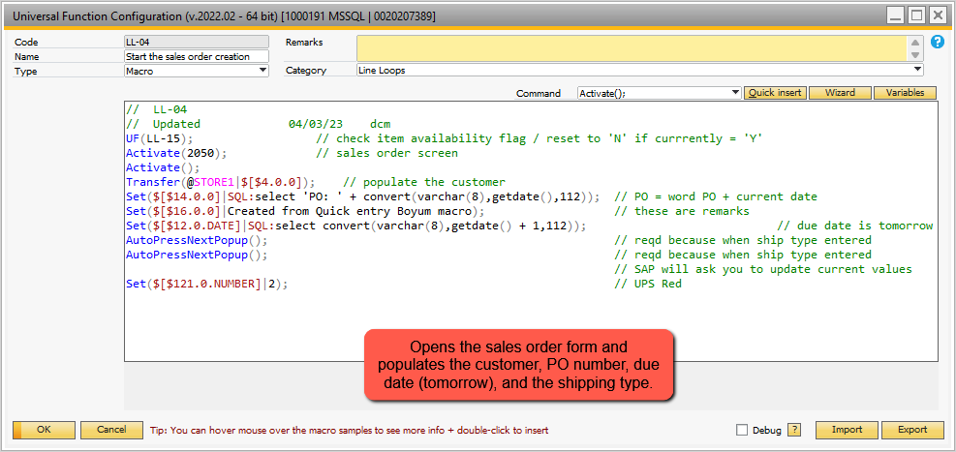

## Figure A-7 Open Up the Sales Order and Populate ‘Header’ Information

**NOTE**: The first step in the UF LL-04 is to call LL-15. The LL-15 call is required if the ‘Availability check’ for on hand inventory is active. Here is what occurs if the availability check is set to ‘Y’ (see Administration 🡪 Document Settings 🡪 Sales Order):

* As the quantity is entered on the sales order, SAP populates the quantity field
* Then SAP checks the availability of this quantity in the warehouse – available quantity
* If the available quantity is less than the quantity being ordered, then the availability check screen is displayed and the user must decide what to do next – keep the item, change the quantity, etc.
* Once the user decides, then the availability screen goes away and the entry process continues

The Boyum tool cannot interrupt this SAP function. It is not a ‘popup’ where using the AutoPressPopup() macro command can automatically determine what to set / do.

To get around this limitation, IF the availability flag is set when I start the Quick Entry program, I reset it to ‘N’ and save this change. This is what the UF LL-15 does. It will be accompanied by additional code in the final Line Loop macro call – to ‘clean up’. In this UF LL-06, the original availability check flag of ‘Y’ is restored.

**NOTE**: in a high volume order entry shop this solution is NOT recommended because for the short time the quick order is being created the other sales order entry personnel would not have the availability check in place. Over time, errors would creep into the system and you would need to call a customer and say ‘whoops, we really don’t have on hand’. This can be handled in the Boyum functions in one of 2 ways:

1. When the quick entry button is clicked and the items list is displayed for entry of quantity – omit items without any availability. This may lead to a ‘false’ look at the quick entry because some items would not appear in the list.
2. Leave the SQL display of items in the program as-is and modify the validation for the ‘Close’ of the SQL item list to (see Figure A-5 above) to call the UF LL-03 only if all of the items selected for the order have available on hand. In other words, stop the processing of the quick order if there is not enough on hand. Since the idea of a ‘Quick Entry’ is that you always have on hand for these items, this should not be a major concern when entering ‘Quick orders’.

In either case, I would recommend that the SQL script include the on hand available. i.e. the UF LL-02 currently shows the field warehouse on hand. The available on hand can be calculated and displayed in its stead.

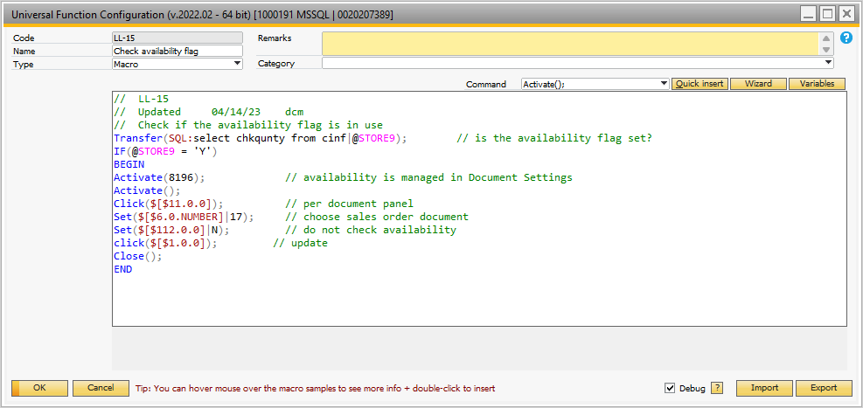

## Figure A-8 Check Item Availability Flag

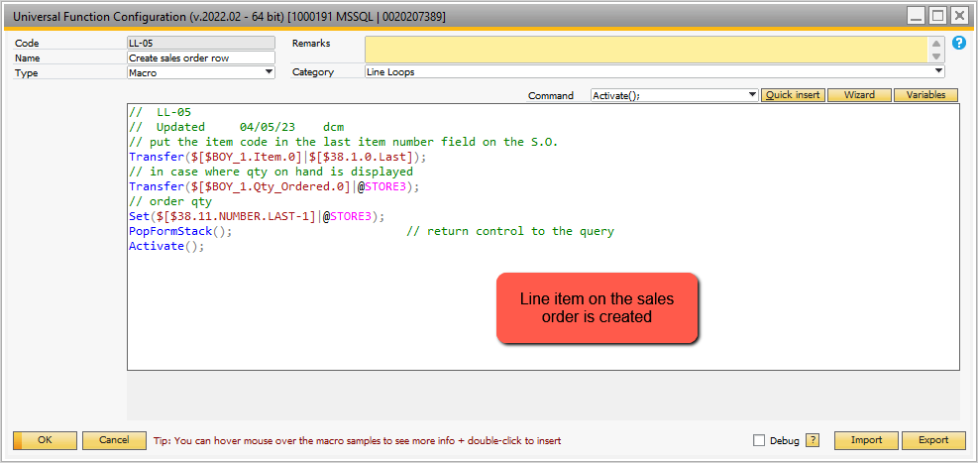

## Figure A-9 Quick Order Line Item Creation

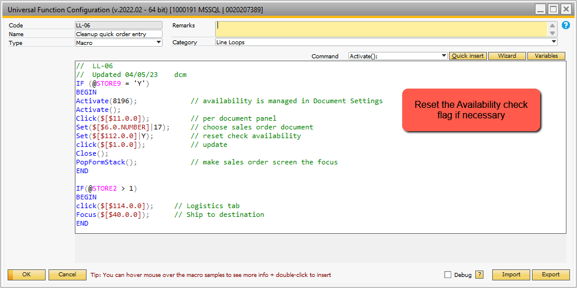

## Figure A-10 Set Focus on Sales Order to Ship To – If Needed

These Boyum and SAP functions are used to set the ‘property 10’ flag in the item master to indicate the items are available for ‘Quick entry’.

I recommend the first step – change the name of property 10 for the item master. This is done in SAP: Administration 🡪 Setup 🡪 Inventory 🡪 Item Properties. I have changed the description of property 10 – as shown in Figure A-11.

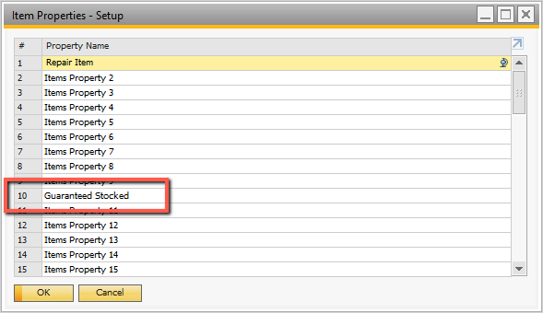

## Figure A-11 Renaming Property 10 For Items

The ITP function shown in Figure A-2 creates the button to ‘Set Property’. This must be linked to a B1 Validation to initiate the processing. Figure A-12 shows the B1 Validation. It calls LL-07 universal function.

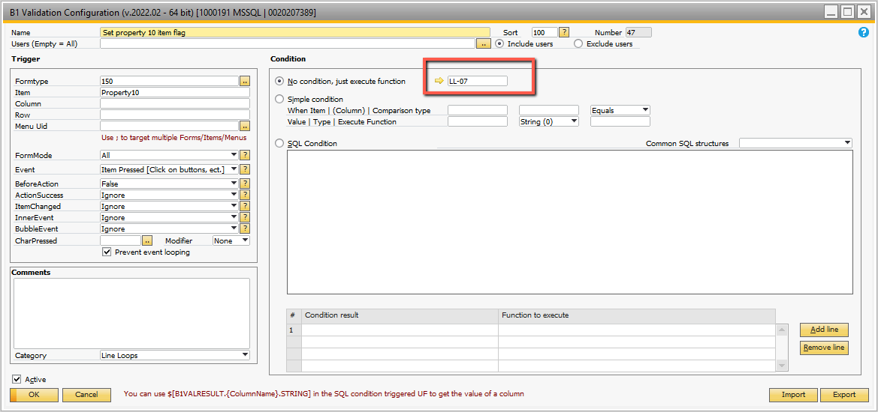

## Figure A-12 Validation for Click on ‘Set Property’

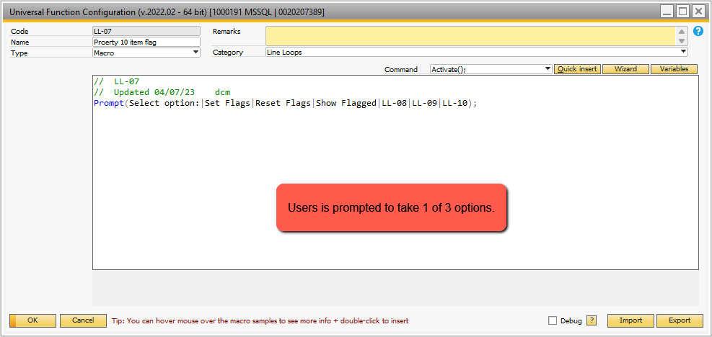

## Figure A-13 Options for Setting Item Property 10

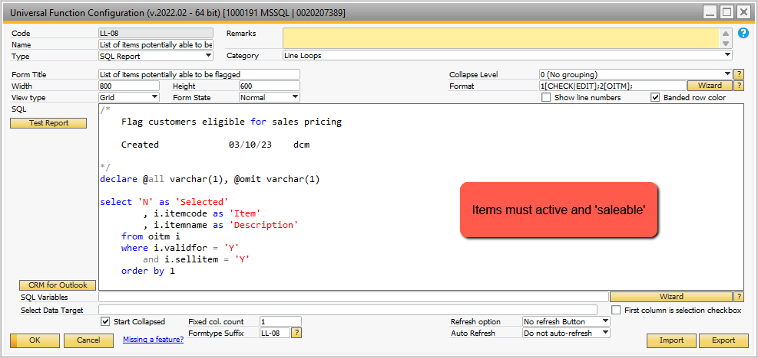

## Figure A-14 Query to Display Items to Select for ‘Quick Entry’

**Note**: field 1 in the SQL UF LL-08 is set to ‘Editable’.

When the user has selected all the items to flag property 10, the ‘Close’ button is clicked and this triggers a B1 Validation – shown in Figure A-15.

The line loop initiated when the close button is clicked is UF LL-12. **Note**: the ‘Ignore Last Line’ is unchecked. This is because queries need to include the last line, whereas if the line loop was on a sales order line item, the last line would always be empty.

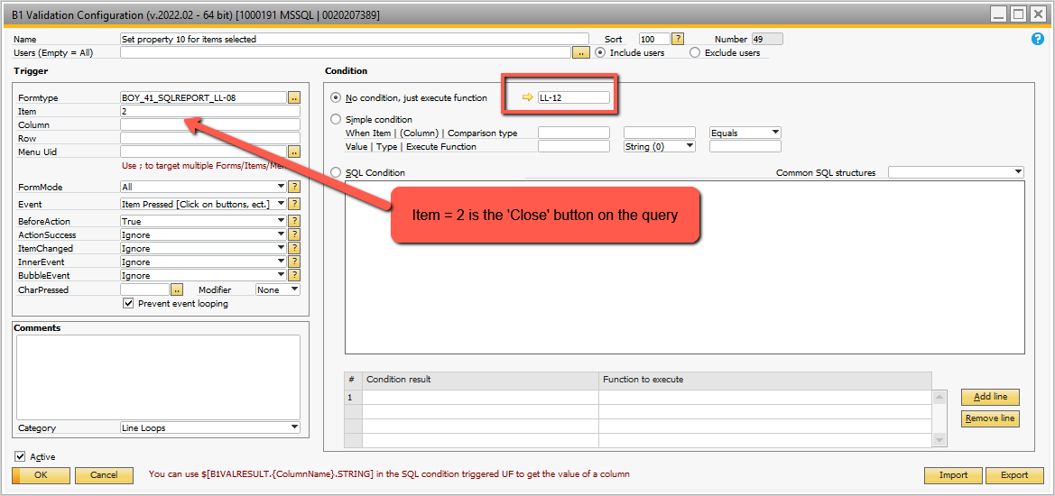

## Figure A-15 Validation after Selecting the Items to Set Property 10

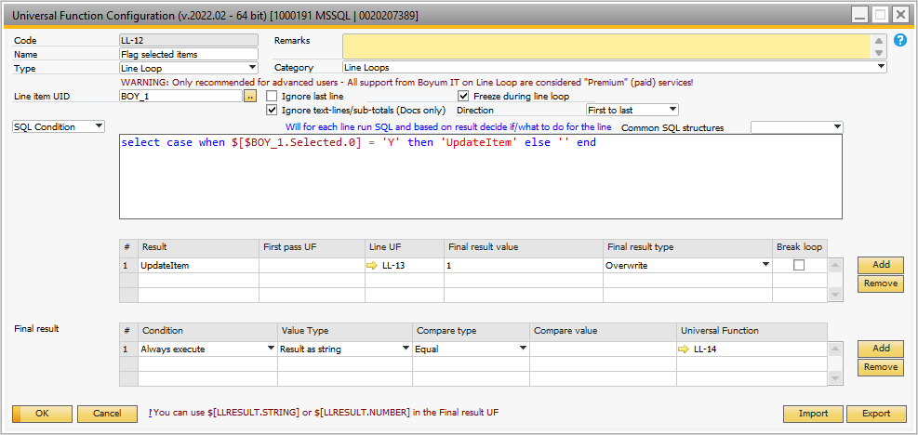

## Figure A-16 Line Loop to Set the Item Property 10

The Universal Function LL-13 processes the item lines selected. Refer to Figure A-17. The UF LL-14 cleans up the screen after all of the property flags are set. Refer to Figure A-19. This same Universal Function is used to ‘Show Flagged’ items from the popup shown in Figure A-13.

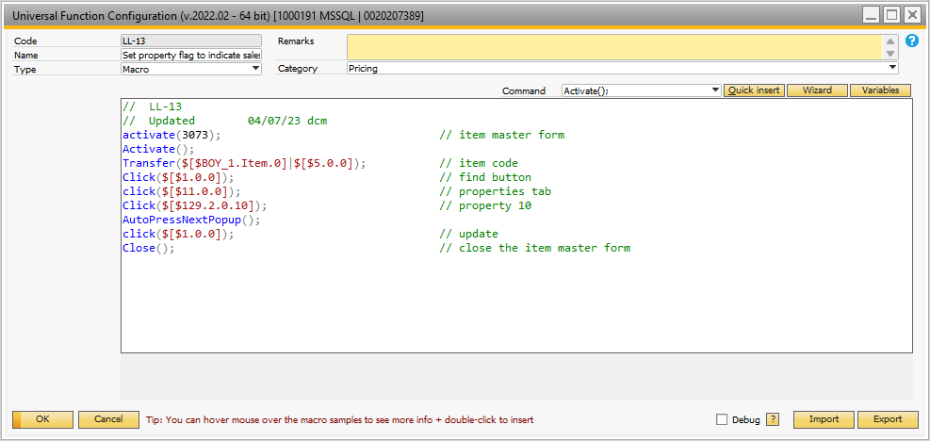

## Figure A-17 Set the Item Property 10

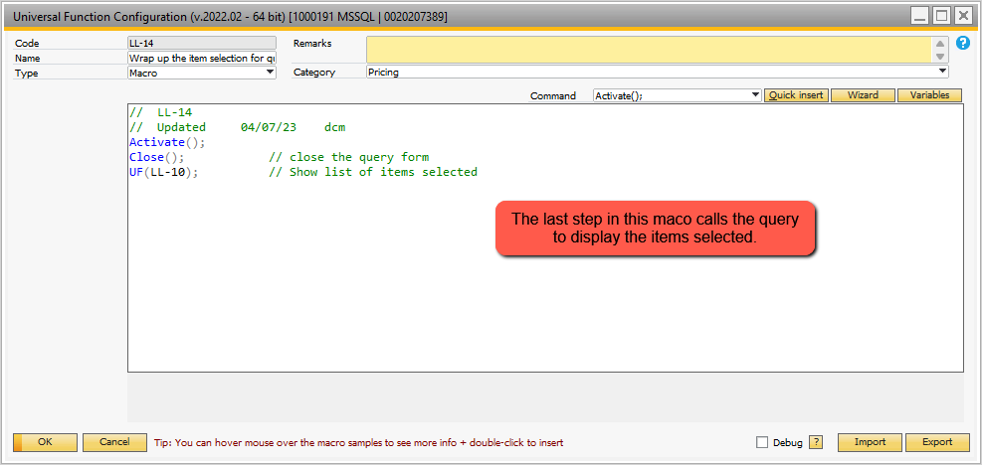

## Figure A-18 Close the Query Form

When the ‘Reset Flags’ option (A-13) is selected, the Universal Function LL-09 is called. It is a macro with a ‘While’ loop. The macro commands within the While loop unchecks the item property 10 for those items that had the property 10 set. Note the use of ‘@STORE1’ to count the remaining items with property 10 set to ‘Y’. It controls the ‘While’ loop exit.

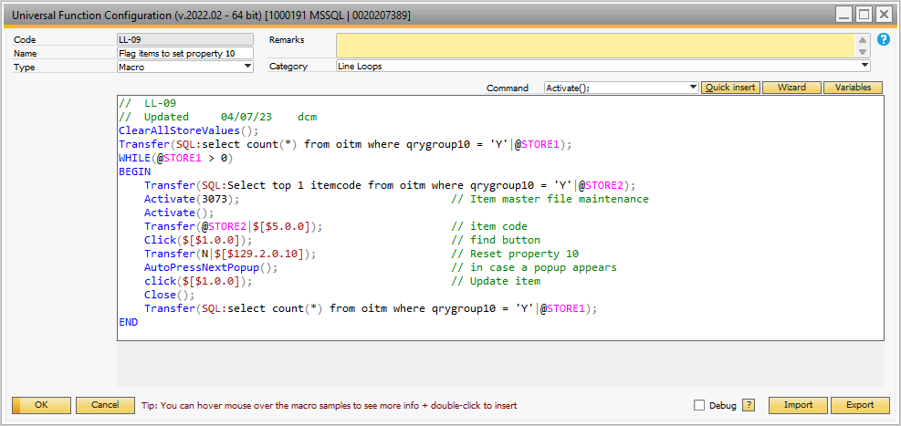

## Figure A-19 Reset the Item Property Flag 10