**Using QR Codes in Crystal Reports**

**Mascidon LLC**

**July 2023**

Contents

Introduction 3

Item master QR Codes 3

Figure 1.1 QR Code Content – Pointing to Web Site 3

Figure 1.2 QR Code Content – Pointing to Web Site Page 4

Figure 1.3 QR Code for a Marketing Document 4

Sales and Purchasing documents – QR Codes 5

Figure 1.4 QR Code Pointing to a Specific Latitude – Longitude 5

Figure 1.5 QR Code Pointing to an Email Address 6

How To Add QR Codes to a Crystal Report 6

Figure 1.6 Label with QR Codes – Web Site Redirection 6

Figure 1.6 Label with QR Codes – With Email Address 7

Figure 1.6 Label with QR Codes – With GPS Coordinates 7

Figure 1.7 Crystal Report Page Settings 8

Figure 1.8 Crystal Report Data Base Expert – Command Lines 8

Figure 1.9 Crystal Report Data Base Expert – Command Line Linkages 9

Figure 1.10 Crystal Report ‘Get Item’ parameter creation 9

Figure 1.11 Crystal Report – Access From Boyum 10

Figure 1.12 SQL View of QR Code Data 10

Figure 1.13 SQL View of QR Code Data – Linked to Item Master 11

# Introduction

SAP has introduced the use of QR Codes in version 10. They have included QR Code data fields on all sales and purchasing documents and on the item master. How can you use this information to better run your business.

# Item master QR Codes

* Labels with links to compliance information
* Labels with links to engineering specific information
* Labels with links to pictures of the product
* Labels with detailed description of the part – i.e. 500 – 1000 characters rather than just the normal 100.

Figure 1.1 shows an item with QR Code information pointing to my web site. This is textual information. There is a separate table in SAP with the converted QR Code information – for display or printing of the QR Code. Figure 1.2 shows an item with QR Code information pointing to a specific page on my web site. Note: I used the ‘Edit Form UI’ option under Tools 🡪 Edit Form UI to make the ‘Create QR Code From’ field larger so that it is easier to read.

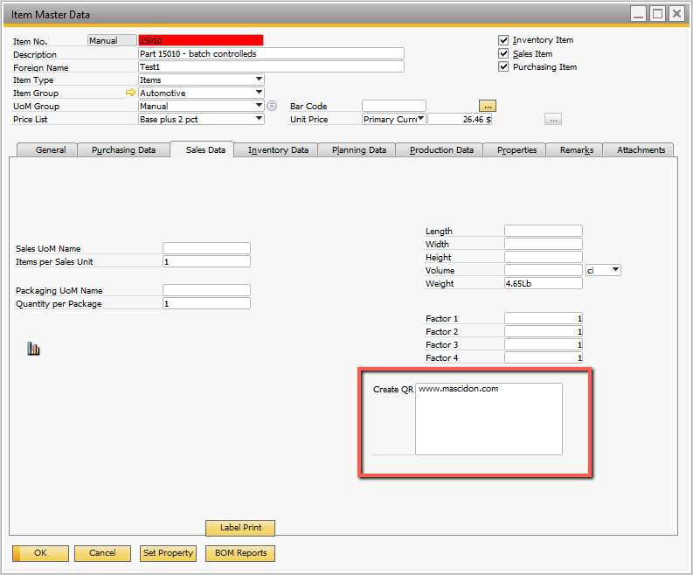

## Figure 1.1 QR Code Content – Pointing to Web Site

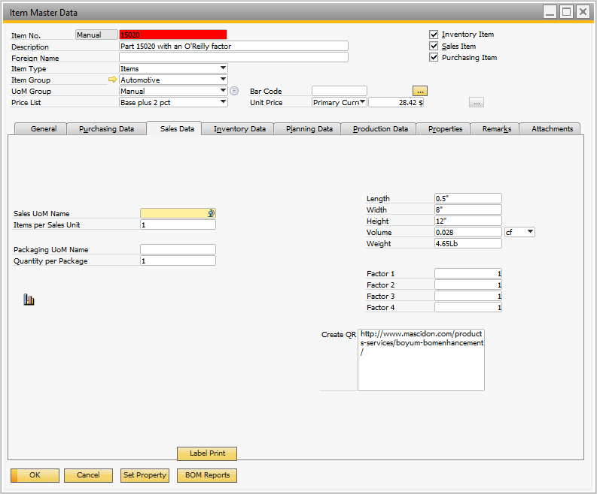

## Figure 1.2 QR Code Content – Pointing to Web Site Page

The QR Codes for the marketing documents – all sales and all purchasing documents – are found in the ‘Accounting’ tab as shown for the invoice shown in Figure 1.3.

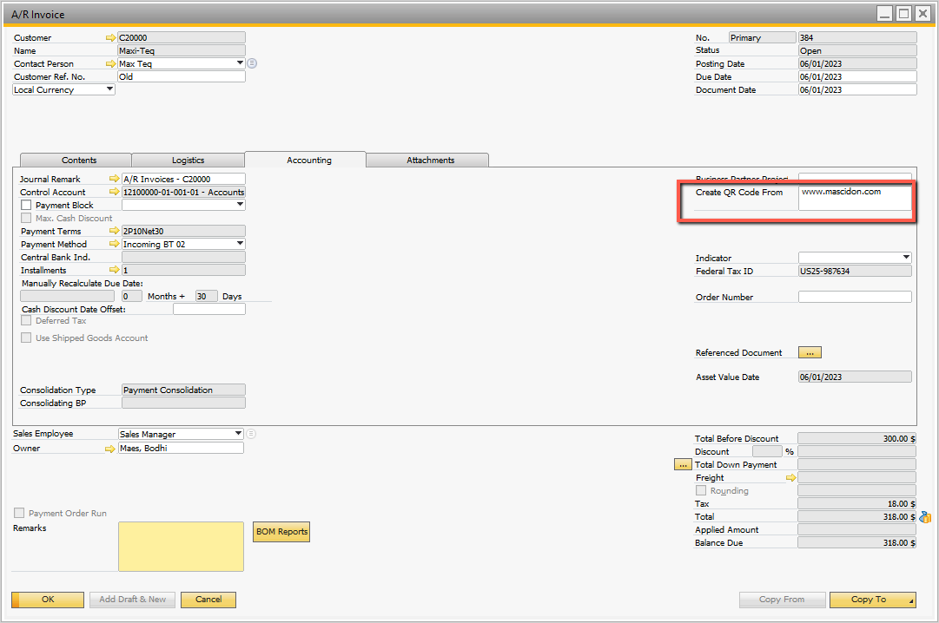

## Figure 1.3 QR Code for a Marketing Document

# Sales and Purchasing documents – QR Codes

* Include link to tracking information – UPS, FEDX, etc.
* Link to logistics paperwork / forms
* Links to sales of products
* Links to your support web site / contact information
* Direct email to support or sales
* Purchase order with links to each item’s purchasing specifications
* Links to products that if you purchase this – you should look at these products

QR Codes can actually be linked to other data. For instance, the QR code information could be the location latitude – longitude. It could be an email address. These are shown in Figures 1.4 and 1.5.

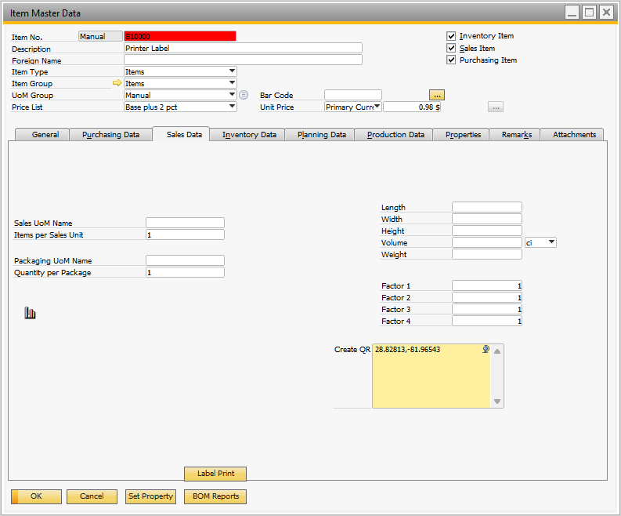

## Figure 1.4 QR Code Pointing to a Specific Latitude – Longitude

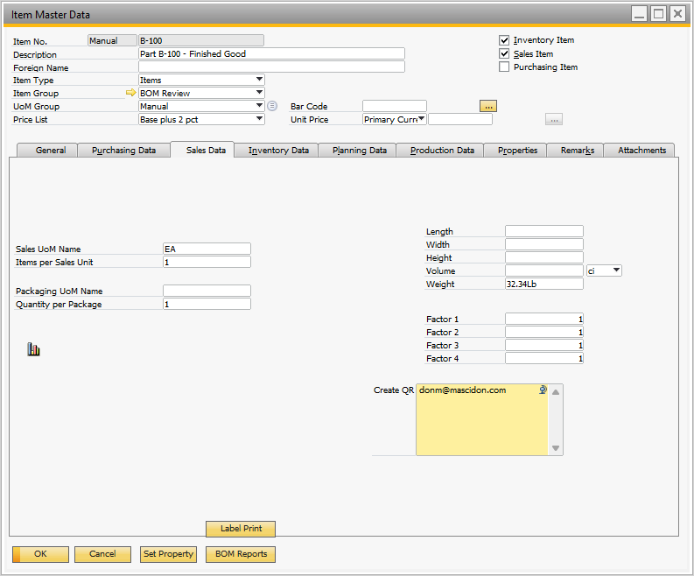

## Figure 1.5 QR Code Pointing to an Email Address

# How To Add QR Codes to a Crystal Report

It’s nice to have the capability to store data for QR Codes, but how is this implemented using Crystal reports? On the Item documents shown in the Figures above there is a button ‘Label’ print. Figures 1.6, 1.7 and 1.8 show the result of clicking this button when there is an item on the item master screen.

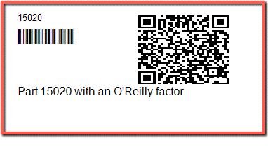

## Figure 1.6 Label with QR Codes – Web Site Redirection

If you use your phone camera to view this label you will see a yellow box with ‘mascidon.com’. Click this to go to the Mascidon website page for BOM Enhancements.

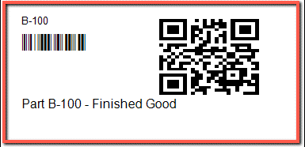

## Figure 1.6 Label with QR Codes – With Email Address

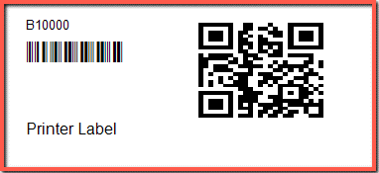

## Figure 1.6 Label with QR Codes – With GPS Coordinates

The label print program is obviously a simple Crystal report, but the inclusion of the QR Code is slick. Let’s review the steps for the Crystal Report creation. I am assuming you know how to use Crystal reports.

1. Define the page setting for the label. I have a Brother QL-700 label printer and the settings are shown in Figure 1.7. The width of my label printer is 2.4 inches.
2. The database Expert shows there are 2 ‘Command’ lines in the label report. See Figure 1.8. These two command lines are:
   1. select itemcode, itemname, docentry, objtype, qrcodesrc from oitm where qrcodesrc is not null
   2. select "FileContnt", Cast("SrcObjType" as varchar(20)) as ObjType , cast("SrcObjAbs" as integer) as ObJAbs from OQRC where FieldName= 'QRCodeSrc'
3. The linkages between these two command lines is shown in Figure 1.9.
   1. Docentry is the linking field from the item master.
   2. The item master object type is ‘4’ and this links to the QR Code object type.

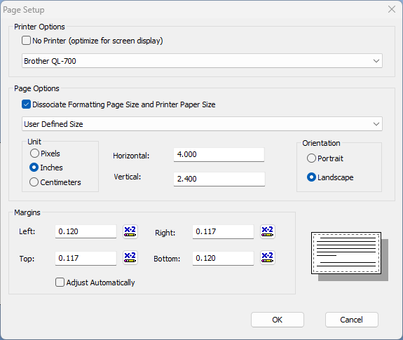

## Figure 1.7 Crystal Report Page Settings

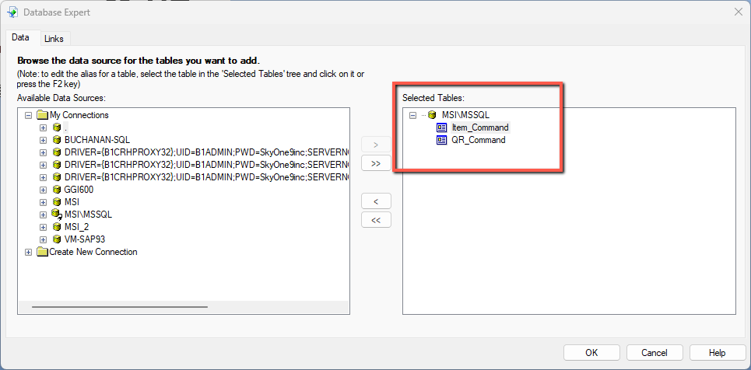

## Figure 1.8 Crystal Report Data Base Expert – Command Lines

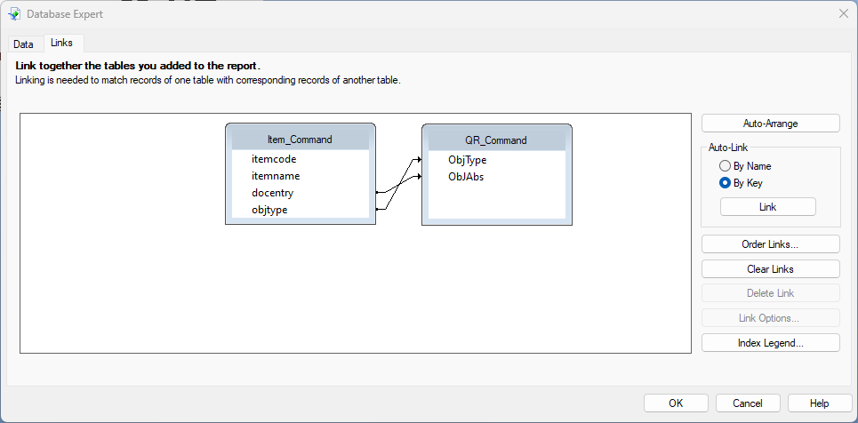

## Figure 1.9 Crystal Report Data Base Expert – Command Line Linkages

1. The fields on the label itself are:
   1. Itemcode – from the Item_Command SQL Script
   2. Itemname – from the Item_Command SQL Script
   3. Itemcode - from the Item_Command SQL Script with the font = Code39AzaleaWide3 (16 high)
   4. FileContnt – from the QR_Command Script

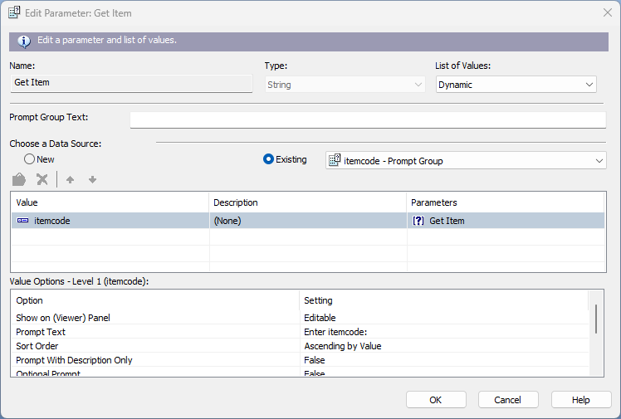

## Figure 1.10 Crystal Report ‘Get Item’ parameter creation

1. There is a parameter field – ‘Get Item’ defined as shown in Figure 1.10.
2. The Crystal report is ‘Test Item Label.rpt’. It is accessed from SAP when the ‘Print Label’ button on the item master is clicked. Refer to Figure 1.11.

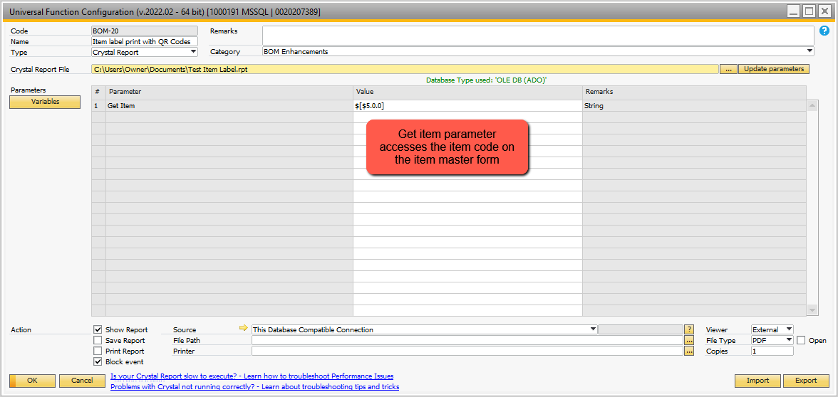

## Figure 1.11 Crystal Report – Access From Boyum

Where is the data stored for the QR Codes being shown in the labels? Figure 1.12 shows a simple SQL select statement that shows how the data is stored in SAP.

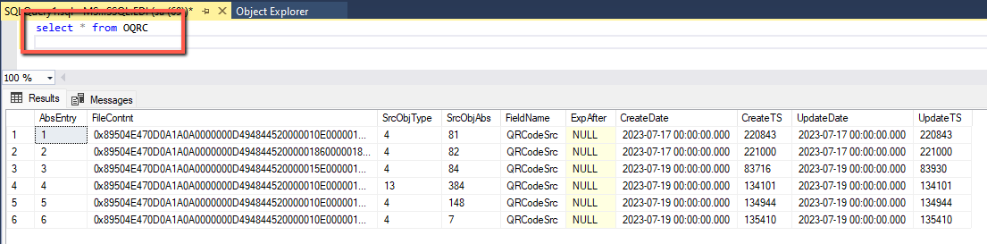

## Figure 1.12 SQL View of QR Code Data

The field ‘ FileCnntnt’ contains the formatted QR Code data. SrcObjAbs is the ‘docentry’ for the items when the ‘SrcObjType’ code is ‘4’. ‘13’ indicates this is an ‘Invoice’.

Figure 1.13 shows the same QR File information linked to the item master table.

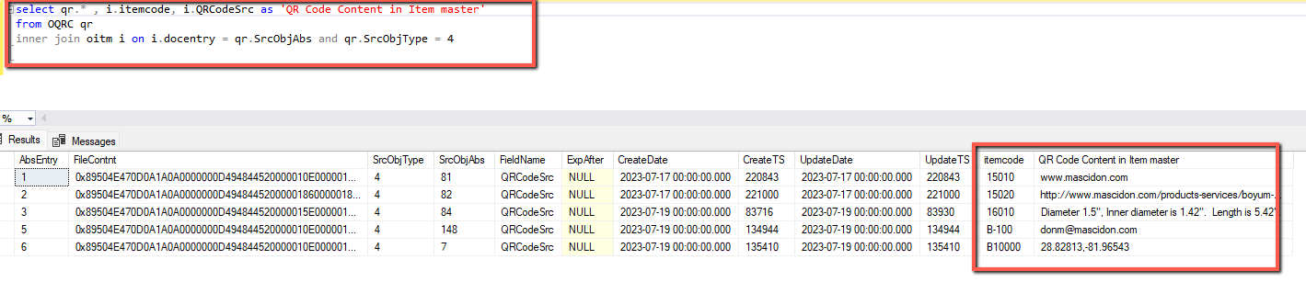

## Figure 1.13 SQL View of QR Code Data – Linked to Item Master

**Note**: there are 5 forms for the QR Content shown. Refer to Figure 1.13:

1. 15010 – links to a web site
2. 15020 – links to a web site page: <http://www.mascidon.com/products-services/boyum-bomenhancement/>
3. 16010 links to an item specification: Diameter 1.5", Inner diameter is 1.42". Length is 5.42".
4. B-100 – links to an email address
5. B10000 – links to GPS coordinates – clicking on it will bring up google maps.