**Manufacturing Sales & Units of Measure**

**July 2023**

**Mascidon LLC**

Contents

SAP B1 Units of Measure 3

Figure 1.1 Units of Measure Setup 4

Figure 1.2 Packaging – Pallet Setup 4

Figure 1.3 Unit of Measure Group Definition 5

Figure 1.4 Part Using BOX1 with 20 Pieces in the Box 6

Figure 1.5 Sales UoM and Package Types for a Specific Item 6

Figure 1.6 Second Part Setup – Quantity 10 per box, 16 Boxes / Pallet 7

Figure 1.7 Pricing by UoM 8

Processing an Order Using Box Quantities 8

Figure 1.8 Sales Order – Single Item 8

Figure 1.9 Delivery Order – Single Item 9

Figure 1.10 Auto Definition of Packaging 9

Figure 1.11 Delivery Order Printed Document 10

Figure 1.12 Sales Order with 2 Parts with Box – Pallet Definitions 11

Figure 1.13 Breakdown of Pallets for Multiple Containers 12

Figure 1.14 Delivery Order with Multiple Parts and Pallets 13

Figure 1.15 Two Box Order – no Pallet Required 14

Figure 1.16 Default Pallet Packaging 14

Figure 1.17 ‘Loose’ Box Definitions 15

Figure 1.18 Shipping Document with ‘Loose’ Boxes 15

Appendix A Boyum ‘Documents’ – Adding Packaging Details 16

Figure A-1 Delivery Order with Packaging Data 16

Figure A-2 Packaging Sub-Report Command Line SQL 17

Figure A-3 Limiting the Package Details to Delivery Orders 18

# SAP B1 Units of Measure

If you access SAP B1 tutorials on units of measure the examples deal with distributors of products. The ‘paper’ sold in reams, boxes and pallets is their example. 6 packs of soda vs 24 packs of soda are other examples.

Based on my experience here are more likely scenarios in a manufacturing plant:

* Parts are sold with part specific packaging
  + Packaging for an axle assembly for a car or truck – the packaging is designed to fit the part.
  + In many instances the packaging becomes part of the BOM for the part – because that is the only way it is shipped.
* Parts are placed in standard box sizes, so many pieces to the box
  + Most often a plant has a limited number of box sizes – perhaps 8 – 10 sizes to handle the non-designer packaging in the plant
* In many cases boxes of parts are placed on pallets for shipment
  + Certain sized boxes are placed in ‘layers’ on a pallet
* Depending on the box size and the weights of parts, only so many ‘layers’ of boxes can be placed on a pallet. This is known in advance and most plants are shipping the same parts on a regular basis.

Designer packaging is unique and part of the BOM, so from a shipping managers’ view it is not interesting. Boxed shipments and pallet shipments are another matter for the shipping department. What follows is an example of ‘Automotive’ parts that are being sold in varying size boxes and then palletized for shipment. The same logic applies to most manufactured parts. Here are the steps required in SAP Business One:

1. In the units of measure setup form, enter these units of measure codes. (Administration 🡪 Setup –> Inventory 🡪 Units of measure). Figure 1.1 shows the units of measure setups.
   1. Define the boxes used for shipments. In my example I have 4 different sized boxes. Depending on the parts, differing quantities can be packaged in the box. I have called these BOX1_12, BOX1_20, BOX1_24, BOX2_10, BOX3_40 and BOX4_10. Not real clever, but practical.
2. Note that in Figure 1.1 I never explicitly define BOX1, BOX2, etc. What I do is define 3 BOX1 units of measure, naming them BOX1_12, BOX1_20 and BOX1_24. You will see why I do this in a few minutes.
3. A units of measure group is required for production items that will be sold to customers. This is accessed from Administration 🡪 Setup –> Inventory 🡪 Units of measure groups. I defined one new group ‘Production’. When I highlight the ‘Production’ unit of measure group and then click the group definition button, Figure 1.3 displays the form. You can see how I have used the ‘_nn’ number to indicate the base quantity. For instance, BOX1_20 has a base quantity of 20.
4. Inventory of the production parts being sold is in ‘EACH’ (in my example). Referring to Figure 1.3, the ‘Each’ unit of measure has a base quantity of 1 – it is the ‘Base UoM’.
   1. Define the pallet(s) used for shipments.
   2. Then I define each of the boxes previously defined in Figure 1.1 – with the ‘each’ quantity contained within the Box. For instance, BOX1_20 shows the base quantity as 20 ‘Each’.
5. I defined one 6 foot by 4 foot wooden pallet. This is defined in SAP B1 under: Administration 🡪 Setup –> Inventory 🡪 Packaging. See Figure 1.2.

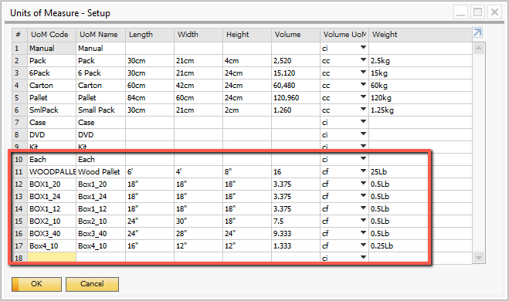

## Figure 1.1 Units of Measure Setup

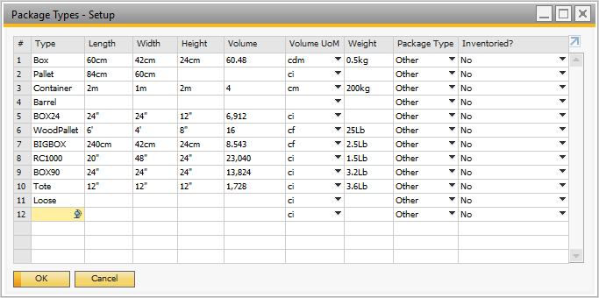

## Figure 1.2 Packaging – Pallet Setup

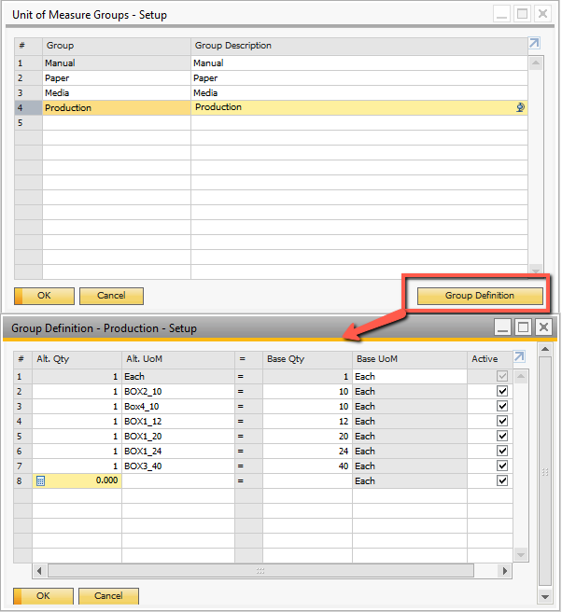

## Figure 1.3 Unit of Measure Group Definition

More setup is required in the item master form for each part that you ship to customers. In the part master for the parts produced and sold, I have set up the ‘UoM Group’ as the ‘Production’ group. I have displayed the part ‘Auto1’ in Figure 1.4. **Note**: the sales UoM Code is ‘BOX1_20’ and the items per sales unit is 20 Each. The Package type is ‘WoodPallet’ and it has a quantity of 24 boxes on the pallet. Looking back at the BOX1 definition in Figure 1.1, the box length – width is 18 inches by 18 inches (regardless of the actual BOX1 definition – i.e. BOX1_24 has these dimensions and so does BOX1_20. The pallet is 6 feet by 4 feet. This means that each ‘layer’ of boxes on the pallet are 2 wide by 4 long. 2 wide is 36 inches or 3 feet – which fits comfortably on a pallet 4 foot wide. The length of 4 boxes is 6 feet (4 x 18 inches / 12). So that fits on a pallet as well. Since the pallet has 24 boxes, and each layer consists of 8 boxes, then there are 3 layers of boxes. If the ellipsis next to the ‘BOX1_20 is clicked, the form shown in Figure 1.5 displays.

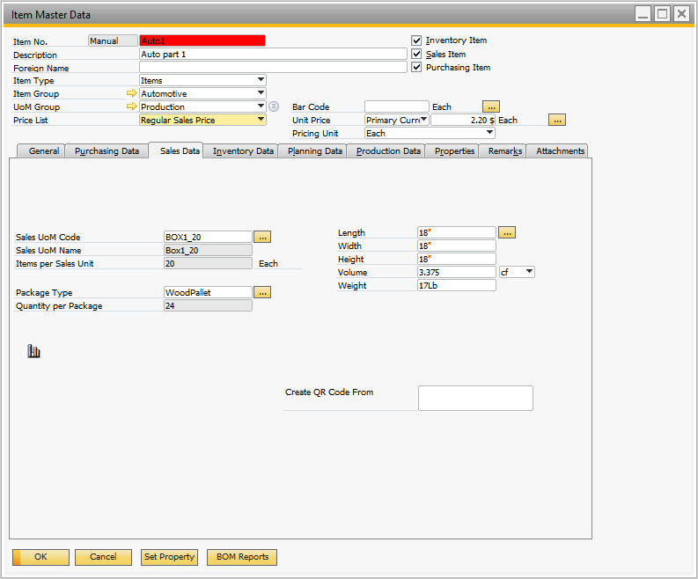

## Figure 1.4 Part Using BOX1 with 20 Pieces in the Box

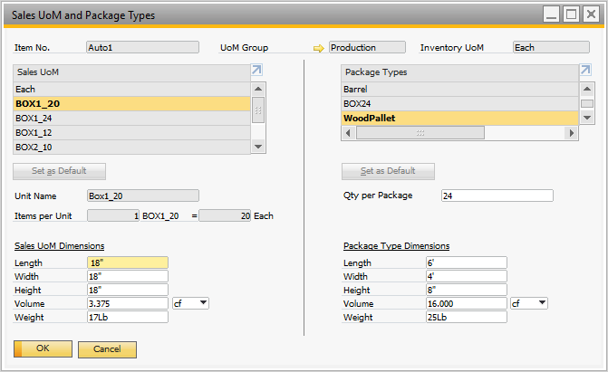

## Figure 1.5 Sales UoM and Package Types for a Specific Item

A second part is set up that uses Box2. This is shown in Figure 1.6.

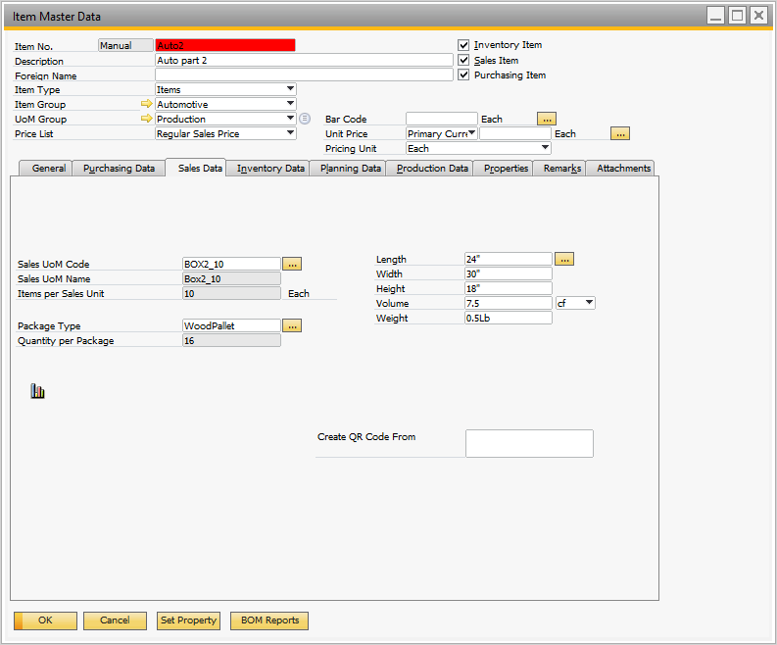

## Figure 1.6 Second Part Setup – Quantity 10 per box, 16 Boxes / Pallet

This second part has 4 boxes per layer and layers of boxes on a pallet – for a total of 16 boxes.

The pricing for the parts can be defined for the ‘Each’ quantity and for the ‘Box’ quantity. Figure 1.7 shows the pricing for the 2nd part. Most manufacturing plants do not ship parts in less than box quantities, so there is no discount associated with a box of parts – that’s just the price.

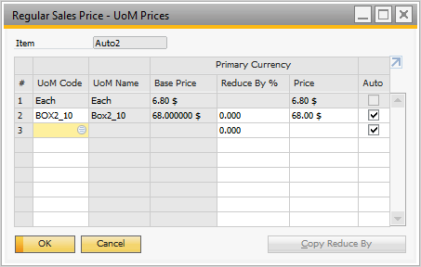

## Figure 1.7 Pricing by UoM

## Processing an Order Using Box Quantities

A simple one item sales order is shown in Figure 1.8. The item quantity sold is 24 of BOX1_20 – meaning 480 pieces of the item are being sold. The price is $44.00 per box ($2.20 / Each). Okay that is simple enough, let’s ship this using a delivery order by copying the sales order to a delivery order – Figure 1.9. There is nothing special about this on the main delivery order screen. If we ‘Right click’ and select ‘Packing Slip’, the packaging is already pre-defined for us. Refer to Figure 1.10.

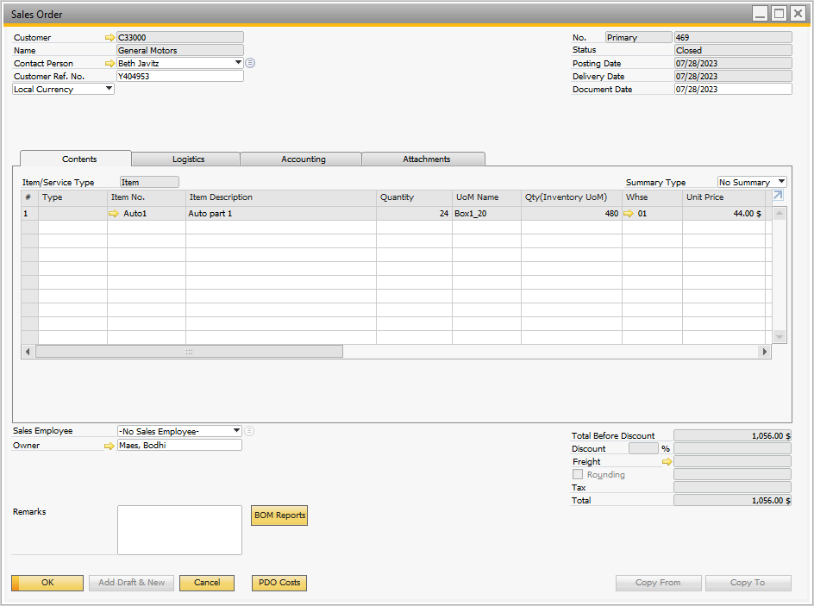

## Figure 1.8 Sales Order – Single Item

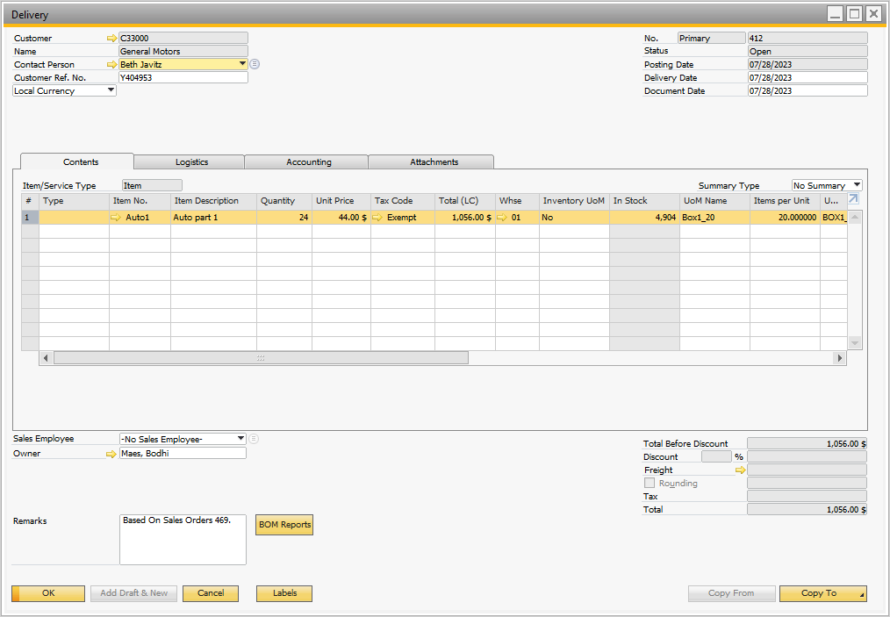

## Figure 1.9 Delivery Order – Single Item

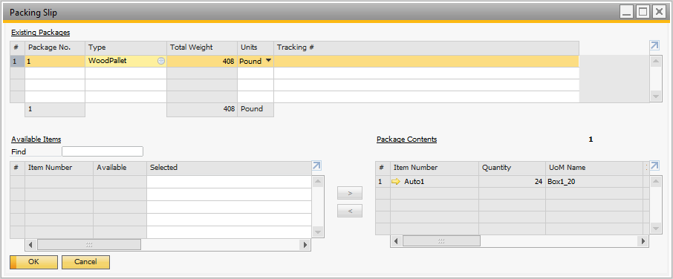

## Figure 1.10 Auto Definition of Packaging

The math is all correct – and we didn’t need to do any of it! **Note**: the weight of the part ‘Auto1’ is 0.85 pounds and 480 x 0.85 = 408 pounds as shown.

If we use the standard Boyum delivery order form as modified by Mascidon, the full impact of the packaging is revealed. Refer to Figure 1.11.

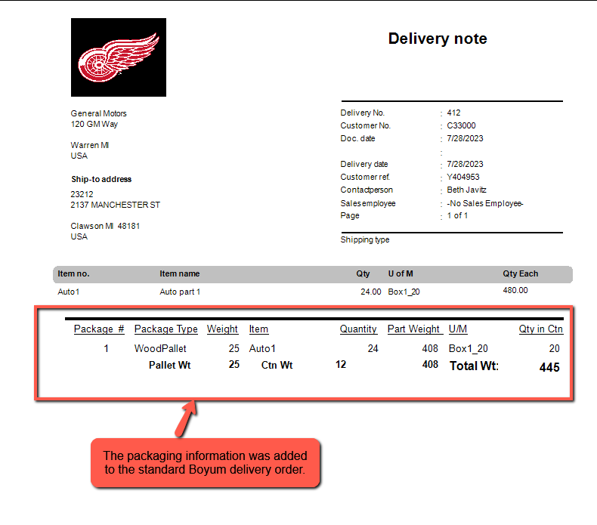

## Figure 1.11 Delivery Order Printed Document

All of the packaging information is shown – 1 pallet weighing 25 pounds. Then 24 box containers weighing 0.5 pounds each – for 12 pounds. Then of course the part weight itself – 408 pounds.

A second example with 2 parts – one requiring a full pallet and one part requiring over 1 pallet is shown. Refer to Figure 1.12 for the sales order.

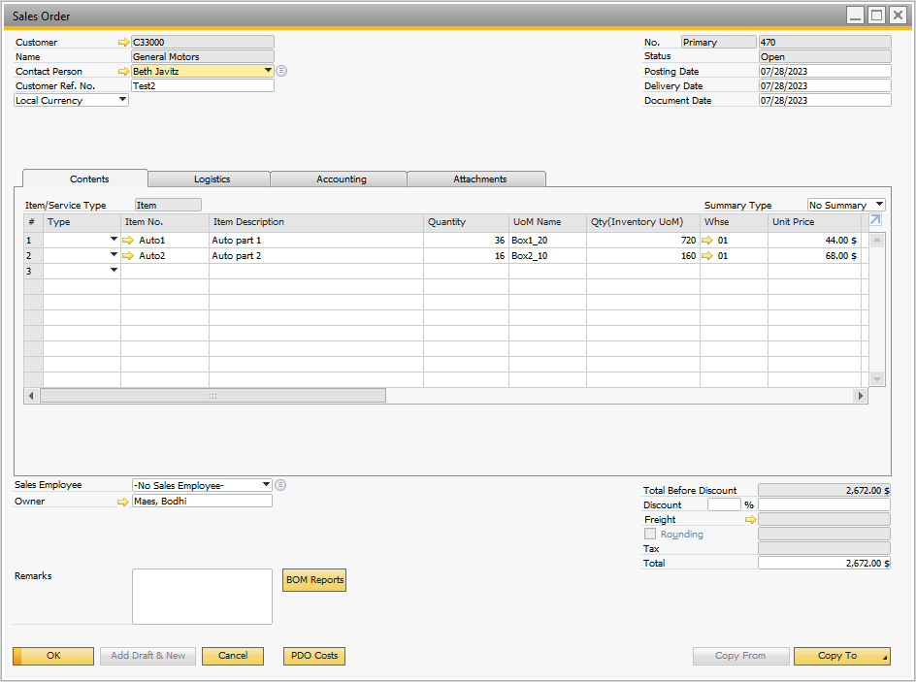

## Figure 1.12 Sales Order with 2 Parts with Box – Pallet Definitions

The first part ‘Auto1’ has 24 boxes on a pallet, so a 36-box sale will require one and a half pallets. The second part ‘Auto2’ has 16 boxes on a pallet and there are 16 boxes being sold, so a single pallet is required.

When the sales order is converted to a delivery order the packing slip is shown in Figure 1.13. I have highlighted each of the 3 pallets to show the contents of the pallet. The 1st pallet is associated with part Auto1 – a full pallet of 24 boxes. The second pallet is a partial pallet with only 12 boxes. The last pallet is full of boxes for part Auto2.

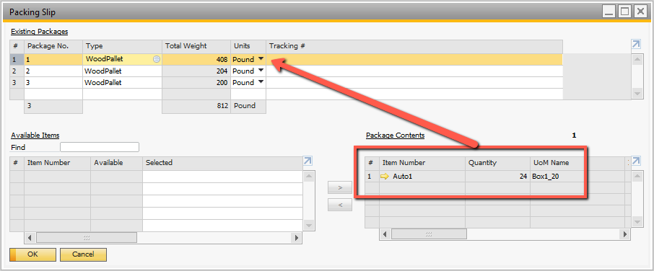

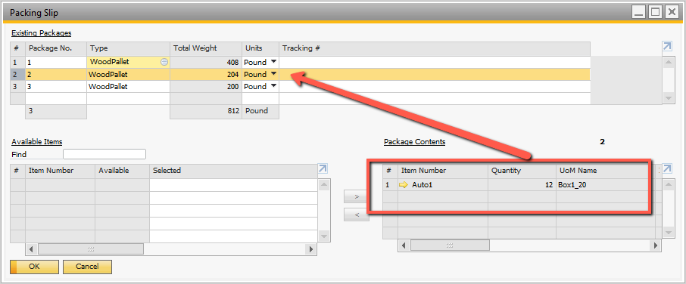

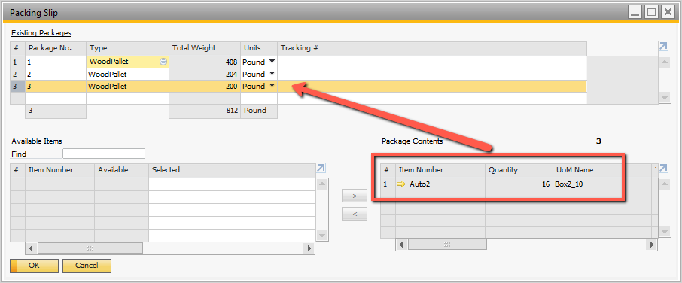

## Figure 1.13 Breakdown of Pallets for Multiple Containers

The delivery document reflects all the weights and quantities properly.

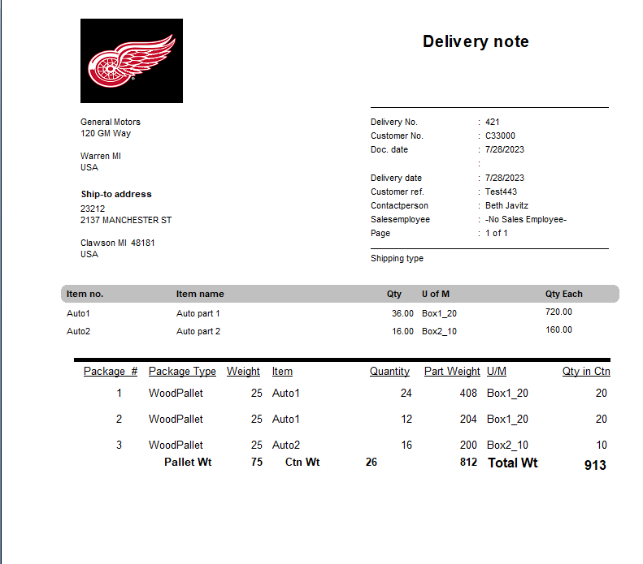

## Figure 1.14 Delivery Order with Multiple Parts and Pallets

What would happen if you only wanted to ship 2 boxes of parts and not use a ‘Pallet’. Figure 1.15 has a sales order with just such a scenario.

The default packaging is shown in Figure 1.16. The system ‘Assumes’ that a pallet is required. The user must edit this packing slip as shown in Figure 1.17.

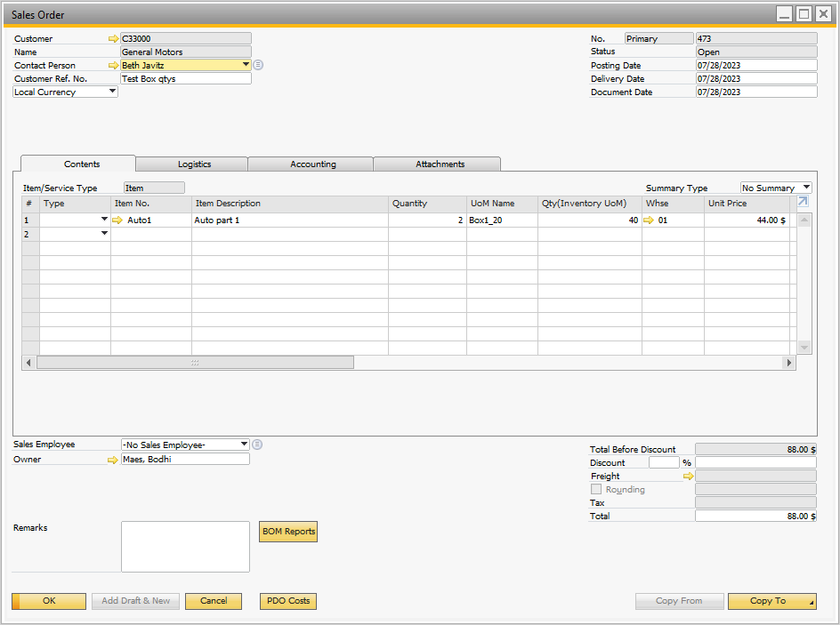

## Figure 1.15 Two Box Order – no Pallet Required

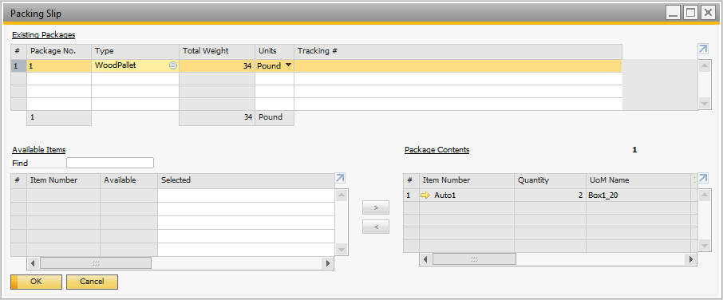

## Figure 1.16 Default Pallet Packaging

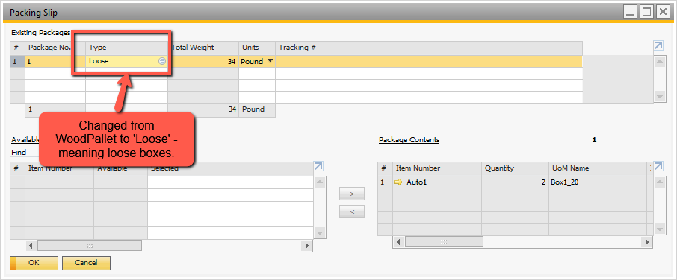

## Figure 1.17 ‘Loose’ Box Definitions

The delivery order print is shown in Figure 1.18.

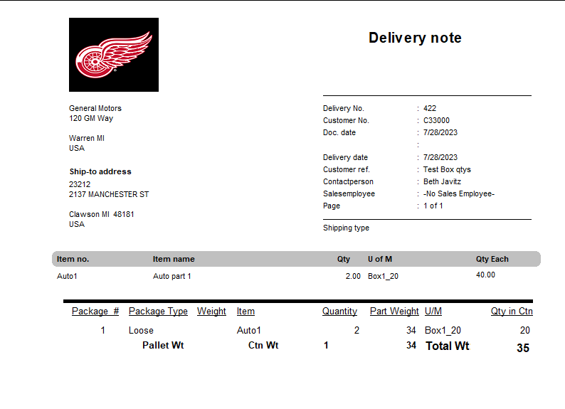

## Figure 1.18 Shipping Document with ‘Loose’ Boxes

**NOTE**: in the packaging screens I show a field ‘Tracking’ number. This is a user defined field I use to integrate with UPS Worldship – SAP B1. It would store the tracking number.

# Appendix A Boyum ‘Documents’ – Adding Packaging Details

Boyum provides a comprehensive ‘Document’ print template for all marketing documents. It is much more accessible for modifications than the standard SAP ‘system’ documents. I have made a few changes to the form and renamed it to reflect that Mascidon has made changes. The first thing I did was changed the logo – you would need to do this for your company.

Then I added a ‘subreport’ to report packaging information when the document being printed is a ‘Delivery Order’. Figure A-1 shows the resulting report showing the packaging.

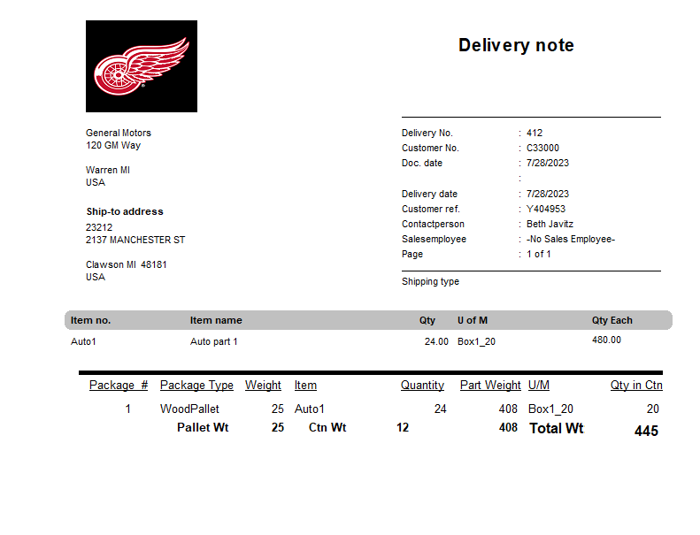

## Figure A-1 Delivery Order with Packaging Data

The packaging information is stored in 2 tables – DLN7 – the header packaging level, and DLN8 the container level detail. The ‘command line’ code behind the packaging is shown in Figure A-2.

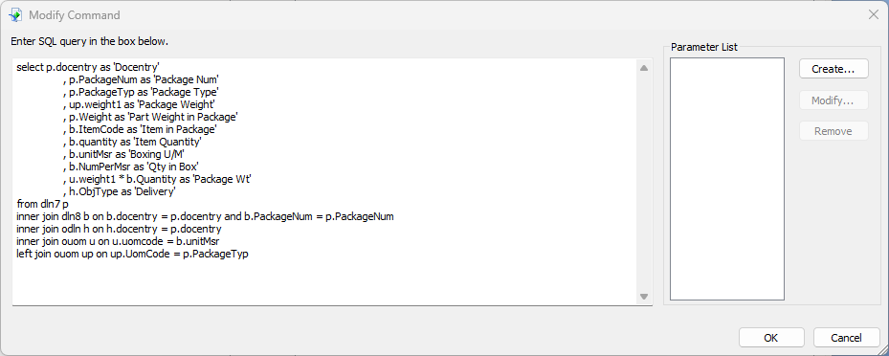

## Figure A-2 Packaging Sub-Report Command Line SQL

**NOTE**: the links are only to ODLN – the delivery order, so packaging will not appear on any other ‘Document’ reports.

To ensure the packaging only appears for delivery order documents, I added the information shown in Figure A-3 to the Section Expert for the main report. The sub-report is in the ‘Report Footer b’ section of the main report. I suppress the sub-report for documents that are not object type 15 (delivery orders).

The sub-report has a few calculations to determine the total weight of the parts, boxes and pallets.

The link between the main report and the sub-report is ‘Docentry’.

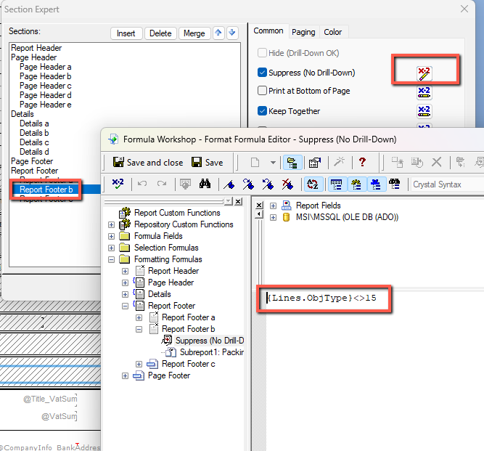

## Figure A-3 Limiting the Package Details to Delivery Orders