**RESERVE INVENTORY**

**Prepared by: Mascidon LLC**

**May 2023**

**Phone: Dr. Don Maes 248-568-0418**

Contents

Reserve Inventory – What is it? 3

Setup 5

Figure 1.1 Warehouse Setup Options 5

Figure 1.2 Reserve Items 6

Using the Reserve Item Feature – Sales Order by Sales Order 9

Figure 1.3 Reserve Quantity Update 9

Figure 1.4 Updated Sales Order Quantity – Reserve Changes 10

Figure 1.5 Double Click to See Reserve Quantity for an Item 10

Figure 1.6 Activity Created When Reserving Inventory Problem Occurs 11

Using the Reserve Item Feature – “Periodic Processing’ 12

Figure 1.7 Setup for Periodic Processing 12

Figure 1.8 Inventory Reserves – Initial 12

Figure 1.9 Completion of Periodic Recalculation of Reserve Quantities 13

Figure 1.10 Report of Reserved Quantities 13

Figure 1.11 Items Reserved – by Sales Order 13

Recommendations 15

Reserve Items Form 16

Figure 2.1 Reserve Items Form 16

Figure 2.2 Warning for Clearing Reserves 17

Figure 2.3 Clear Reserve Quantity Options 17

Figure 2.4 List of Reserved Items for this Warehouse 17

Figure 2.5 Auto Reserve Report Option 18

Figure 2.6 Auto Reserve Inventory Report – By Item 18

Figure 2.7 Auto Reserve Inventory Report – By Sales Order 18

Figure 2.8 Manually Apply Reserve Quantities 19

Figure 2.9 Posting of Manually Reserved Quantities is Complete 19

# Reserve Inventory – What is it?

SAP has the functionality to allocate inventory to specific sales orders when the items are batch or serial controlled. This Boyum add-on provides the means to reserve non-batch or serial controlled inventory. In many instances inventory availability is subject to shortages. This Boyum ‘add-on’ provides the capability to ‘reserve’ inventory for specific sales orders. For instance, you may have 1,000 on hand of an item and 6 open sales orders that require a total quantity of 1,500. You want to allocate this inventory in some manner to keep the bulk of your customers happy, or at least your critical customers.

This Boyum add-on provides the means to ‘reserve’ inventory for specific item – orders. There are considerations for how to handle inventory reservations.

* There are that items do not require inventory to be reserved.
  + The levels of inventory available for these items are rarely less than the sum of the open order quantities so there is no need to change SAP procedures to include ‘reserve on hand’.
  + Some items can be purchased and received quickly, so reserving the current on hand is not necessary.
* There are items that do require inventory to be reserved.
  + This can be done on a first come – first served basis. ‘First come – first served’ needs to be defined.
  + Or reserved via manual intervention

Here are options for handling inventory reservations within a single warehouse:

1. Only items specifically flagged as subject to reservations (i.e. a means to handle chronic shortages).
2. All items sold are subject to reservations.
   1. A subset of these items could be identified as being handled manually.

‘First come – first served’ Definition – a ‘Sort hierarchy’ flag is set in the setup by warehouse. It is either by due date of the sales order or customer priority plus due date. The customer priority is a field in the ‘payment terms’ of the business partner master form. You can define the ‘priority code values’, but make sure an alphabetic sort of these values sort in the manner you want to assign reserved inventory.

Available to sell definition - For the purposes of ‘reserving’ inventory the definition of available to sell is the on hand in a specific warehouse less the quantity in a ‘return request’ document that is being sent to another warehouse from this same warehouse. The ‘return request’ is treated as an in-transit inventory transfer. For example, part A has 250 on hand in warehouse ‘10’ and a ‘return request’ of this same part for 80 pieces is being sent to warehouse ‘20’. The net available on hand for part A in warehouse 10 is 250 – 80 = 170 ‘available to sell’.

One of the considerations necessary is how should inventory be reserved. The choices are:

* As orders are entered the inventory is reserved
  + This could be done automatically based on formulae
  + This could be a manual entry by the entry clerk
* Periodically, a process is run to reserve the inventory based on formulae.

In practice, how would your company use this Boyum – SAP functionality? Here are two basic options on a conceptual level:

* You have several thousand parts within your warehouse, but only a small subset of these parts is routinely subject to shortages. You would want to ‘flag’ this subset of parts and manage the allocation of on hand as new orders are received from customers. A ‘setup’ function is required to identify the subset of parts. You would add or remove parts from this list as shortages emerge or fade.
* You have several thousand parts within your warehouse and you want to manage all items with inventory reservations by sales order. In this instance, there is a ‘general’ setup for all items, but no specific items need to be identified for inventory reservations.

# Setup

On the warehouse setup screen there is a button ‘Reserve Inventory’. When this button is clicked the form shown in Figure 1.1 displays. Only 1 record per warehouse is allowed in this form. The data in this table per warehouse is:

* Sort hierarchy – within the formulae for reserving inventory there are two options for ‘sorting’ where to start applying inventory reserves. The options are:
  + Due date of order – use this to optimize the reserving of inventory based on earliest due dates for orders have preference over later dates.
  + Customer priority – use this code to alter the allocation of reserve inventory. When looking at open sales orders the process looks first at the customer priority code and then the sales order due date. **Note**: the priority code is on the payment terms tab of the customer maintenance screen. Make certain the definitions you have for the priority code sort in the sequence you want for reserving inventory.
* How to reserve inventory – there are 3 options available
  + **Only** process those items defined in the UDO as subject to reservations. i.e. if an item is specifically tagged as requiring inventory reservations, it will be subject to reservations, otherwise no other items are subject to reservations.
  + Process **all** items being sold as requiring reservations.
    - Any items identified in the list of items in the UDO in this instance are subject to ‘Manual’ intervention by the entry clerk. All other items are processed automatically.
* Timing of reserves – this addresses when the inventory is actually reserved. If items are identified as ‘manually reserved’, then this flag does not apply. For automatically reserving inventory, the options are:
  + Order by order – inventory is reserved as a sales order is entered or updated.
  + Periodic – inventory is reserved when a ‘process’ is run periodically.

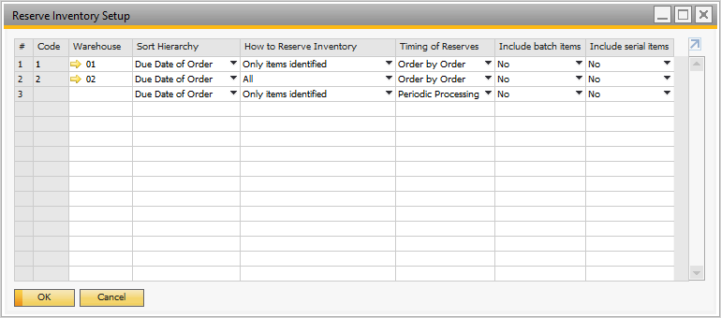

## Figure 1.1 Warehouse Setup Options

Since standard SAP has a means of allocating batches and serial numbers to sales orders, this is optional in our implementation. By default, the ‘Include batch items’ and ‘Include serial items’ flags are set to ‘No’.

The processing is a ‘matrix’ of options. There are four possibilities:

|  |  |  |
| --- | --- | --- |
| **How to Reserve Inventory** | **Timing of Reserving** | **Comment** |
| O = Only items in table | O = order by order | Scenario 1 |
| O = Only items in table | P = Periodic processing | Scenario 2 |
| A = All items | O = order by order | Scenario 3 |
| A = All items | P = Periodic processing | Scenario 4 |

The ‘Table’ of reserve items is a form – shown in Figure 1.2.

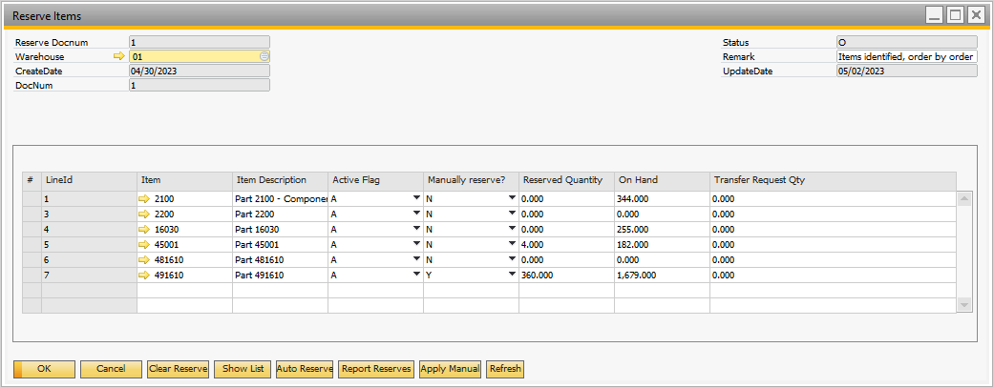

## Figure 1.2 Reserve Items

If items in the list of items for inventory reserves are flagged as Manual = ‘Y’, then those items are always handled manually regardless of which scenario is being used. i.e. the entry clerk reserves inventory as they process orders or once a day or week – this is their choice to handle these items manually.

1. **Description of scenario 1**
   1. Settings: reserve inventory for only those items listed in the ‘Reserve items’ form; and apply the reservations as each sales order is entered.
   2. Clear Reserves: when this button is clicked all of the items in the ‘Reserve items’ form have the quantity reserved set to zero unless the ‘Manual reserve flag’ is set to ‘Y’.
   3. Show List: this lists the items from the ‘Reserve items’ form and the quantities currently reserved, on hand or in transit.
   4. Auto Reserve: this does nothing in this scenario since reserving inventory is done sales order by sales order.
   5. Report reserves: this shows each item from the ‘Reserve items’ form and how the reservation of quantities is formed – i.e. it shows quantities reserved sales order by sales order. The report can be sorted by item or by sales order.
   6. Apply manual: this function is only available in this scenario if one or more items on the ‘Reserve items’ form are flagged as ‘Manual’ = ‘Y’. If so, a screen will display showing those items, order by order, and the user has the option of reserving the on hand.
   7. Refresh: refreshes the ‘Reserve items’ form.
2. **Description of scenario 2**:
   1. Settings: reserve inventory for only those items listed in the ‘Reserve items’ form; and apply the reservations ‘Periodically’ is entered.
   2. Clear Reserves: when this button is clicked all of the items in the ‘Reserve items’ form have the quantity reserved set to zero unless the ‘Manual reserve flag’ is set to ‘Y’.
   3. Show List: this lists the items from the ‘Reserve items’ form and the quantities currently reserved, on hand or in transit.
   4. Auto Reserve: this clears the currently ‘periodically reserved’ inventory and recalculates the reserve quantity on a sales order by sales order basis using the ‘Sort hierarchy’ to determine the order in which reservations are applied. The auto reserve is only looking at the items in the ‘Reserve items’ form that do not have ‘Manual’ = ‘Y’. **NOTE**: by recalculating, the current reserve on hand of an item for a specific order could be changed. For instance, yesterday the auto reserve ran and applied a reserve quantity of 50 to a sales order item that is due on May 15. Today a sales order for the same item was received and it has a due date of May 12. Part or all of the 50 reserved for the first sales order will be used to fulfill the May 12 sales order – assuming there is insufficient on hand to satisfy both. The same issue would occur if using the sort hierarchy ‘Customer priority’ and the May 12 due date sales order has a higher priority customer.
   5. Report reserves: this shows each item from the ‘Reserve items’ form and how the reservation of quantities is formed – i.e. it shows quantities reserved sales order by sales order. The report can be sorted by item or by sales order.
   6. Apply manual: this function is only available in this scenario if one or more items on the ‘Reserve items’ form are flagged as ‘Manual’ = ‘Y’. If so, a screen will display showing those items, order by order, and the user has the option of reserving the on hand.
   7. Refresh: refreshes the ‘Reserve items’ form.
3. **Description of scenario 3**:
   1. Settings: reserve inventory for ‘All’ items being sold; and apply the reservations as each sales order is entered.
      1. In this scenario, the ‘Reserve items’ form should only have items that specifically need to be manually reserved. i.e. Manual flag = ‘Y’.
   2. Clear Reserves: when this button is clicked all of the items have their inventory reserve quantity set to zero except for items in the ‘Reserve items’ form that have the ‘Manual reserve flag’ is set to ‘Y’.
   3. Show List: this lists all items and the quantities currently reserved, on hand or in transit.
   4. Auto Reserve: this does nothing in this scenario since reserving inventory is done sales order by sales order.
   5. Report reserves: this shows all items with open sales order quantities and how the reservation of quantities is formed – i.e. it shows quantities reserved sales order by sales order. The report can be sorted by item or by sales order.
   6. Apply manual: this function is only available in this scenario if one or more items on the ‘Reserve items’ form are flagged as ‘Manual’ = ‘Y’. If so, a screen will display showing those items, order by order, and the user has the option of reserving the on hand.
   7. Refresh: refreshes the ‘Reserve items’ form.
4. **Description of scenario 4**:
   1. Settings: reserve inventory for ‘All’ items being sold; and apply the reservations periodically.
      1. In this scenario, the ‘Reserve items’ form should only have items that specifically need to be manually reserved. i.e. Manual flag = ‘Y’.
   2. Clear Reserves: when this button is clicked all of the items have their inventory reserve quantity set to zero except for items in the ‘Reserve items’ form that have the ‘Manual reserve flag’ is set to ‘Y’.
   3. Show List: this lists all items and the quantities currently reserved, on hand or in transit.
   4. Auto Reserve: this clears the currently ‘periodically reserved’ inventory and recalculates the reserve quantity on a sales order by sales order basis using the ‘Sort hierarchy’ to determine the order in which reservations are applied. The auto reserve is looking at all items on sales order except the items in the ‘Reserve items’ form that have ‘Manual’ = ‘Y’. **NOTE**: by recalculating, the current reserve on hand of an item for a specific order could be changed. For instance, yesterday the auto reserve ran and applied a reserve quantity of 50 to a sales order item that is due on May 15. Today a sales order for the same item was received and it has a due date of May 12. Part or all of the 50 reserved for the first sales order will be used to fulfill the May 12 sales order – assuming there is insufficient on hand to satisfy both. The same issue would occur if using the sort hierarchy ‘Customer priority’ and the May 12 due date sales order has a higher priority customer.
   5. Report reserves: this shows all items with open sales order quantities and how the reservation of quantities is formed – i.e. it shows quantities reserved sales order by sales order. The report can be sorted by item or by sales order.
   6. Apply manual: this function is only available in this scenario if one or more items on the ‘Reserve items’ form are flagged as ‘Manual’ = ‘Y’. If so, a screen will display showing those items, order by order, and the user has the option of reserving the on hand.
   7. Refresh: refreshes the ‘Reserve items’ form.

***Note: each of the warehouse managers in your organization could choose any of the four scenarios to manage reserved inventory. Only one of the four may be used for any single warehouse.***

# Using the Reserve Item Feature – Sales Order by Sales Order

Figures 1.1 and 1.2 show the warehouse options and the individual items identified for being reserved for warehouse ‘01’. The entry clerk or supervisor can begin using the system. Let’s review the handling of reserving inventory with these settings. Figure 1.3 shows the entry of a sales order for a part ‘2100’ – which is in the list of reserve items. At the time of this entry, item 2100 has 344 on hand and no in transit quantity. The expectation is that an entry of an item quantity of 344 or less will result in the application of the sales order quantity for this part 2100. Looking at Figure 1.3, the reserve quantity equals the quantity ordered – as we would expect.

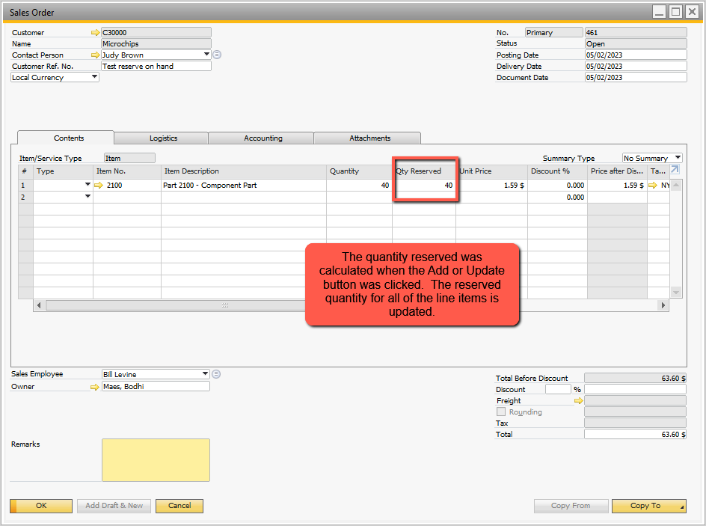

## Figure 1.3 Reserve Quantity Update

To see the order-by-order change, I altered the quantity for this item ordered from 40 to 280. Figure 1.4 shows the result after the ‘Update’ of the sales order. I also changed the due date to 5/15. Since there is still sufficient on hand to reserve the full quantity, the reserved quantity was set to 280.

If we need to see the quantity reserved of an item from within the sales order form, double click the item and the popup shown in Figure 1.5 displays.

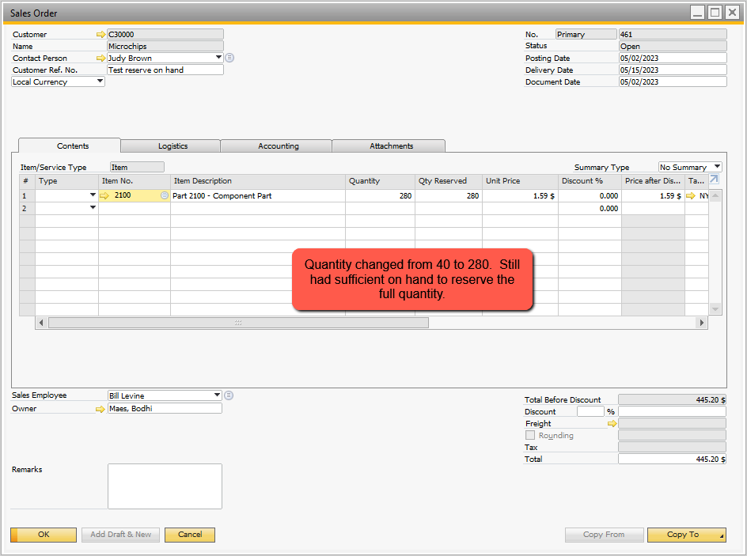

## Figure 1.4 Updated Sales Order Quantity – Reserve Changes

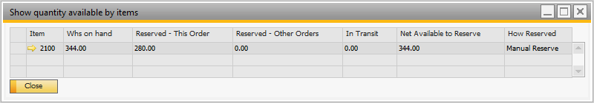

## Figure 1.5 Double Click to See Reserve Quantity for an Item

### **NOTE – Problem with reserving inventory:**

**Problem Definition**

There is a problem reserving inventory sales order by sales order.

* Setup for the **sort hierarchy is by due date**
  + A sales order is entered last week for part A and has a 2 week delivery
    - Inventory is reserved for this order (1)
  + 3 days later another order comes in for the same part A but is promised a 3 day delivery
    - Inventory is reserved for this order (2)
  + Strictly speaking, the 2nd order should get all of the reserved quantity it needs before any reserved quantity is applied to the 1st order
    - But the 1st order is already on file
    - There may be a large number of orders for this part that have a due date after this second order
* Setup for the **sort hierarchy is by customer priority, by due date**
  + A sales order is entered for part A for a customer today – their priority is level 3
  + A second sales order is entered today for part A for a customer with priority level 2
  + If there is insufficient reserve quantity to fulfill the 2nd order, what should we do?

**Problem Solution(s)**

One way to deal with this is to have the system automatically update all sales order reserves for this part while the 2nd order is being saved. This is dangerous because some of the other orders may already be released to the shipping department – paperwork on the floor, picking process ongoing, etc.. This could result in a mess.

The way I have chosen to deal with it is to send an SAP activity to the sales person to make them aware that this order should have a higher priority than the other orders on file for this part. This activity alerts them to the problem and these people are responsible for manually making reservation changes as needed. The resulting ‘Activity’ is shown in Figure 1.6.

I have chosen not to get more sophisticated than sending an activity. If you need more ‘sophistication’ processing rules would need to be developed prior to altering the current reserve policies.

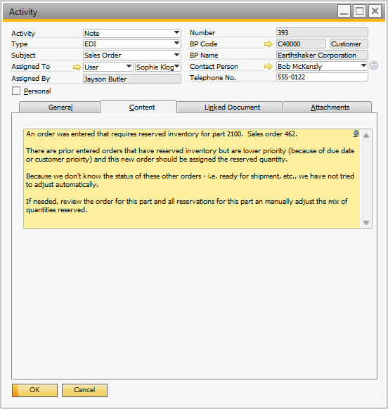

## Figure 1.6 Activity Created When Reserving Inventory Problem Occurs

# Using the Reserve Item Feature – “Periodic Processing’

Figures 1.7 and 1.8 show the warehouse options and the individual items identified for being reserved for warehouse ‘01’ using ‘Periodic’ processing. The entry clerk or supervisor can begin using the system. The inventory reserves for all orders are set to zero to begin this demo process.

Let’s review the handling of reserving inventory with these settings. Since this is a ‘Periodic’ assignment of inventory for reserves, sales orders are entered for a period of time and then the ‘reserve’ inventory function is run to reserve stock. You would want to do this at the start and end of day and perhaps at a mid-day lull. However, if you have sales order entry proceeding across multiple time zones, early morning or late evening are probably the best times. Note: periodic updates are done by warehouse so timing could be the begin and end of day at this warehouse and perhaps at noon.

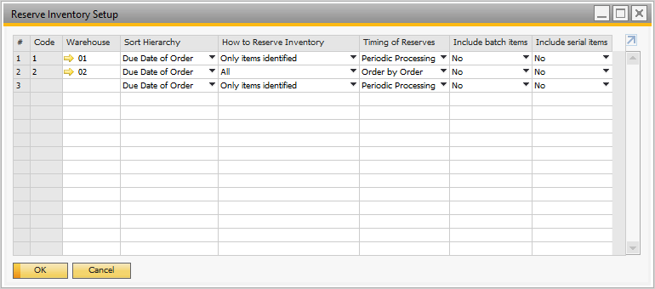

## Figure 1.7 Setup for Periodic Processing

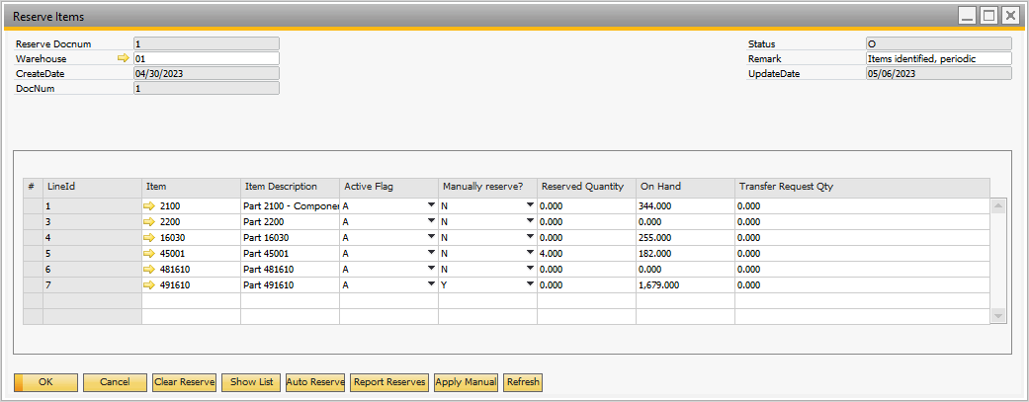

## Figure 1.8 Inventory Reserves – Initial

To process periodically, bring up the ‘Reserve Items’ form for this warehouse and click on the ‘Auto Reserve’ function. The processing occurs and the message shown in Figure 1.9 displays. Figure 1.10 shows the report of items reserved.

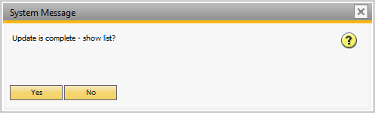

## Figure 1.9 Completion of Periodic Recalculation of Reserve Quantities

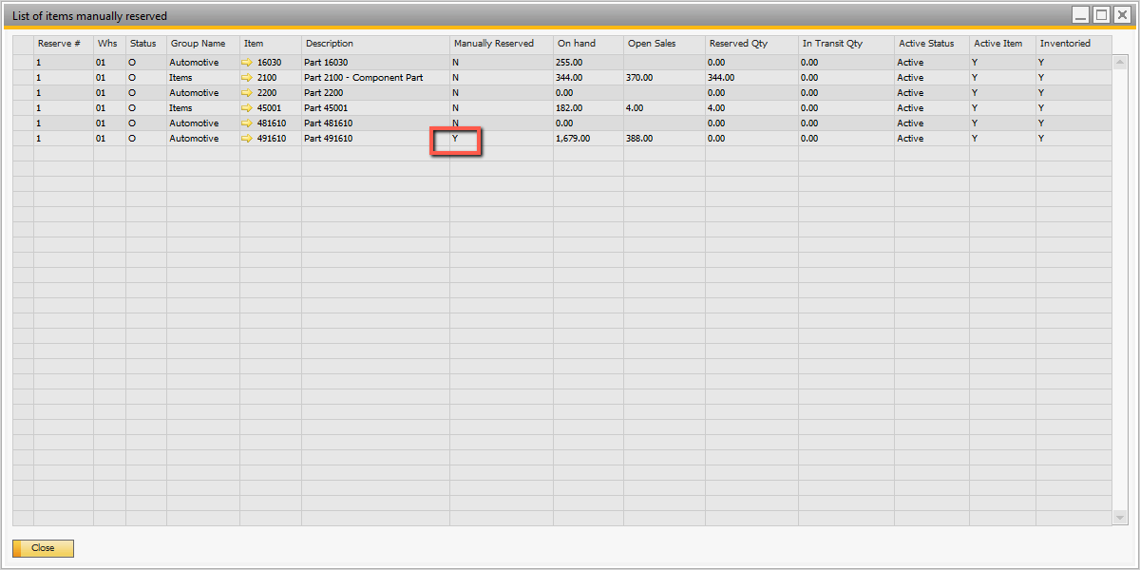

## Figure 1.10 Report of Reserved Quantities

Make a note – the part 491610 was not subject to the auto-reserve process because it is set to ‘manual’ reserve.

Two parts were reserved: part 2100 and part 45001. Use the ‘Report Reserves’ button to report the reserved quantities by sales order. This report is shown in Figure 1.11.

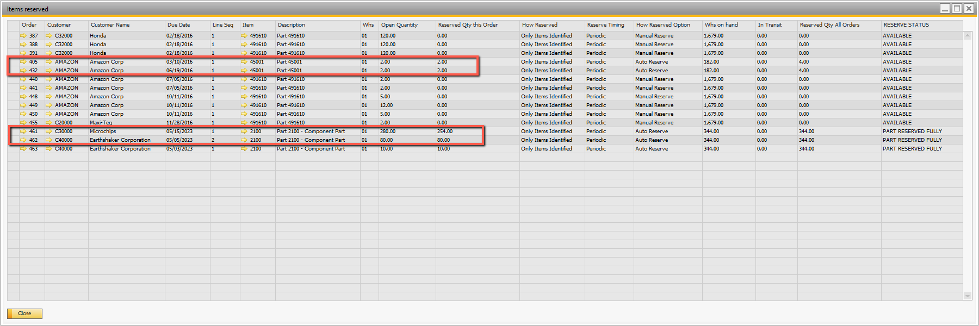

## Figure 1.11 Items Reserved – by Sales Order

The first part, ‘45001’ has 182 on hand and only 4 on order from 2 sales orders – so the quantities being reserved are easy to determine – 2 each order. This is shown in the report.

The second part, ‘2100’ has 344 on hand and order quantities totaling 360 – so the system needs to decide which order gets the ‘reserve quantity’. From the report, order 462 was fully assigned – 80 on order, 80 reserved. The second order, 461, received less than the full 280. The reason for this is that the due date of order 462 is 5/5/23, which is earlier than the due date for order 461.

Unlike the application of reserves on a sales order by sales order basis, the order entered latest received the reserved quantity.

### **NOTES on Periodic Processing**

Since the periodic processing function is run under user control there are enhancements that could be made to the process. Here is what occurs for the ‘standard’ periodic processing function:

* User initiates the process
* System looks at all non-manually applied inventory reserves for open orders and zeroes out the reserve quantities for these item – orders. **Note**: orders entered after the last ‘periodic’ update would have 0 as the reserve quantity.
* System then recalculates the reserve quantities for each item order according to the ‘sort hierarchy’ – normally by due date.

How could this be improved?

* Rather than zero out all the reserve quantities for all open sales orders (non-manual), the system could look for ‘pick lists’ for orders and if the orders are being picked ignore zeroing out these orders.
* When re-applying the reserve quantities, the items on the pick list are excluded.
* This would reduce the update to ‘open sales orders less current open pick list items’.

This ‘improvement’ would reduce confusion on the floor in case paperwork has been issued to ‘pick stock’.

Use the ‘Approval’ of Sales Orders

* Another option is to not include any sales orders in the ‘reserve inventory’ calculations that have been ‘Approved’
* This implies that all orders come into SAP as unapproved and there is an approval process that locks these orders in.

This would actually be an excellent internal process. You have sales orders coming in and run a ‘periodic’ update at end of day or first thing in the AM. The next step in the process would be to ‘Approve’ sales orders so they can be released to the floor. Then use B1 Print and Delivery from Boyum to deliver sales acknowledgments to the customer – essentially telling them the order timing. At that point you would not want to take away inventory reserved for an order because them customer issues would arise.

This process would be especially useful if you are using the inventory reserves to reserve critical part shortages.

# Recommendations

SAP Business One is an excellent inventory sales distribution ERP system. Use its capabilities to manage inventory:

* Use open sales orders, forecasts and MRP to predict purchase requirements
* Use minimum / maximum and order quantities to flag when purchases are required
* Use sales analyses reports to spot trends and possible future shortages
* Analyze back-order reports to spot shortfalls before they get out of hand
* Pay close attention to lead times for product – especially products delivered from overseas as this takes extra planning and longer deliveries

If after using SAP to its fullest you still have a problem managing shortages, then reserving inventory may be the answer. I would strongly recommend that you identify the parts that are critical to sales and have chronic shortages and only use the reserve inventory function for these parts.

Don’t leave these ‘chronically’ shorted parts on the list forever. You should be taking steps to find new vendors and work with current vendors to alleviate the shortages.

**The reserve inventory process is extra work – don’t use it as a crutch for poor inventory management!**

# Reserve Items Form

The reserve items form is shown in Figure 2.1. It is a ‘Document’ form and using ‘Right Click’ it can be removed, cancelled or closed. Once it is closed or cancelled it has no effect on the reserve inventory process.

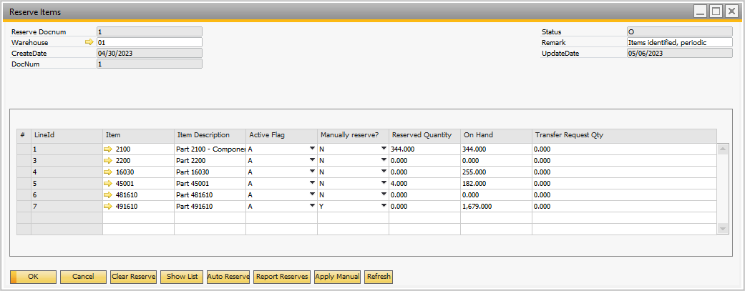

## Figure 2.1 Reserve Items Form

The ‘body’ portion of the form identifies the items subject to inventory reserves if the option to process ‘Identified Only’ is chosen. There is a flag – ‘Manually Reserve’. If this is set to ‘Y’ then the user is manually reserving the inventory for this part and none of the automatic processes have any effect on these items.

The ‘Reserved Quantity’ is updated as you access this screen or click the ‘Refresh’ button.

These are the functions of the ‘Buttons’:

1. **Clear Reserve** – this option provides the means to clear the quantities on reserve for this warehouse. When this button is clicked the screen shown in Figure 2.2 is presented. Click ‘No’ if you really don’t want to do this or you are not certain. If you answer ‘Y’ the screen shown in Figure 2.3 displays. Clearing reserves presents 3 options (all for this specific warehouse):
   1. Auto Only – this option only clears reserve quantities that are not manually controlled but ‘automatically’ controlled. Referring to Figure 2.1, the item 491610 would NOT have the reserve quantities set to zero because it is flagged as manually reserved.
   2. Manual only – this option provides the means to reset all of the manually controlled item reserve quantities to zero. This would only be used if the ‘manual’ application of reserve quantities needed to be re-done due to changes in priorities (or because someone messed up the reserve quantities).
   3. All – it means what it says – all items would have their reserve quantities zeroed.

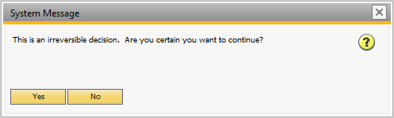

## Figure 2.2 Warning for Clearing Reserves

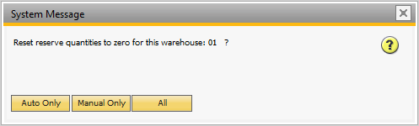

## Figure 2.3 Clear Reserve Quantity Options

1. **Refresh** – after making changes to the screen clicking the ‘Refresh’ button will update the screen with the latest values. For instance, if the ‘Clear reserve’ had selected to clear the ‘manual reserves’ then the screen would be inaccurate. Clicking the ‘Refresh’ button updates the information on the screen.
2. **Show List** – the information on the screen in Figure 2.1 is displayed in the sequence it was entered. The show list displays the information in either item sequence or item group, item sequence. The resulting report is shown in Figure 2.4.

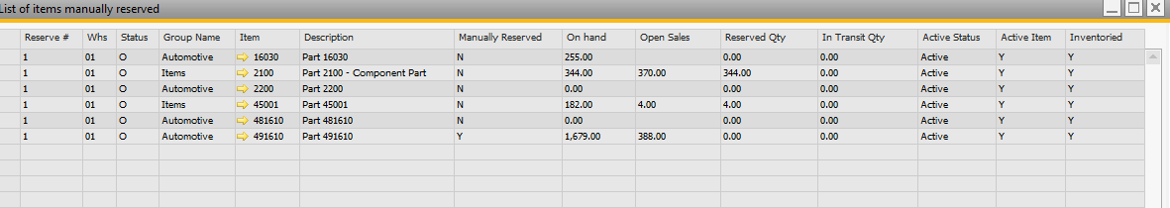

## Figure 2.4 List of Reserved Items for this Warehouse

1. **Auto Reserve** – this button is used to automatically calculate the reserve quantity for those inventory items that are not ‘Manually’ assigned. When this button is clicked a secondary screen displays as shown in Figure 2.5. **Note**: the reserve quantities are applied based on the setup function ‘Sort Hierarchy’. The report option either prints the report of reserve quantities by item or by sales order. Figures 2.6 and 2.7 show the 2 different reports based on the selection.

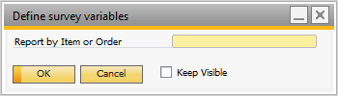

## Figure 2.5 Auto Reserve Report Option

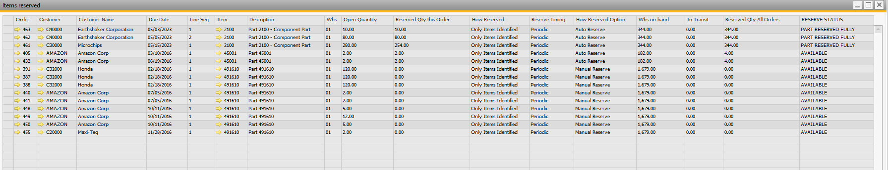

## Figure 2.6 Auto Reserve Inventory Report – By Item

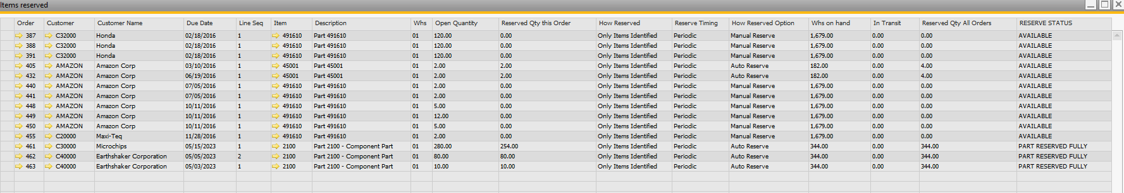

## Figure 2.7 Auto Reserve Inventory Report – By Sales Order

1. **Report Reserves** – this option button provides the means to display a report of the items / orders with reserved quantities. The user is asked whether to display this report in item sequence of sales order sequence. The reports are the same as in Figure 2.6 and 2.7.
2. **Apply Manual** – this option provides the means to manually apply reserve quantities. When it is pressed the system displays the items that are manually controlled as shown in Figure 2.8. To apply a quantity, enter the quantity in the applicable ‘row’ in the ‘Reserved Qty this Order’ column and click on the ‘Post’ check box. When you click on the ‘Close’ button the update of the reserved quantities will be applied. The message box shown in Figure 2.9 will be displayed. You can verify this by clicking on the ‘Refresh’ button or by clicking on the ‘Apply Manual’ a second time.

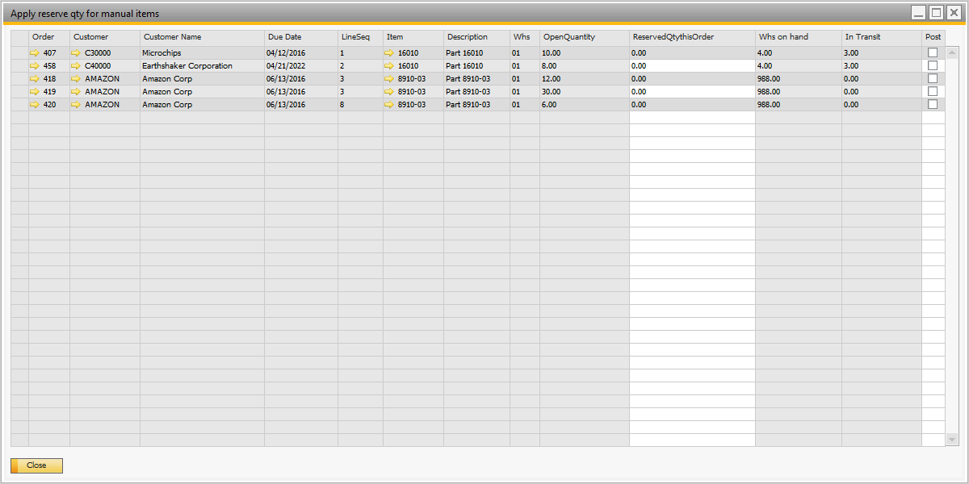

## Figure 2.8 Manually Apply Reserve Quantities

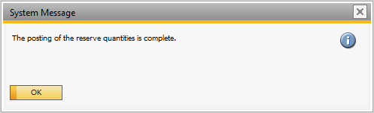

## Figure 2.9 Posting of Manually Reserved Quantities is Complete

### **NOTE: IN TRANSIT**

In this document there are references to ‘in transit’ on hand. There is no such designation within SAP Business One. The SAP Inventory Transfer Request’ is the document to use for recording in-transit stock between warehouses. Assume you are sending part ‘A’ from warehouse ‘01’ to warehouse ‘02’. The on hand in warehouse ‘01’ is 400 and you are sending 100 to warehouse 2.

After entering the inventory transfer request document in SAP, you will still have 400 in warehouse 01. I am assuming you enter the transfer request and then ship the product to warehouse 02. Depending on how it is shipped it may be several days before it arrives at warehouse 02. This stock is not available in either warehouse to sell to a customer. Therefore, I omit this inventory from the reserve inventory calculations and have called it ‘In transit’.

# Boyum Functions

The business functions and operations have been defined – now how is Boyum being used to perform these functions?

The first step within SAP is to defined some new fields and a user defined object (form). There are 3 new tables defined and shown in Figure 3.1. The fields are shown in Figure 3.2.

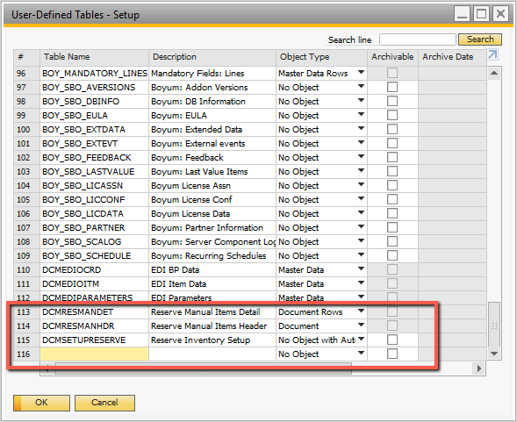

## Figure 3.1 User Tables Required

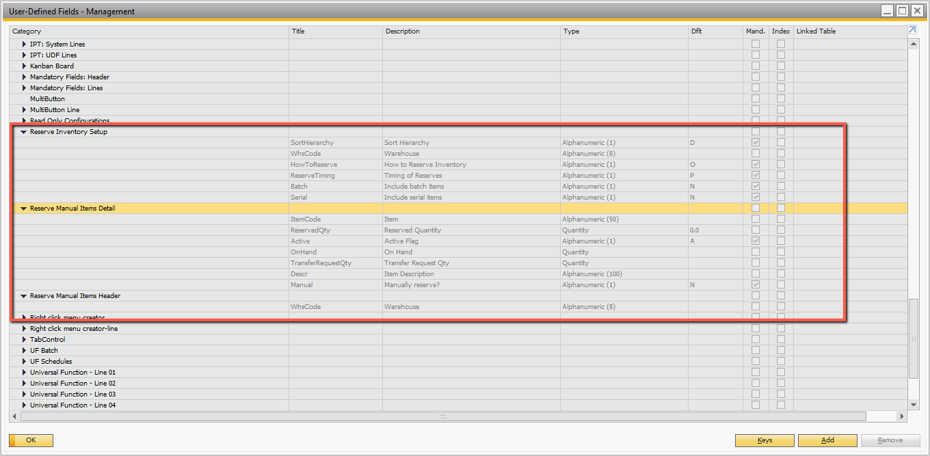

## Figure 3.2 User Tables – Field Definitions

The setup table ‘Reserve Inventory Setup’ is an object type ‘No object – with auto numbering’. It is a table that will have one record per warehouse (maximum), so it is not a ’user defined object’. Normally you can access this via: Tools 🡪 User Defined Windows 🡪 Select this table. I added a button on the warehouse setup form to make this easier for the user. To do this I used Boyum Item Placement Tool to add a button. This is shown in Figure 3.3. A Validation is used when the button is clicked – Figure 3.4.

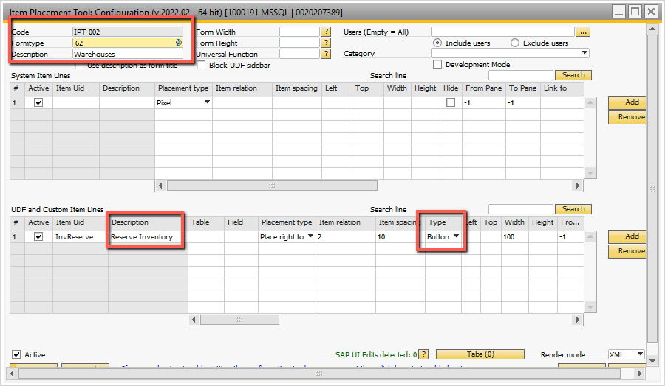

## Figure 3.3 IPT to Display ‘Reserve Inventory’ Button

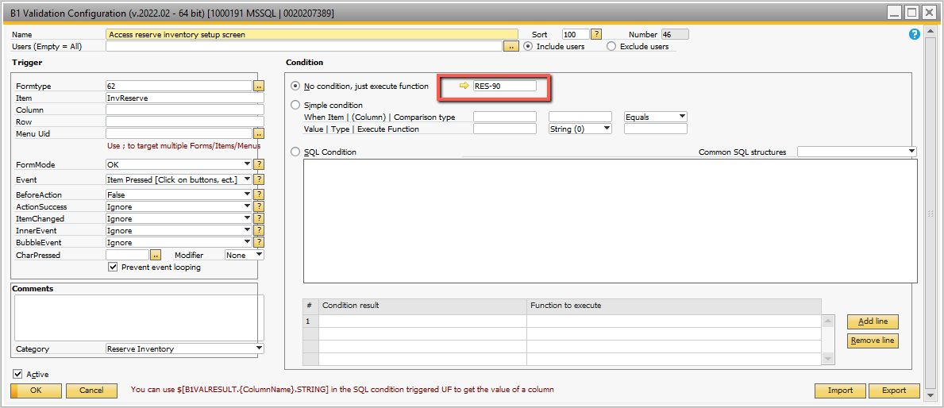

## Figure 3.4 B1 Validation on ‘Reserve Inventory Button’

The Universal Function RES-90 is called when the button is clicked – Figure 3..5.

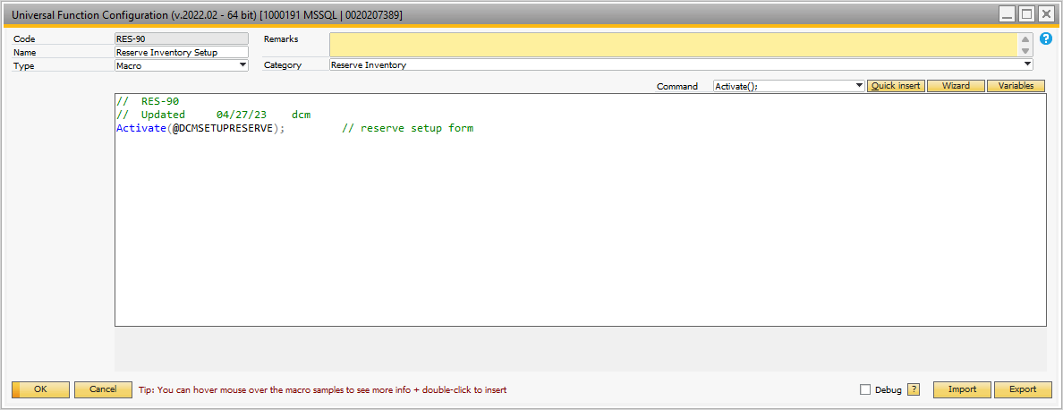

## Figure 3.5 Macro to Activate the Reserve Inventory Setup Form

The remaining 2 tables DCMRESMANHDR and DCMRESMANDET at document and document rows object types. As such they can be used to create a user define object (UDO). Figures 3.6 through 3.11 show the settings for this UDO.

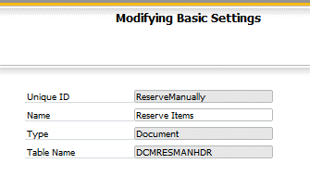

## Figure 3.6 UDO Setup – 1

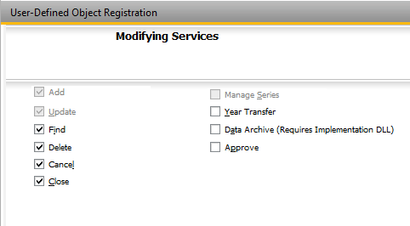

## Figure 3.7 UDO Setup – 2

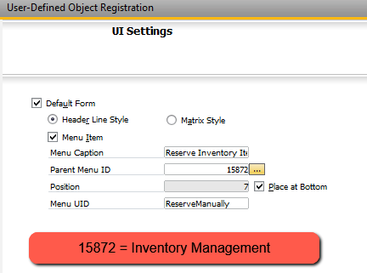

## Figure 3.8 UDO Setup – 3

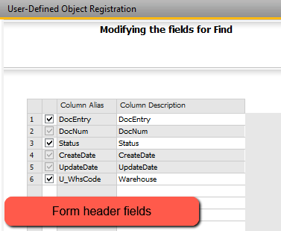

## Figure 3.9 UDO Setup – 4

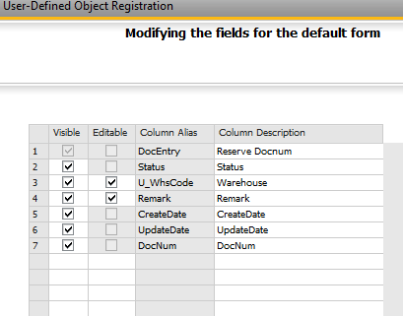

## Figure 3.10 UDO Setup – 5

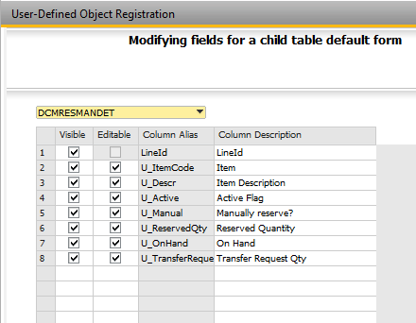

## Figure 3.11 UDO Setup – 6

The UDO is shown in Figure 3.12.

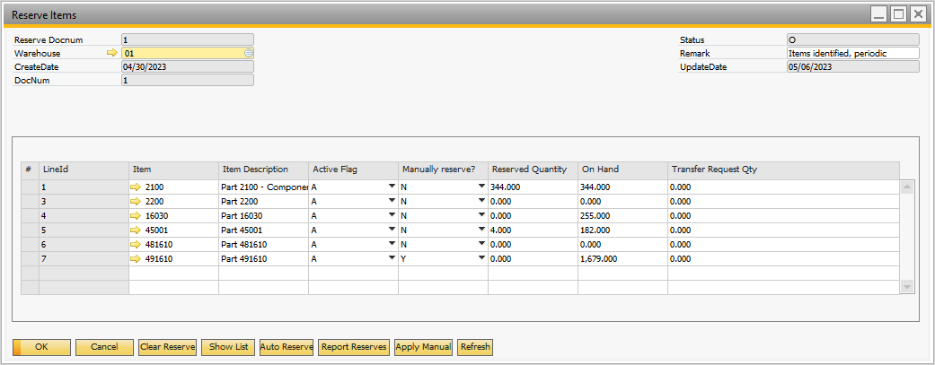

## Figure 3.12 Reserve Items UDO

The buttons on this form are all prepared in the Item Placement Tool – Figure 3.13. Before going into these buttons we’ll look at other B1 Validations used on the form.

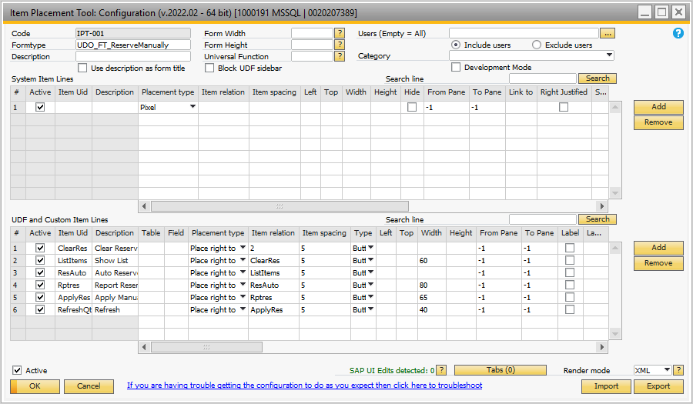

## Figure 3.13 IPT Defines Buttons on Reserve Items UDO

There is a B1 Validation to check if the user has inadvertently entered the same item on the Reserve Items form multiple times. This is initiated when the user adds or updates the form – see Figure 3.14. If there are, UF RES-35 is called – Figure 3.15. It is a SQL report of the duplicates.

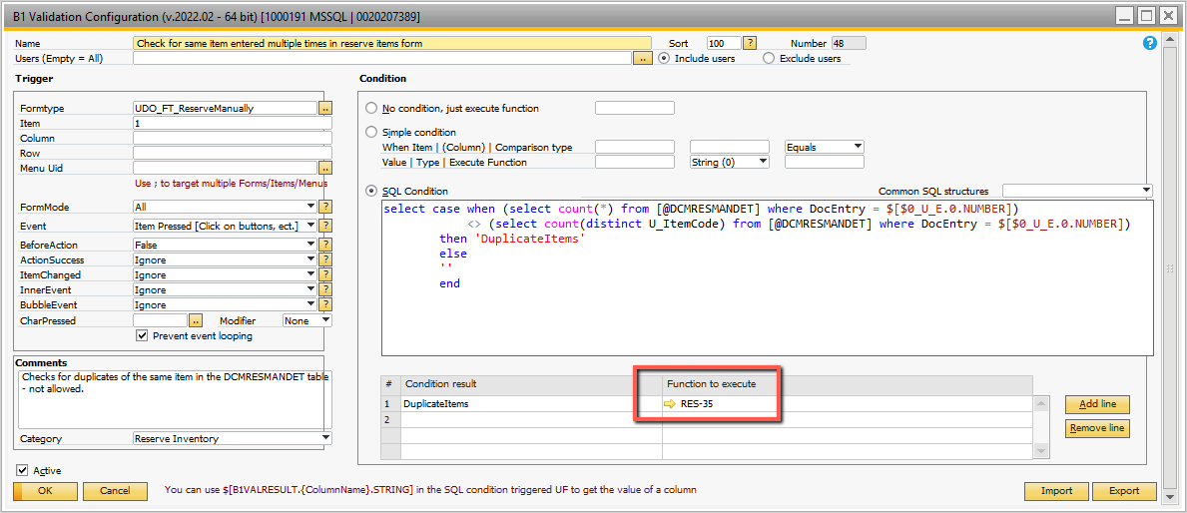

## Figure 3.14 Check for Multiple Occurrences of Same Item on Form

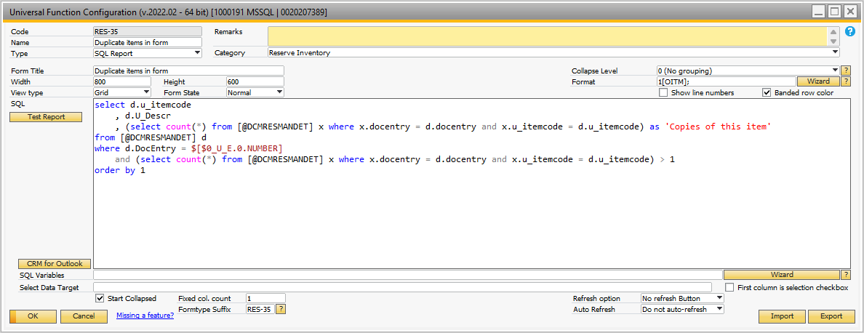

## Figure 3.15 SQL Report of Duplicate Items Entered

As the item is entered, the initial setup is checked to see if we are allowing batch controlled or serial controlled items to be ‘reserved’. The B1 Validation in Figure 3.16 is initiated as we validate the item.

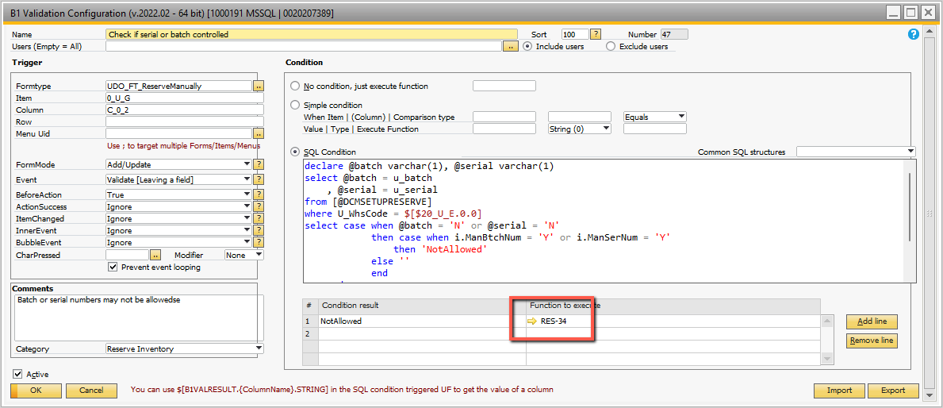

## Figure 3.16 B1 Validation to Check for Serial or Batch Control Allowed

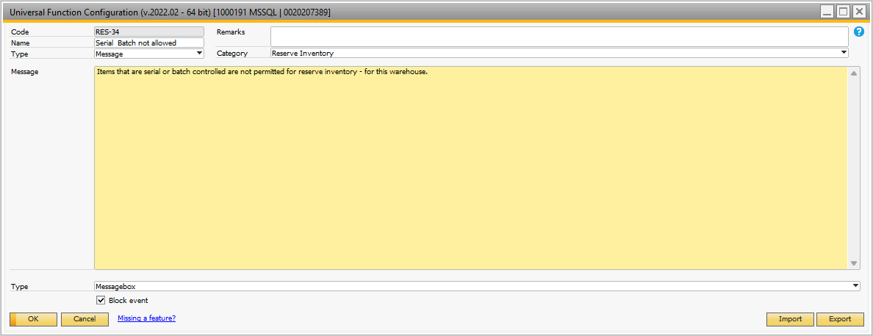

## Figure 3.17 Message When Serial / Batch not Allowed

When the item is validated the quantities on the form are updated. The B1 Validation is shown in Figure 3.18 and the UF called is shown in Figure 3.19. Figure 3.20 shows the SQL.

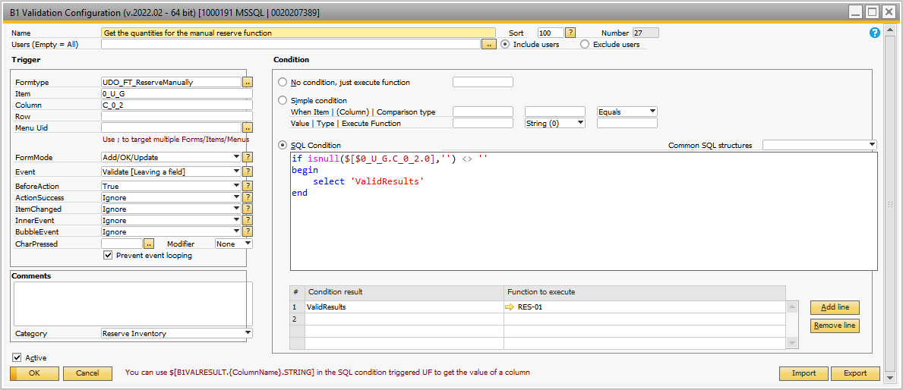

## Figure 3.18 Use Validate Item to Get Reserved Quantities

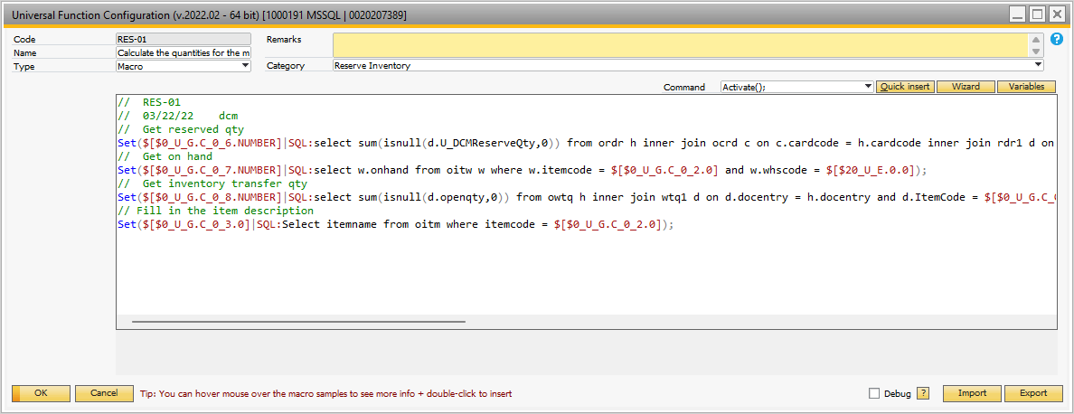

## Figure 3.19 Calculate Item Reserve Quantities

*// RES-01// 03/22/22 dcm// Get reserved qtySet($[$0_U_G.C_0_6.NUMBER]|SQL:select sum(isnull(d.U_DCMReserveQty,0)) from ordr h inner join ocrd c on c.cardcode = h.cardcode inner join rdr1 d on d.docentry = h.docentry and d.whscode = $[$20_U_E.0.0] and d.itemcode = $[$0_U_G.C_0_2.0] inner join oitm i on i.itemcode = d.itemcode where i.InvntItem = 'Y' and h.docstatus <> 'C' and h.CANCELED = 'N' and d.linestatus <> 'C' and d.OpenQty > 0 );// Get on handSet($[$0_U_G.C_0_7.NUMBER]|SQL:select w.onhand from oitw w where w.itemcode = $[$0_U_G.C_0_2.0] and w.whscode = $[$20_U_E.0.0]);// Get inventory transfer qtySet($[$0_U_G.C_0_8.NUMBER]|SQL:select sum(isnull(d.openqty,0)) from owtq h inner join wtq1 d on d.docentry = h.docentry and d.ItemCode = $[$0_U_G.C_0_2.0] and d.fromwhscod = $[$20_U_E.0.0] where h.docstatus <> 'C' and h.canceled = 'N' and d.linestatus <> 'C');// Fill in the item descriptionSet($[$0_U_G.C_0_3.0]|SQL:Select itemname from oitm where itemcode = $[$0_U_G.C_0_2.0]);*

## Figure 3.20 Item Reserve Calculations – Showing SQL

There are B1 Validations for each of the 6 buttons created using the item placement tool.

## Refresh Button

Figure 3.20 shows the B1 validation for the refresh button.

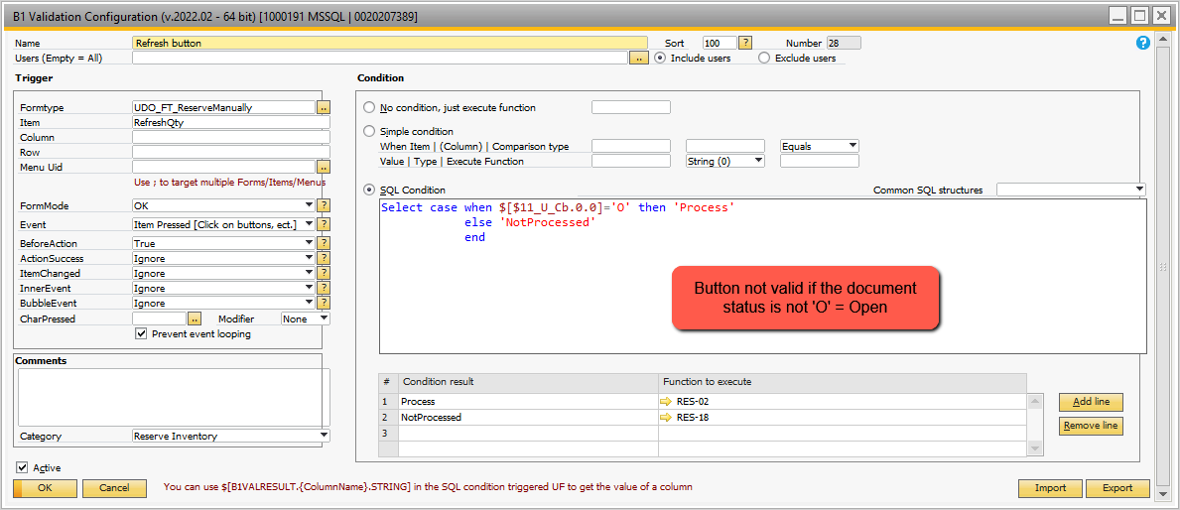

## Figure 3.20 Validation for the Refresh Button

If the document is not open an error message is displayed using the Universal Function RES-18 as shown in Figure 3.21.

## 

## Figure 3.21 Refresh Error – Document not Open

The Refresh UF RES-02 is shown in Figure 3.22.It is a line loop that loops through the line on the reserve item form and recalculates the quantities. The UF RES-03 ends the line loop. It is shown in Figure 3.23. It re-displays the form.

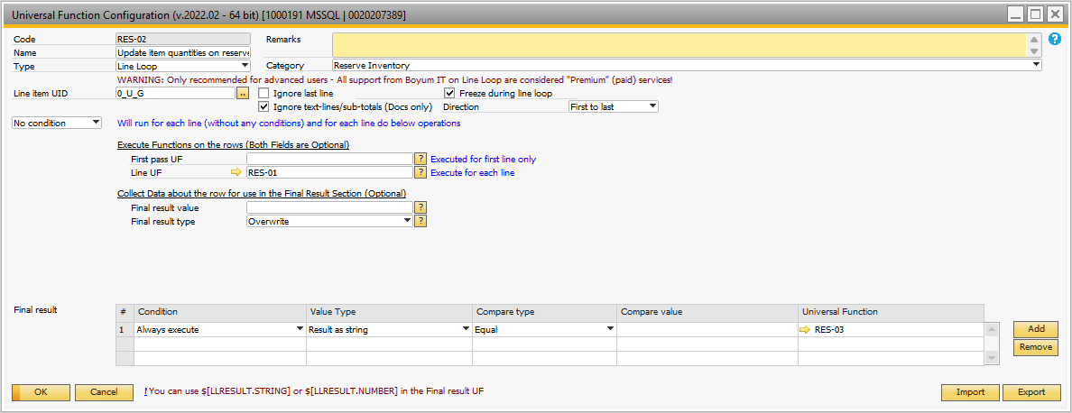

## Figure 3.22 Refresh Process

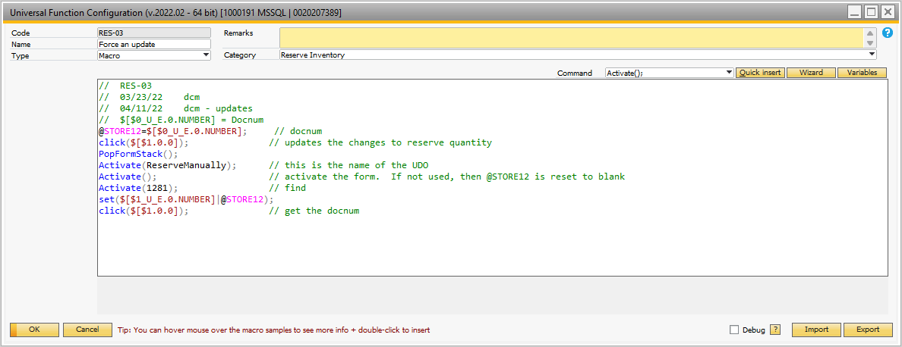

## Figure 3.23 Re-display the Reserve Item Form

The Validation for the Clear Reserves button is shown in Figure 3.24.

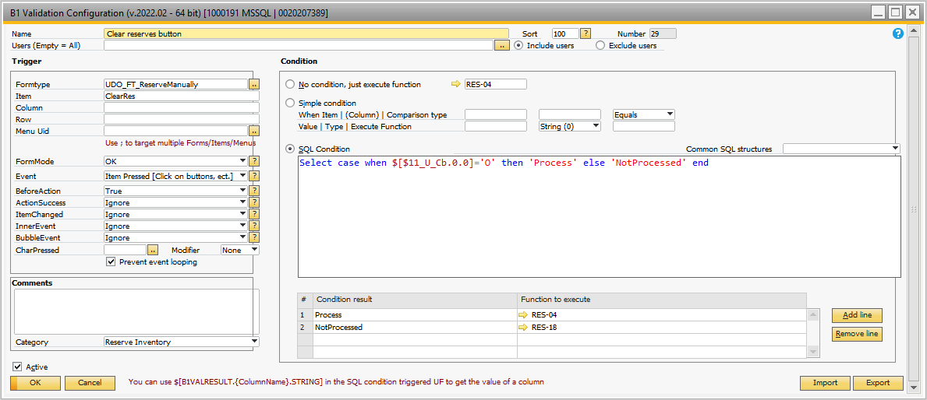

## Figure 3.24 Validation for Clear Reserves Button

If the document is ‘Open’, then the process calls the RES-04 universal function shown in Figure 3.25. It simply asks if you know what your about to do – clear reserve quantities does affect this entire application!

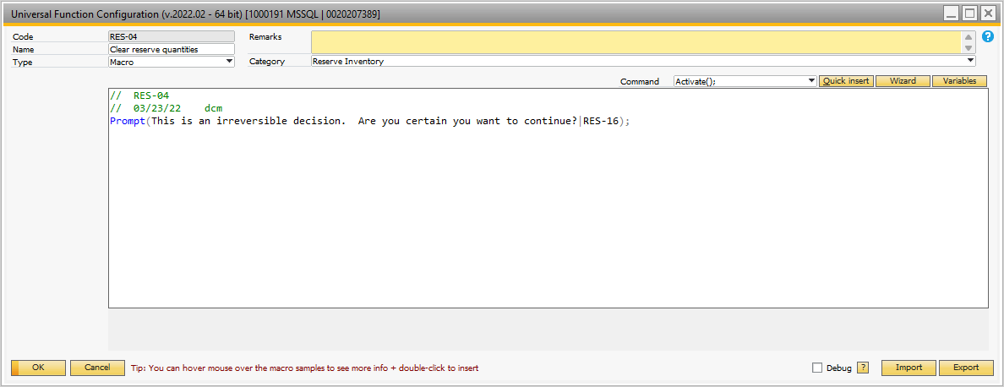

## Figure 3.25 Clear reserves UF RES-04

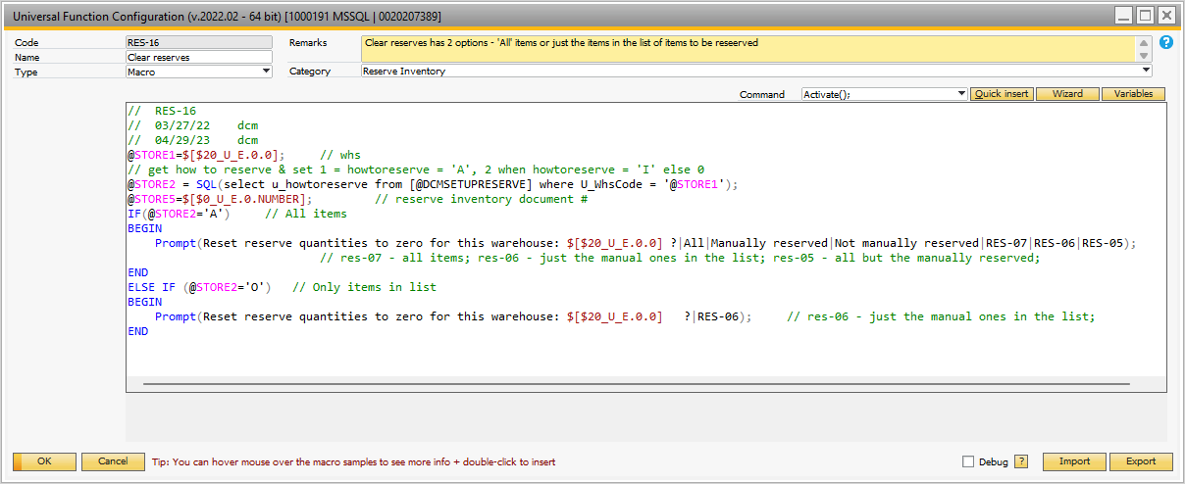

## Figure 3.26 Clear Reserves Process

The UF RES-16 shown in Figure 3.26 asks additional questions of the user. The user can clear ‘All’ reserves, ‘Manually reserved quantities’, or just items not manually reserved – this is if the user is applying the rules to all inventory items. If only applying the rules to items in the reserve items list, then there is a single question to go ahead or not. Depending on the settings and the answers, RES-07, RES-06, RES-05 universal function is called. These are shown in Figures 3.27 through 3.35.

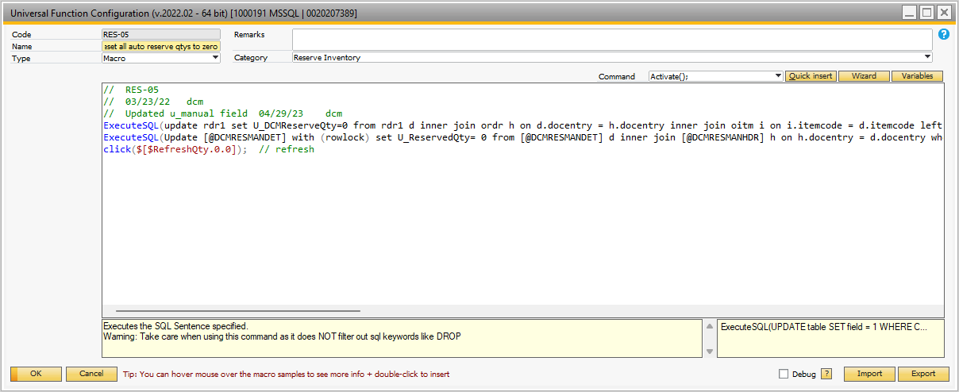

## Figure 3.27 Reset Reserve Quantities for all Items not Manually Reserved

The SQL codes for these 2 statements are shown in detail below – Figure 3.28 and 3.29.

*update rdr1*

*set U_DCMReserveQty=0*

*from rdr1 d*

*inner join ordr h on d.docentry = h.docentry*

*inner join oitm i on i.itemcode = d.itemcode*

*left join [@DCMRESMANHDR] m on m.u_whscode = $[$20_U_E.0.0] and m.status <> 'C'*

*left join [@DCMRESMANDET] n on n.docentry = m.docentry*

*and n.u_itemcode = i.itemcode*

*and n.u_active = 'A'*

*where i.InvntItem = 'Y'*

*and h.docstatus <> 'C'*

*and h.CANCELED = 'N'*

*and d.linestatus <> 'C'*

*and d.OpenQty > 0*

*and d.whscode = $[$20_U_E.0.0]*

*and n.u_manual ='N'*

## Figure 3.28 RES-05 Clear Reserves SQL Statement

*Update [@DCMRESMANDET] with (rowlock)*

*set U_ReservedQty= 0*

*from [@DCMRESMANDET] d*

*inner join [@DCMRESMANHDR] h on h.docentry = d.docentry*

*where h.docentry = @STORE5*

*and d.u_manual = 'N'*

## Figure 3.29 RES-05 Clear Reserves SQL Statement 2

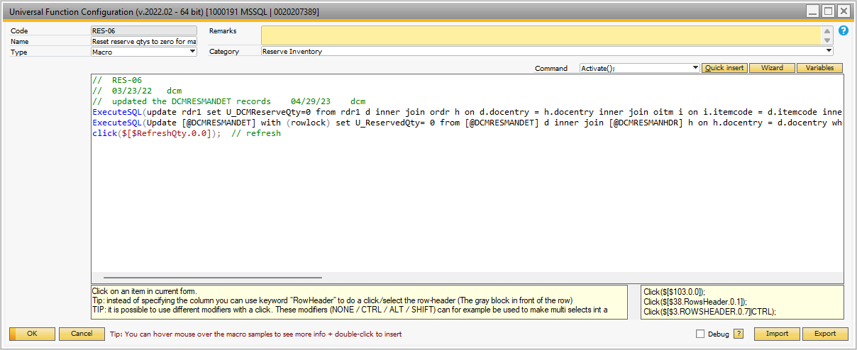

## Figure 3.30 Clear Reserves for Manual Items

The SQL Statements are shown in Figure 3.31 and 3.32.

*update rdr1*

*set U_DCMReserveQty=0*

*from rdr1 d*

*inner join ordr h on d.docentry = h.docentry*

*inner join oitm i on i.itemcode = d.itemcode*

*inner join [@DCMRESMANHDR] m on m.u_whscode = $[$20_U_E.0.0] and m.status <> 'C'*

*inner join [@DCMRESMANDET] n on n.docentry = m.docentry*

*and n.u_itemcode = i.itemcode*

*and n.u_active = 'A'*

*where i.InvntItem = 'Y'*

*and h.docstatus <> 'C'*

*and h.CANCELED = 'N'*

*and d.linestatus <> 'C'*

*and d.OpenQty > 0*

*and d.whscode = $[$20_U_E.0.0]*

*and n.u_manual = 'Y'*

## Figure 3.31 Clear Reserves SQL Statement for Manually Reserved Items

Update [@DCMRESMANDET] with (rowlock)

set U_ReservedQty= 0

from [@DCMRESMANDET] d

inner join [@DCMRESMANHDR] h on h.docentry = d.docentry

where h.docentry = @STORE5

and d.u_manual = 'Y'

## Figure 3.32 Clear Reserves – Manual Items – SQL Statement 2

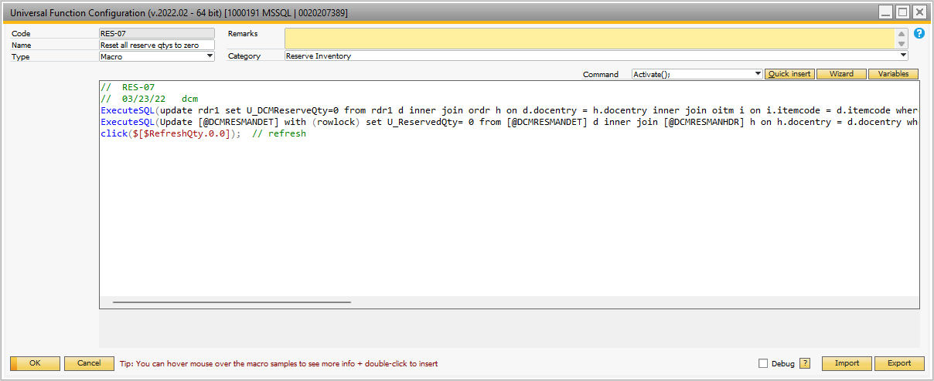

## Figure 3.33 Clear Reserves – All Items

The interior SQL Statements for RES-07 are shown in Figures 3.34 and 3.35.

*update rdr1*

*set U_DCMReserveQty=0*

*from rdr1 d*

*inner join ordr h on d.docentry = h.docentry*

*inner join oitm i on i.itemcode = d.itemcode*

*where i.InvntItem = 'Y'*

*and h.docstatus <> 'C'*

*and h.CANCELED = 'N'*

*and d.linestatus <> 'C'*

*and d.OpenQty > 0*

*and d.whscode = $[$20_U_E.0.0]*

## Figure 3.34 Clear Reserves All Items – SQL Statement 1

*Update [@DCMRESMANDET] with (rowlock)*

*set U_ReservedQty= 0*

*from [@DCMRESMANDET] d*

*inner join [@DCMRESMANHDR] h on h.docentry = d.docentry*

*where h.docentry = @STORE5*

## Figure 3.35 Clear Reserves All Items – SQL Statement 2

The ‘Show List’ button has a B1 Validation that initiates it. This is shown in Figure 3.36. The UF RES-08 is shown in Figure 3.37. It is a SQL report showing that displays the reserve item information. The user is prompted to show the report in item (I) or item group (G) sequence. The SQL for this report is shown in Figure 3.38.

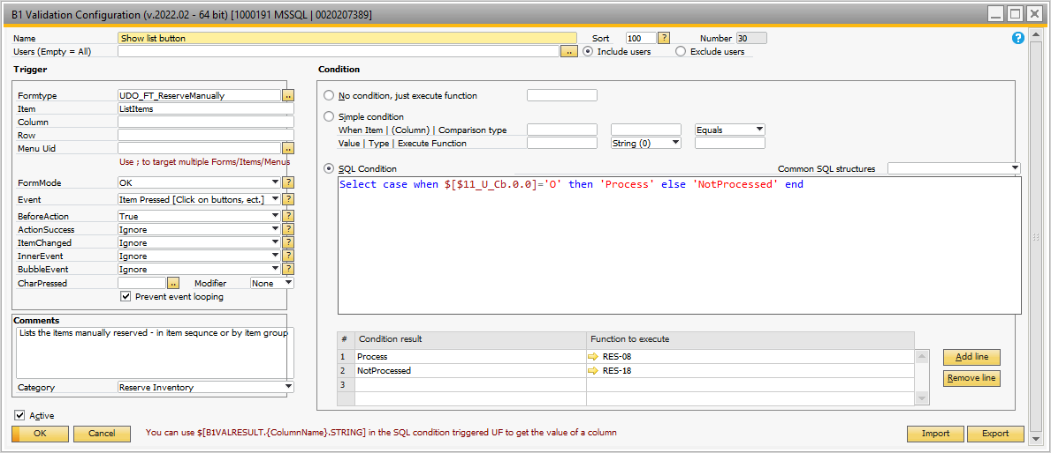

## Figure 3.36 Show List B1 Validation

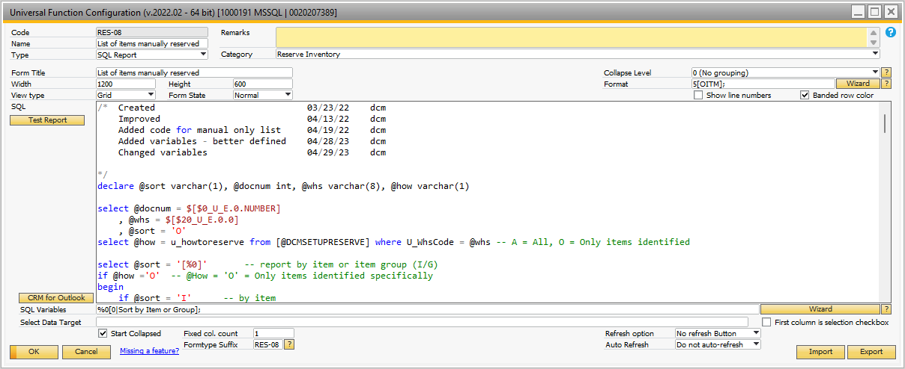

## Figure 3.37 SQL Show List Report

*/* Created 03/23/22 dcm Improved 04/13/22 dcm Added code for manual only list 04/19/22 dcm Added variables - better defined 04/28/23 dcm Changed variables 04/29/23 dcm*/declare @sort varchar(1), @docnum int, @whs varchar(8), @how varchar(1)select @docnum = $[$0_U_E.0.NUMBER] , @whs = $[$20_U_E.0.0] , @sort = 'O'select @how = u_howtoreserve from [@DCMSETUPRESERVE] where U_WhsCode = @whs -- A = All, O = Only items identifiedselect @sort = '[%0]' -- report by item or item group (I/G)if @how ='O' -- @How = 'O' = Only items identified specifically begin if @sort = 'I' -- by item begin select h.docnum as 'Reserve #' , h.u_whscode as 'Whs' , h.status as 'Status' , g.itmsgrpnam as 'Group Name' , i.itemcode as 'Item' , i.itemname as 'Description' , d.u_manual as 'Manually Reserved' , w.onhand as 'On hand' , (select sum(dd.openqty) from ordr hh inner join rdr1 dd on dd.docentry = hh.docentry where hh.docstatus <> 'C' and dd.linestatus <> 'C' and dd.openqty > 0 and dd.itemcode = d.U_ItemCode and dd.WhsCode = @whs) as 'Open Sales' , isnull((select sum(isnull(dd.U_DCMReserveQty,0)) from ordr h inner join ocrd c on c.cardcode = h.cardcode inner join rdr1 dd on dd.docentry = h.docentry and dd.whscode = @whs and dd.itemcode = d.u_itemcode inner join oitm ii on ii.itemcode = dd.itemcode where ii.InvntItem = 'Y' and h.docstatus <> 'C' and h.CANCELED = 'N' and dd.linestatus <> 'C' and dd.OpenQty > 0 ),0) as 'Reserved Qty' , isnull((select sum(isnull(dd.openqty,0)) from owtq h inner join wtq1 dd on dd.docentry = h.docentry and dd.ItemCode = d.u_itemcode and dd.fromwhscod = @whs where h.docstatus <> 'C' and h.canceled = 'N' and dd.linestatus <> 'C'),0) as'In Transit Qty' , case when d.u_active = 'A' then 'Active' else 'Inactive' end as 'Active Status' , i.validfor as 'Active Item' , i.invntitem as 'Inventoried' from [@DCMRESMANHDR] h inner join [@DCMRESMANDET] d on d.docentry = h.docentry inner join oitm i on i.itemcode = d.u_itemcode inner join oitb g on g.itmsgrpcod = i.itmsgrpcod inner join oitw w on w.itemcode = i.itemcode and w.whscode = @whs where h.docnum = @docnum order by 1,5 end else begin -- sort by item group select h.docnum as 'Reserve #' , h.u_whscode as 'Whs' , h.status as 'Status' , g.itmsgrpnam as 'Group Name' , i.itemcode as 'Item' , i.itemname as 'Description' , d.u_manual as 'Manually Reserved' , w.onhand as 'On hand' , (select sum(dd.openqty) from ordr hh inner join rdr1 dd on dd.docentry = hh.docentry where hh.docstatus <> 'C' and dd.linestatus <> 'C' and dd.openqty > 0 and dd.itemcode = d.U_ItemCode and dd.WhsCode = @whs) as 'Open Sales' , isnull((select sum(isnull(dd.U_DCMReserveQty,0)) from ordr h inner join ocrd c on c.cardcode = h.cardcode inner join rdr1 dd on dd.docentry = h.docentry and dd.whscode = @whs and dd.itemcode = d.u_itemcode inner join oitm ii on ii.itemcode = dd.itemcode where ii.InvntItem = 'Y' and h.docstatus <> 'C' and h.CANCELED = 'N' and dd.linestatus <> 'C' and dd.OpenQty > 0 ),0) as 'Reserved Qty' , isnull((select sum(isnull(dd.openqty,0)) from owtq h inner join wtq1 dd on dd.docentry = h.docentry and dd.ItemCode = d.u_itemcode and dd.fromwhscod = @whs where h.docstatus <> 'C' and h.canceled = 'N' and dd.linestatus <> 'C'),0) as'In Transit Qty' , case when d.u_active = 'A' then 'Active' else 'Inactive' end as 'Active Status' , i.validfor as 'Active Item' , i.invntitem as 'Inventoried' from [@DCMRESMANHDR] h inner join [@DCMRESMANDET] d on d.docentry = h.docentry inner join oitm i on i.itemcode = d.u_itemcode inner join oitb g on g.itmsgrpcod = i.itmsgrpcod inner join oitw w on w.itemcode = i.itemcode and w.whscode = @whs where h.docnum = @docnum order by 1,4,5 endendelse begin -- @how = 'A' = All items if @sort = 'I' -- sort by item begin select h.docnum as 'Order #' , d.whscode as 'Whs' , h.docstatus as 'Status' , g.itmsgrpnam as 'Group Name' , i.itemcode as 'Item' , i.itemname as 'Description' , w.onhand as 'On hand' , d.U_DCMReserveQty as 'Reserve Qty' , isnull((select sum(isnull(dd.openqty,0)) from owtq h inner join wtq1 dd on dd.docentry = h.docentry and dd.ItemCode = d.itemcode and dd.fromwhscod = @whs where h.docstatus <> 'C' and h.canceled = 'N' and dd.linestatus <> 'C'),0) as'In Transit Qty' , i.validfor as 'Active Item' , i.invntitem as 'Inventoried' from ordr h inner join rdr1 d on d.docentry = h.docentry inner join oitm i on i.itemcode = d.itemcode inner join oitb g on g.itmsgrpcod = i.itmsgrpcod inner join oitw w on w.itemcode = i.itemcode and w.whscode = @whs where h.docstatus <> 'C' and d.linestatus <> 'C' and d.openqty > 0 and isnull(d.u_dcmreserveqty,0) > 0 order by 5,1 end else begin -- sort by item group select h.docnum as 'Order #' , d.whscode as 'Whs' , h.docstatus as 'Status' , g.itmsgrpnam as 'Group Name' , i.itemcode as 'Item' , i.itemname as 'Description' , w.onhand as 'On hand' , d.U_DCMReserveQty as 'Reserve Qty' , isnull((select sum(isnull(dd.openqty,0)) from owtq h inner join wtq1 dd on dd.docentry = h.docentry and dd.ItemCode = d.itemcode and dd.fromwhscod = @whs where h.docstatus <> 'C' and h.canceled = 'N' and dd.linestatus <> 'C'),0) as'In Transit Qty' , i.validfor as 'Active Item' , i.invntitem as 'Inventoried' from ordr h inner join rdr1 d on d.docentry = h.docentry inner join oitm i on i.itemcode = d.itemcode inner join oitb g on g.itmsgrpcod = i.itmsgrpcod inner join oitw w on w.itemcode = i.itemcode and w.whscode = @whs where h.docstatus <> 'C' and d.linestatus <> 'C' and d.openqty > 0 and isnull(d.u_dcmreserveqty,0) > 0 order by 4,5,1 end end*

## Figure 3.38 SQL Report For Show List

The ‘Auto Reserve’ button is initiated using the B1 Validation shown in Figure 3.39. Several options are possible depending on the settings.

* Reserve ‘All’ and reserve timing is ‘Periodic’ 🡪 RES-36 Universal function called. The actual update is done using RES-09, followed by a prompt asking if the reserve inventory report should be displayed. See Figures 3.40, 3.41 and 3.42.
* Reserve ‘Only Identified Items’ and reserve timing is ‘Periodic’ 🡪 RES-37 Universal function called. This macro calls RES-33 to do the processing. See Figures 3.43, 3.44 and 3.45.
* If reserve timing is not ‘Periodic’ then a message is displayed using RES-17 saying the auto reserve is not being used.

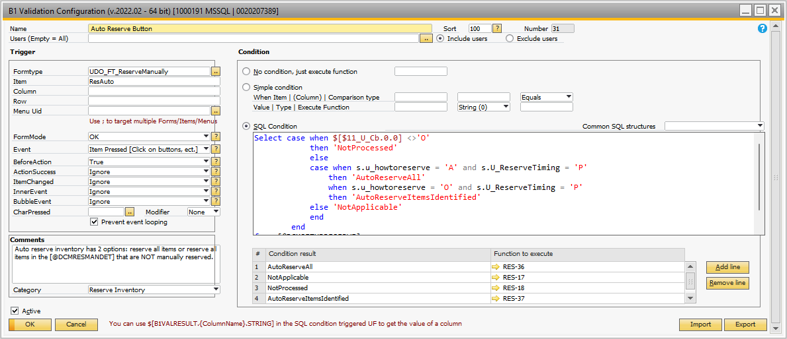

## Figure 3.39 B1 Validation for Auto Reserve Inventory

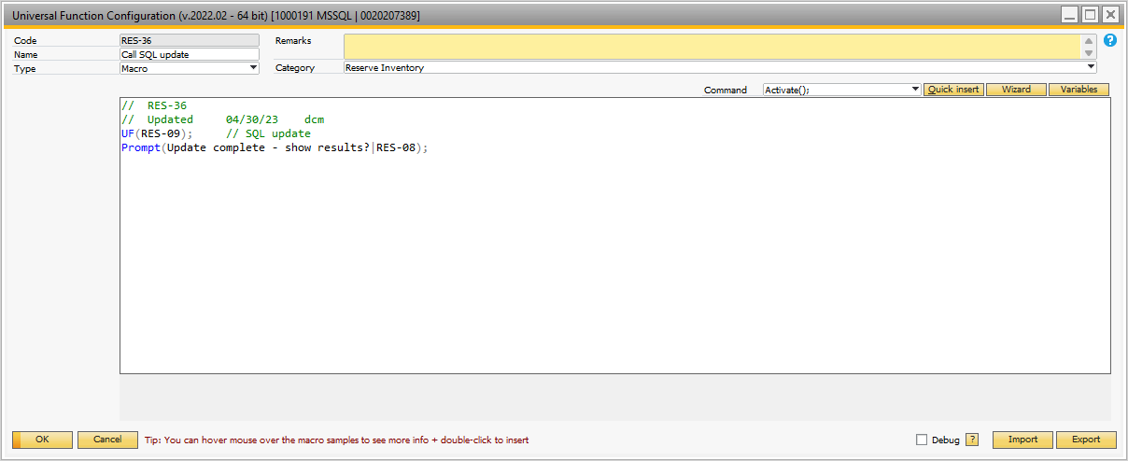

## Figure 3.40 Initiate the Auto Reserve Inventory Process

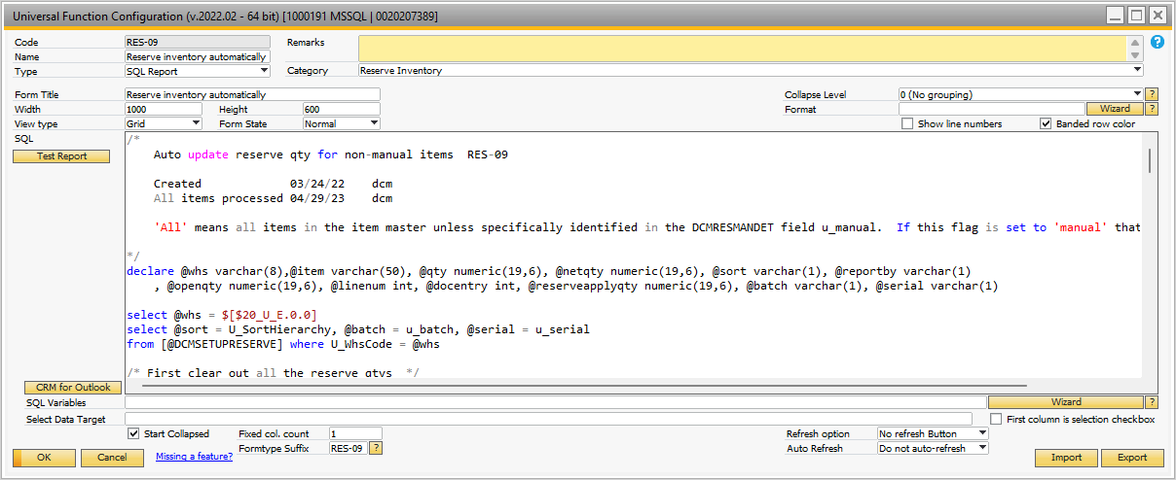

## Figure 3.41 RES-09 – Main Auto Reserve SQL Program

*/* Auto update reserve qty for non-manual items RES-09 Created 03/24/22 dcm All items processed 04/29/23 dcm 'All' means all items in the item master unless specifically identified in the DCMRESMANDET field u_manual. If this flag is set to 'manual' that item is ignored*/declare @whs varchar(8),@item varchar(50), @qty numeric(19,6), @netqty numeric(19,6), @sort varchar(1), @reportby varchar(1) , @openqty numeric(19,6), @linenum int, @docentry int, @reserveapplyqty numeric(19,6), @batch varchar(1), @serial varchar(1)select @whs = $[$20_U_E.0.0]select @sort = U_SortHierarchy, @batch = u_batch, @serial = u_serial from [@DCMSETUPRESERVE] where U_WhsCode = @whs/* First clear out all the reserve qtys */update rdr1 with (rowlock)set U_DCMReserveQty=0 from rdr1 d inner join ordr h on d.docentry = h.docentry inner join oitm i on i.itemcode = d.itemcode and i.validfor = 'Y' left join [@DCMRESMANHDR] m on m.u_whscode = @whs and m.status <> 'C' left join [@DCMRESMANDET] n on n.docentry = m.docentry and n.u_itemcode = i.itemcode and n.u_active = 'A' and n.u_manual = 'N' where h.docstatus <> 'C' and h.CANCELED = 'N' and d.linestatus <> 'C' and d.whscode = @whs and ( (i.ManBtchNum = 'N' and i.ManSerNum = 'N') OR (i.ManBtchNum = 'Y' and @batch = 'Y') OR (i.ManSerNum= 'Y' and @serial = 'Y') )/* Now reset them */declare applyreserveloop cursor forselect i.itemcode , w.onhand - isnull((select sum(isnull(d.openqty,0)) from owtq h inner join wtq1 d on d.docentry = h.docentry and d.ItemCode = i.itemcode and d.FromWhsCod = @whs where h.docstatus <> 'C' and h.canceled = 'N' and d.linestatus <> 'C'),0)from oitw winner join oitm i on i.itemcode = w.itemcodeleft join [@DCMRESMANHDR] m on m.u_whscode = @whs and m.status <> 'C' left join [@DCMRESMANDET] n on n.docentry = m.docentry and n.u_itemcode = i.itemcode and n.u_active = 'A' where w.WhsCode= @whs and n.u_manual = 'N' and (select count(*) from ordr h inner join rdr1 d on d.docentry = h.docentry and d.itemcode = i.itemcode and d.whscode = @whs where h.docstatus <> 'C' and h.CANCELED = 'N' and d.linestatus <> 'C' and d.openqty > 0)>0 -- only choose items that have open orders and i.validfor = 'Y' and ( (i.ManBtchNum = 'N' and i.ManSerNum = 'N') OR (i.ManBtchNum = 'Y' and @batch = 'Y') OR (i.ManSerNum= 'Y' and @serial = 'Y') )order by i.itemcodeopen applyreserveloopfetch applyreserveloop into @item, @qtywhile @@FETCH_STATUS= 0begin if @qty > 0 -- no need to apply reserve qty if available on hand is less than 0 begin select @netqty = @qty if @sort = 'D' -- by due date begin declare applysubloop cursor for select d.openqty , d.docentry , d.linenum from rdr1 d inner join ordr h on h.docentry = d.docentry where d.itemcode = @item and d.whscode = @whs and h.docstatus <> 'C' and h.CANCELED ='N' and d.linestatus <> 'C' and d.openqty > 0 order by h.docduedate, h.doctime, h.docnum open applysubloop fetch applysubloop into @openqty, @docentry, @linenum while @@FETCH_STATUS = 0 and @netqty > 0 begin if @netqty >= @openqty select @reserveapplyqty = @openqty, @netqty = @netqty - @openqty else select @reserveapplyqty = @netqty, @netqty = 0 update rdr1 with (rowlock) set U_DCMReserveQty = @reserveapplyqty where docentry = @docentry and LineNum = @linenum fetch applysubloop into @openqty, @docentry, @linenum end close applysubloop deallocate applysubloop end else begin declare applysubloop cursor for select d.openqty , d.docentry , d.linenum from rdr1 d inner join ordr h on h.docentry = d.docentry inner join ocrd c on c.cardcode = h.cardcode where d.itemcode = @item and d.whscode = @whs and h.docstatus <> 'C' and h.CANCELED ='N' and d.linestatus <> 'C' and d.openqty > 0 order by c.Priority, h.docduedate, h.doctime, h.docnum open applysubloop fetch applysubloop into @openqty, @docentry, @linenum while @@FETCH_STATUS = 0 and @netqty > 0 begin if @netqty >= @openqty select @reserveapplyqty = @openqty, @netqty = @netqty - @openqty else select @reserveapplyqty = @netqty, @netqty = 0 update rdr1 with (rowlock) set U_DCMReserveQty = @reserveapplyqty where docentry = @docentry and LineNum = @linenum fetch applysubloop into @openqty, @docentry, @linenum end close applysubloop deallocate applysubloop end end fetch applyreserveloop into @item, @qtyendclose applyreserveloopdeallocate applyreserveloop*

## Figure 3.42 SQL Code for Auto Reserve Inventory

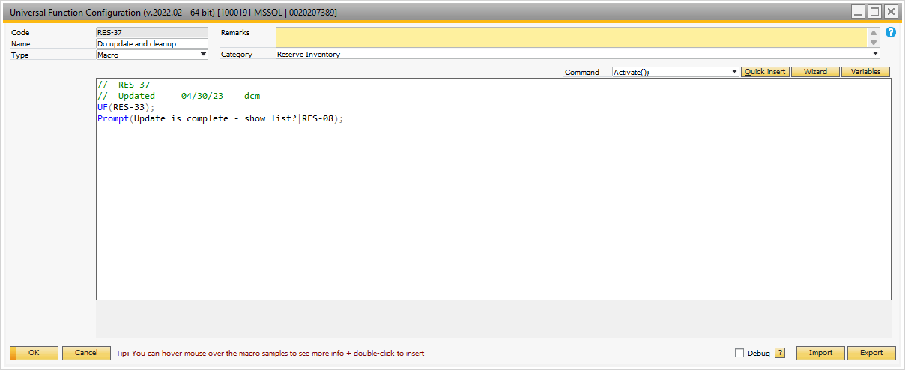

## Figure 3.43 RES-37 Initiate the Auto Reserve for Only Items Identified

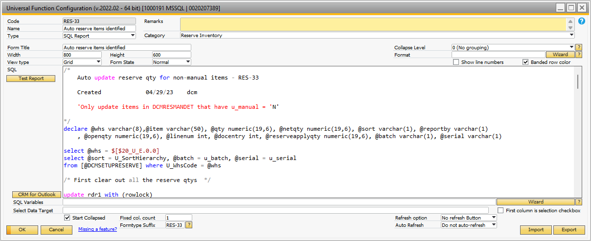

## Figure 3.44 RES-33 SQL Script to Process Auto Reserve Items Identified

*/* Auto update reserve qty for non-manual items - RES-33 Created 04/29/23 dcm 'Only update items in DCMRESMANDET that have u_manual = 'N'*/declare @whs varchar(8),@item varchar(50), @qty numeric(19,6), @netqty numeric(19,6), @sort varchar(1), @reportby varchar(1) , @openqty numeric(19,6), @linenum int, @docentry int, @reserveapplyqty numeric(19,6), @batch varchar(1), @serial varchar(1)select @whs = $[$20_U_E.0.0]select @sort = U_SortHierarchy, @batch = u_batch, @serial = u_serial from [@DCMSETUPRESERVE] where U_WhsCode = @whs/* First clear out all the reserve qtys */update rdr1 with (rowlock)set U_DCMReserveQty=0 from rdr1 d inner join ordr h on d.docentry = h.docentry inner join oitm i on i.itemcode = d.itemcode and i.validfor = 'Y' inner join [@DCMRESMANHDR] m on m.u_whscode = @whs and m.status <> 'C' inner join [@DCMRESMANDET] n on n.docentry = m.docentry and n.u_itemcode = i.itemcode and n.u_active = 'A' and n.u_manual = 'N' where h.docstatus <> 'C' and h.CANCELED = 'N' and d.linestatus <> 'C' and d.whscode = @whs and ( (i.ManBtchNum = 'N' and i.ManSerNum = 'N') OR (i.ManBtchNum = 'Y' and @batch = 'Y') OR (i.ManSerNum= 'Y' and @serial = 'Y') )/* Now reset them */declare applyreserveloop cursor forselect i.itemcode , w.onhand - isnull((select sum(isnull(d.openqty,0)) from owtq h inner join wtq1 d on d.docentry = h.docentry and d.ItemCode = i.itemcode and d.FromWhsCod = @whs where h.docstatus <> 'C' and h.canceled = 'N' and d.linestatus <> 'C'),0)from oitw winner join oitm i on i.itemcode = w.itemcodeinner join [@DCMRESMANHDR] m on m.u_whscode = @whs and m.status <> 'C' inner join [@DCMRESMANDET] n on n.docentry = m.docentry and n.u_itemcode = i.itemcode and n.u_active = 'A' where w.WhsCode= @whs and n.u_manual = 'N' and (select count(*) from ordr h inner join rdr1 d on d.docentry = h.docentry and d.itemcode = i.itemcode and d.whscode = @whs where h.docstatus <> 'C' and h.CANCELED = 'N' and d.linestatus <> 'C' and d.openqty > 0)>0 -- only choose items that have open orders and i.validfor = 'Y' and ( (i.ManBtchNum = 'N' and i.ManSerNum = 'N') OR (i.ManBtchNum = 'Y' and @batch = 'Y') OR (i.ManSerNum= 'Y' and @serial = 'Y') )order by i.itemcodeopen applyreserveloopfetch applyreserveloop into @item, @qtywhile @@FETCH_STATUS= 0begin if @qty > 0 -- no need to apply reserve qty if available on hand is less than 0 begin select @netqty = @qty if @sort = 'D' -- by due date begin declare applysubloop cursor for select d.openqty , d.docentry , d.linenum from rdr1 d inner join ordr h on h.docentry = d.docentry where d.itemcode = @item and d.whscode = @whs and h.docstatus <> 'C' and h.CANCELED ='N' and d.linestatus <> 'C' and d.openqty > 0 order by h.docduedate, h.doctime, h.docnum open applysubloop fetch applysubloop into @openqty, @docentry, @linenum while @@FETCH_STATUS = 0 and @netqty > 0 begin if @netqty >= @openqty select @reserveapplyqty = @openqty, @netqty = @netqty - @openqty else select @reserveapplyqty = @netqty, @netqty = 0 update rdr1 with (rowlock) set U_DCMReserveQty = @reserveapplyqty where docentry = @docentry and LineNum = @linenum fetch applysubloop into @openqty, @docentry, @linenum end close applysubloop deallocate applysubloop end else begin declare applysubloop cursor for select d.openqty , d.docentry , d.linenum from rdr1 d inner join ordr h on h.docentry = d.docentry inner join ocrd c on c.cardcode = h.cardcode where d.itemcode = @item and d.whscode = @whs and h.docstatus <> 'C' and h.CANCELED ='N' and d.linestatus <> 'C' and d.openqty > 0 order by c.Priority, h.docduedate, h.doctime, h.docnum open applysubloop fetch applysubloop into @openqty, @docentry, @linenum while @@FETCH_STATUS = 0 and @netqty > 0 begin if @netqty >= @openqty select @reserveapplyqty = @openqty, @netqty = @netqty - @openqty else select @reserveapplyqty = @netqty, @netqty = 0 update rdr1 with (rowlock) set U_DCMReserveQty = @reserveapplyqty where docentry = @docentry and LineNum = @linenum fetch applysubloop into @openqty, @docentry, @linenum end close applysubloop deallocate applysubloop end end fetch applyreserveloop into @item, @qtyendclose applyreserveloopdeallocate applyreserveloop*

## Figure 3.45 SQL Script to Update Auto Reserve – Identified Items Only

The Report Reserves button is initiated using the B1 Validation shown in Figure 3.46.

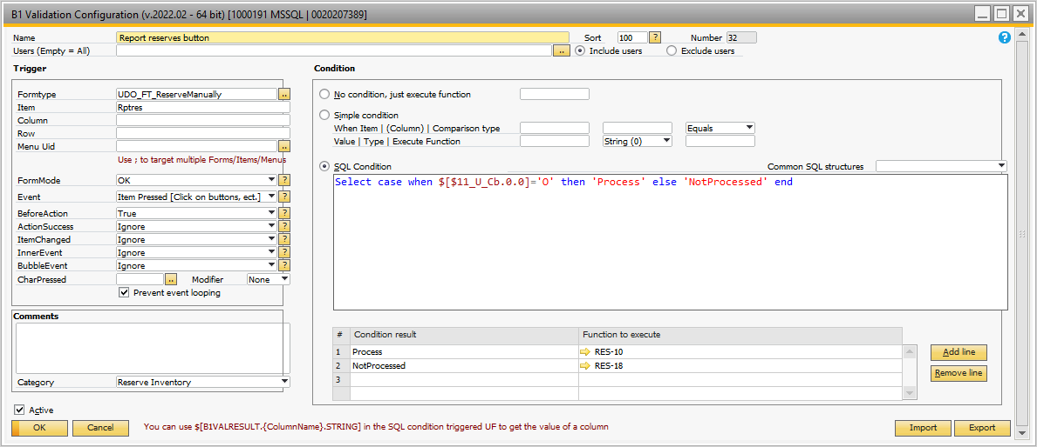

## Figure 3.46 B1 Validation for ‘Report Reserves’ Button

There is a SQL report that shows the items reserved. There are two prompts:

* Sort by Item or Order – this is just a grouping
* Only manually reserved – an option to show only manually reserved items or all reserved items

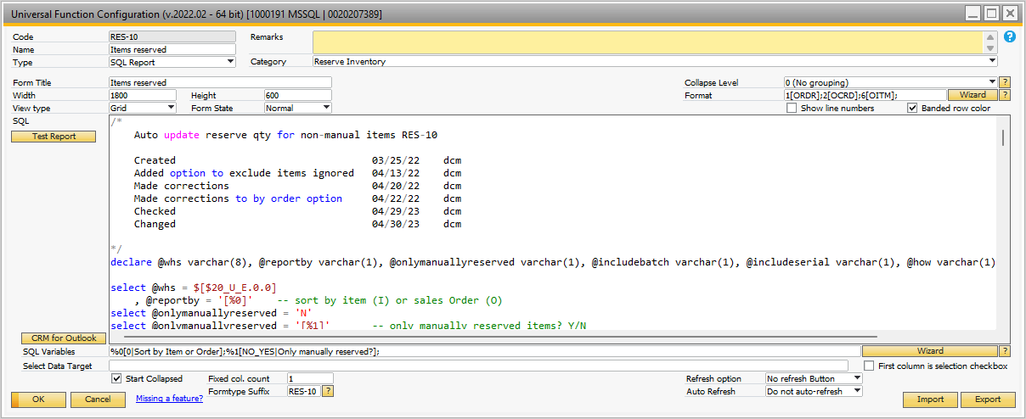

## Figure 3.47 RES-10 Items Reserved Report

*/* Auto update reserve qty for non-manual items RES-10 Created 03/25/22 dcm Added option to exclude items ignored 04/13/22 dcm Made corrections 04/20/22 dcm Made corrections to by order option 04/22/22 dcm Checked 04/29/23 dcm Changed 04/30/23 dcm*/declare @whs varchar(8), @reportby varchar(1), @onlymanuallyreserved varchar(1), @includebatch varchar(1), @includeserial varchar(1), @how varchar(1), @timing varchar(1)select @whs = $[$20_U_E.0.0] , @reportby = '[%0]' -- sort by item (I) or sales Order (O)select @onlymanuallyreserved = 'N'select @onlymanuallyreserved = '[%1]' -- only manually reserved items? Y/N-- determine if batch and / or serial controlled items are included in the reserve implementationselect @includebatch = u_batch , @includeserial = u_serial , @how = U_HowToReserve , @timing = U_ReserveTimingfrom [@DCMSETUPRESERVE] where U_WhsCode = @whsif @reportby = 'I'begin /* Report by item */ select h.docnum as 'Order' , h.cardcode as 'Customer' , h.cardname as 'Customer Name' , h.docduedate as 'Due Date' , d.VisOrder + 1 as 'Line Seq' , d.itemcode as 'Item' , d.dscription as 'Description' , d.whscode as 'Whs' , d.openqty as 'Open Quantity' , d.U_DCMReserveQty as 'Reserved Qty this Order' , case when @how = 'A' then 'All Items' else 'Only Items Identified' end as 'How Reserved' , case when @timing = 'O' then 'Order by Order' else 'Periodic' end as 'Reserve Timing' , case when isnull(y.u_manual,'') = 'Y' then 'Manual Reserve' when isnull(y.u_manual,'') = 'N' then 'Auto Reserve' else 'Follow Timing' end as 'How Reserved Option' , w.onhand as 'Whs on hand' , isnull((select sum(isnull(x.openqty,0)) from owtq y inner join wtq1 x on x.docentry = y.docentry and x.ItemCode = d.itemcode and x.FromWhsCod = '01' where y.docstatus <> 'C' and y.canceled = 'N' and x.linestatus <> 'C'),0) as 'In Transit' , isnull((select sum(x.U_DCMReserveQty) from rdr1 x inner join ordr y on y.docentry = x.docentry inner join oitm j on j.itemcode = x.itemcode where y.docstatus <> 'C' and y.CANCELED = 'N' and x.linestatus <> 'C' and x.itemcode = d.itemcode and x.whscode = @whs ),0) as 'Reserved Qty All Orders' , Case when w.onhand = 0 then 'No On Hand' when w.onhand = isnull((select sum(x.U_DCMReserveQty) from rdr1 x inner join ordr y on y.docentry = x.docentry inner join oitm j on j.itemcode = x.itemcode where y.docstatus <> 'C' and y.CANCELED = 'N' and x.linestatus <> 'C' and x.itemcode = d.itemcode and x.whscode = @whs ),0) + isnull((select sum(isnull(x.openqty,0)) from owtq y inner join wtq1 x on x.docentry = y.docentry and x.ItemCode = d.itemcode and x.FromWhsCod = '01' where y.docstatus <> 'C' and y.canceled = 'N' and x.linestatus <> 'C'),0) then 'PART RESERVED FULLY' when w.onhand - isnull((select sum(isnull(x.openqty,0)) from owtq y inner join wtq1 x on x.docentry = y.docentry and x.ItemCode = d.itemcode and x.FromWhsCod = '01' where y.docstatus <> 'C' and y.canceled = 'N' and x.linestatus <> 'C'),0) > isnull((select sum(x.U_DCMReserveQty) from rdr1 x inner join ordr y on y.docentry = x.docentry inner join oitm j on j.itemcode = x.itemcode where y.docstatus <> 'C' and y.CANCELED = 'N' and x.linestatus <> 'C' and x.itemcode = d.itemcode and x.whscode = @whs ),0) then 'AVAILABLE' else '' end as 'RESERVE STATUS' from rdr1 d inner join ordr h on h.DocEntry = d.docentry inner join oitw w on w.ItemCode = d.itemcode and w.whscode = d.whscode inner join oitm i on i.itemcode = d.itemcode left join [@DCMRESMANHDR] x on x.u_whscode = d.whscode and x.status = 'O' left join [@DCMRESMANDET] y on y.docentry = x.docentry and y.u_itemcode = d.itemcode where h.docstatus <> 'C' and d.linestatus <> 'C' and d.openqty > 0 and (@onlymanuallyreserved = 'N' or (@onlymanuallyreserved = 'Y' and y.u_itemcode is not null)) and h.CANCELED = 'N' and i.validfor = 'Y' and (@includebatch = 'N' and i.ManBtchNum <> 'Y') and (@includeserial = 'N' and i.ManSerNum <> 'Y') and (@how = 'A' or (@how = 'O' and y.docentry is not null)) order by d.itemcode, h.docduedateendelsebegin /* Report by order */ select h.docnum as 'Order' , h.cardcode as 'Customer' , h.cardname as 'Customer Name' , h.docduedate as 'Due Date' , d.VisOrder + 1 as 'Line Seq' , d.itemcode as 'Item' , d.dscription as 'Description' , d.whscode as 'Whs' , d.openqty as 'Open Quantity' , d.U_DCMReserveQty as 'Reserved Qty this Order' , case when @how = 'A' then 'All Items' else 'Only Items Identified' end as 'How Reserved' , case when @timing = 'O' then 'Order by Order' else 'Periodic' end as 'Reserve Timing' , case when isnull(y.u_manual,'') = 'Y' then 'Manual Reserve' when isnull(y.u_manual,'') = 'N' then 'Auto Reserve' else 'Follow Timing' end as 'How Reserved Option' , w.onhand as 'Whs on hand' , isnull((select sum(isnull(x.openqty,0)) from owtq y inner join wtq1 x on x.docentry = y.docentry and x.ItemCode = d.itemcode and x.FromWhsCod = '01' where y.docstatus <> 'C' and y.canceled = 'N' and x.linestatus <> 'C'),0) as 'In Transit' , isnull((select sum(x.U_DCMReserveQty) from rdr1 x inner join ordr y on y.docentry = x.docentry inner join oitm j on j.itemcode = x.itemcode where y.docstatus <> 'C' and y.CANCELED = 'N' and x.linestatus <> 'C' and x.itemcode = d.itemcode and x.whscode = @whs ),0) as 'Reserved Qty All Orders' , Case when w.onhand = 0 then 'No On Hand' when w.onhand = isnull((select sum(x.U_DCMReserveQty) from rdr1 x inner join ordr y on y.docentry = x.docentry inner join oitm j on j.itemcode = x.itemcode where y.docstatus <> 'C' and y.CANCELED = 'N' and x.linestatus <> 'C' and x.itemcode = d.itemcode and x.whscode = @whs ),0) + isnull((select sum(isnull(x.openqty,0)) from owtq y inner join wtq1 x on x.docentry = y.docentry and x.ItemCode = d.itemcode and x.FromWhsCod = '01' where y.docstatus <> 'C' and y.canceled = 'N' and x.linestatus <> 'C'),0) then 'PART RESERVED FULLY' when w.onhand - isnull((select sum(isnull(x.openqty,0)) from owtq y inner join wtq1 x on x.docentry = y.docentry and x.ItemCode = d.itemcode and x.FromWhsCod = '01' where y.docstatus <> 'C' and y.canceled = 'N' and x.linestatus <> 'C'),0) > isnull((select sum(x.U_DCMReserveQty) from rdr1 x inner join ordr y on y.docentry = x.docentry inner join oitm j on j.itemcode = x.itemcode where y.docstatus <> 'C' and y.CANCELED = 'N' and x.linestatus <> 'C' and x.itemcode = d.itemcode and x.whscode = @whs ),0) then 'AVAILABLE' else '' end as 'RESERVE STATUS' from rdr1 d inner join ordr h on h.DocEntry = d.docentry inner join oitw w on w.ItemCode = d.itemcode and w.whscode = d.whscode inner join oitm i on i.itemcode = d.itemcode left join [@DCMRESMANHDR] x on x.u_whscode = d.whscode and x.status = 'O' left join [@DCMRESMANDET] y on y.docentry = x.docentry and y.u_itemcode = d.itemcode where h.docstatus <> 'C' and d.linestatus <> 'C' and d.openqty > 0 and (@onlymanuallyreserved = 'N' or (@onlymanuallyreserved = 'Y' and y.u_itemcode is not null)) and h.CANCELED = 'N' and i.validfor = 'Y' and (@includebatch = 'N' and i.ManBtchNum <> 'Y') and (@includeserial = 'N' and i.ManSerNum <> 'Y') and (@how = 'A' or (@how = 'O' and y.docentry is not null)) order by h.docnum, d.linenumend*

## Figure 3.48 SQL Report of Items Reserved

The Apply Manual button is initiated using the B1 Validation shown in Figure 3.49.

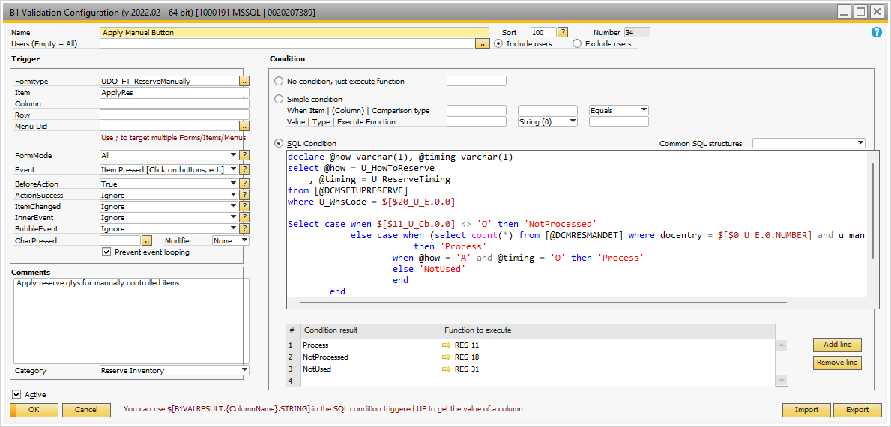

## Figure 3.49 Apply Reserve Quantities Manually

The Universal Function ReS-11 is called to display all of the items that are manually reserved and allow the user to enter the quantity to reserve. This is shown in Figure 3.50. The ‘Format’ SQL portion is shown in Figure 3.51.

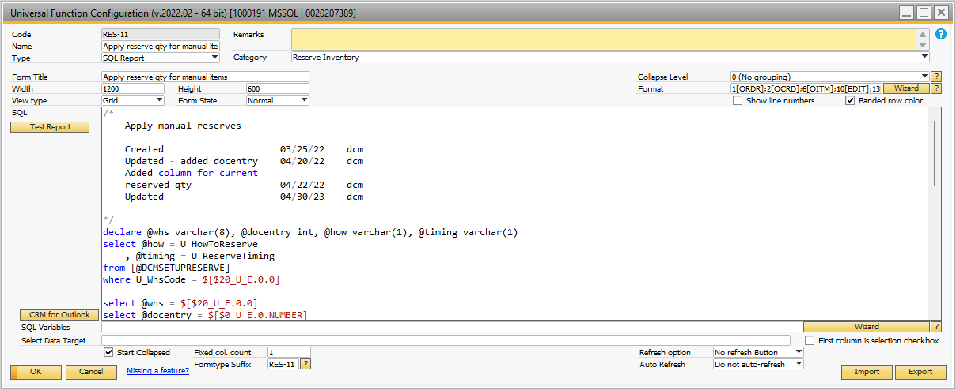

## Figure 3.50 SQL Script to Manually Apply Reserves

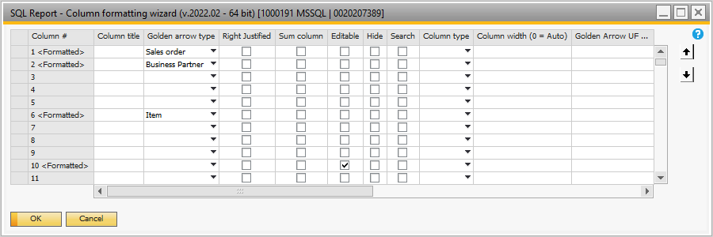

## Figure 3.51 Format Script for RES-11

On the ‘Format’ script, the 10th column ‘ReserveQtyThisOrder’ column is ‘Editable’. The user enters the reserve quantity.

*/* Apply manual reserves Created 03/25/22 dcm Updated - added docentry 04/20/22 dcm Added column for current reserved qty 04/22/22 dcm Updated 04/30/23 dcm*/declare @whs varchar(8), @docentry int, @how varchar(1), @timing varchar(1)select @how = U_HowToReserve , @timing = U_ReserveTimingfrom [@DCMSETUPRESERVE]where U_WhsCode = $[$20_U_E.0.0]select @whs = $[$20_U_E.0.0] select @docentry = $[$0_U_E.0.NUMBER]/* Report by item */select h.docnum as 'Order' , h.cardcode as 'Customer' , h.cardname as 'Customer Name' , h.docduedate as 'Due Date' , d.VisOrder + 1 as 'LineSeq' , d.itemcode as 'Item' , d.dscription as 'Description' , d.whscode as 'Whs' , d.openqty as 'OpenQuantity' , d.U_DCMReserveQty as 'ReservedQtythisOrder' , w.onhand as 'Whs on hand' , isnull((select sum(isnull(x.openqty,0)) from owtq y inner join wtq1 x on x.docentry = y.docentry and x.ItemCode = d.itemcode and x.FromWhsCod = '01' where y.docstatus <> 'C' and y.canceled = 'N' and x.linestatus <> 'C'),0) as 'In Transit' , @docentry as 'Docentry' , d.U_DCMReserveQty as 'OriginalReservedQtythisOrder'from rdr1 d inner join ordr h on h.DocEntry = d.docentryinner join oitw w on w.ItemCode = d.itemcode and w.whscode = d.whscodeleft join [@DCMRESMANHDR] x on x.u_whscode = d.whscode and x.status = 'O'left join [@DCMRESMANDET] y on y.docentry = x.docentry and y.u_itemcode = d.itemcode and y.u_active = 'A'where h.docstatus <> 'C' and d.linestatus <> 'C' and d.openqty > 0 and h.CANCELED = 'N' and (y.u_manual = 'Y' or (@how = 'A' and @timing = 'O'))order by d.itemcode, h.docduedate, h.docnum, d.linenum*

## Figure 3.52 SQL Script to Show Manually Apply Reserves

When the ‘Manual Apply Reserves’ is initiated and the user enters quantities, the B1 Validation shown in Figure 3.53 is initiated when the user clicks the ‘Close’ button.

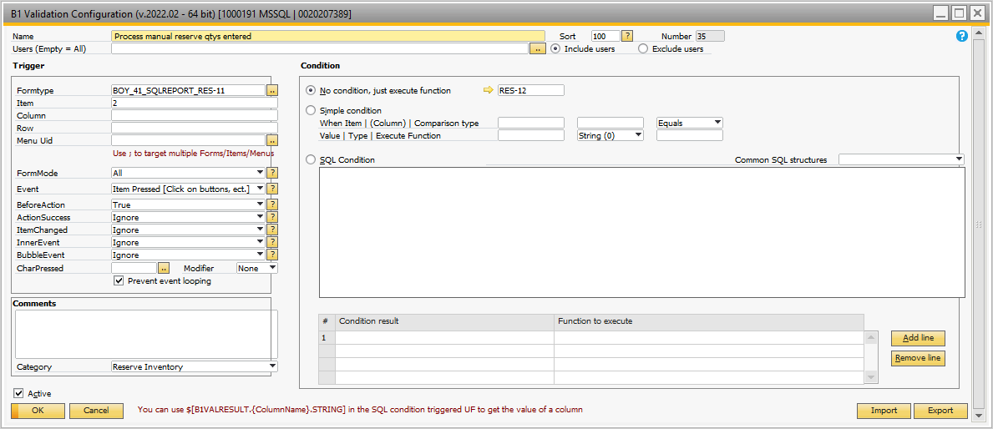

## Figure 3.53 ‘Close’ Button Initiate Posting of Manual Reserve Quantities

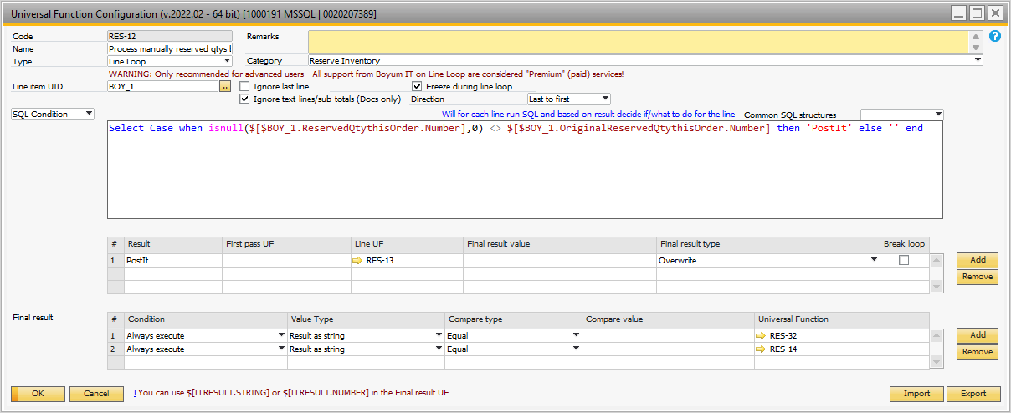

## Figure 3.54 ‘Close’ – Line Loop Process of Manual Reserve Quantities

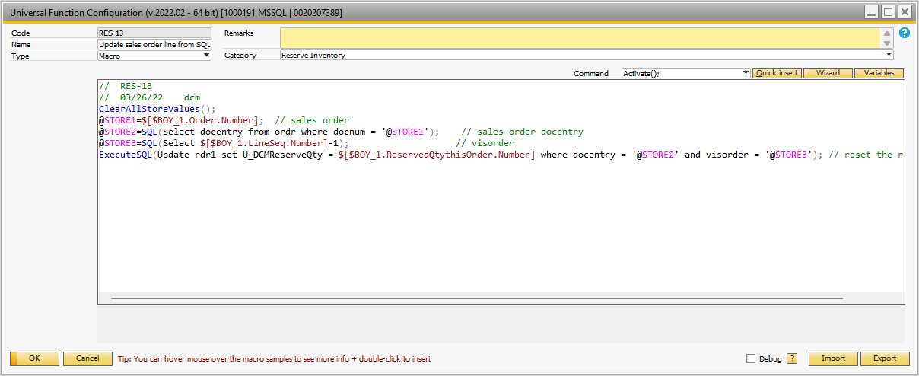

## Figure 3.55 ‘Close’ – Line Loop Process of Single Line Manual Reserve Quantities

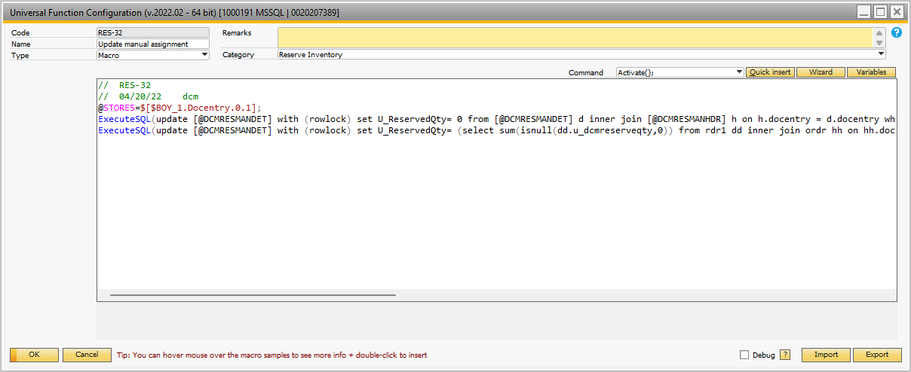

## Figure 3.56 ‘Close’ – Line Loop Process of Manual Reserve – Update of Summaries

*// RES-32// 04/20/22 dcm@STORE5=$[$BOY_1.Docentry.0.1];ExecuteSQL(*

*update [@DCMRESMANDET] with (rowlock)*

*set U_ReservedQty= 0*

*from [@DCMRESMANDET] d*

*inner join [@DCMRESMANHDR] h on h.docentry = d.docentry*

*where h.docentry = @STORE5*

*);ExecuteSQL(*

*update [@DCMRESMANDET] with (rowlock)*

*set U_ReservedQty=*

*(select sum(isnull(dd.u_dcmreserveqty,0)) from rdr1 dd inner join ordr hh on hh.docentry = dd.docentry where dd.itemcode = d.U_ItemCode and dd.whscode = h.U_WhsCode and hh.docstatus <> 'C' and dd.linestatus <> 'C' and dd.openqty > 0)*

*from [@DCMRESMANDET] d*

*inner join [@DCMRESMANHDR] h on h.docentry = d.docentry*

*where h.docentry = @STORE5*

*);*

## Figure 3.57 ‘Close’ – Line Loop Process of Manual Reserve – RES-32 SQL