**B1 Print & Delivery Multi-Language & Multi-Location Examples**

**Mascidon LLC**

**April 2023**

Contents

Multi-Lingual Documents 4

Figure 1.1 French Language Sales Order 4

Figure 1.2 Item Description with French Translation 5

Figure 1.3 Order Confirmation Document 6

Figure 1.4 Forcing the Language Based on the Ship to Location 7

Figure 1.5 Set the Sales Order Language Code 7

Figure 1.6 Language Code Set to French 8

Figure 1.7 Boyum’s Sales Order Document – French 9

Figure 1.6 Payment Terms Translation 10

Figure 1.9 Shipping Types – French Translation 11

Figure 1.10 Item Description Defined in French 12

Figure 1.11 Database Expert for Documents.Rpt Crystal Report 13

Using B1 Print and Delivery in Multi-Lingual Environment 14

Figure 2.1 Crystal Report Definition 14

Figure 2.2 Report Configuration 14

Figure 2.3 Report Action – Print Report 15

Figure 2.4 Report Action – Show Report 16

Figure 2.5 Conditional Action on Email Button 16

Figure 2.6 Email in English 17

Figure 2.7 Email in French 17

Figure 2.8 French Version of the Email 18

Figure 2.9 Emailed Form in French (Truncated) 19

Figure 2.10 English Version of the Email 19

Figure 2.11 Report Action – Save Report 20

Figure 2.12 Adding a BCC to the Customer Email 22

Fax Button 22

Figure 2.13 Faxing Instead of Emailing 23

Using Email Categories 23

Figure 2.14 Using the Email Category 24

Figure 2.15 Using the Email Category to Send Emails 24

Multi-Location B1 Print & Delivery 25

Figure 3.1 Florida Warehouse Location – with Address 25

Figure 3.2 Footer Showing Your Company Name 27

Figure 3.3 Modified Company Information 27

Figure 3.4 Defining Location of Crystal Logo PNG File 27

Printer Selection 28

Figure 3.5 Report Action to Print Report 28

Figure 3.6 Report Configuration with a Conditional ‘Print’ Button’ 29

Figure 3.7 Use SQL to Define Which Print Report Action to Call 29

Figure 3.8 Defining a Location Specific Printer 30

Figure 3.9 Defining a Second Location Specific Printer 30

Figure 3.10 Standard Email Format 31

Figure 3.11 Manage SMTP 32

# Multi-Lingual Documents

SAP has the capability for multi-lingual implementations. What does that mean when you need to provide documents to your customers or vendors in multiple languages? Within SAP Figure 1.1 shows a sales order where the language used is French. The captions are in French. Several of the items do have French translations – refer to Figure 1.2 which shows an item description in French. These descriptions are not displayed in the sales order in Figure 1.1.

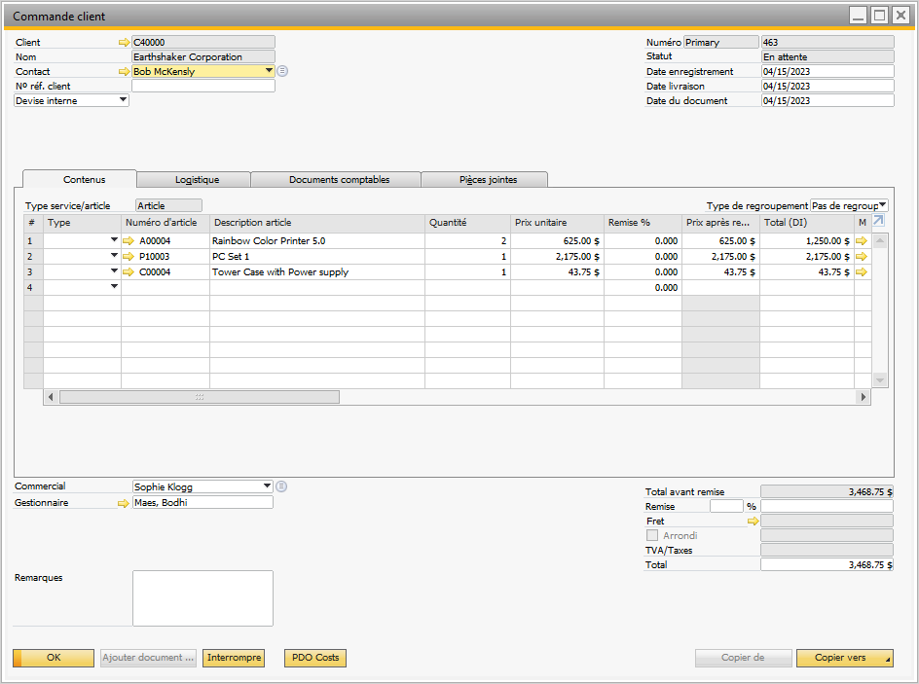

## Figure 1.1 French Language Sales Order

In Figure 1.2 you can see the French translation for the item A00004 – but it is not on the screen in the sales order shown in Figure 1.1. When the sales order associated with the ‘French’ sales order form is printed the outcome is Figure 1.3. This ‘form’ does not have any French rendition.

This explanation shows the limitation for the multi-lingual implementation of SAP.

What can Boyum B1 Productivity and Boyum B1 Print and Delivery provide to ‘improve’ the multi-lingual implementation?

1. When the sales order is Added or Updated the language for the form could be set to French – if applicable.
2. When the sales order form is printed:
   1. The item description could be printed in its French translation
   2. All of the form captions could be printed in French
3. Item descriptions could be shown in French on the sales orders. I have not done this but Boyum certainly has the capability to provide this.

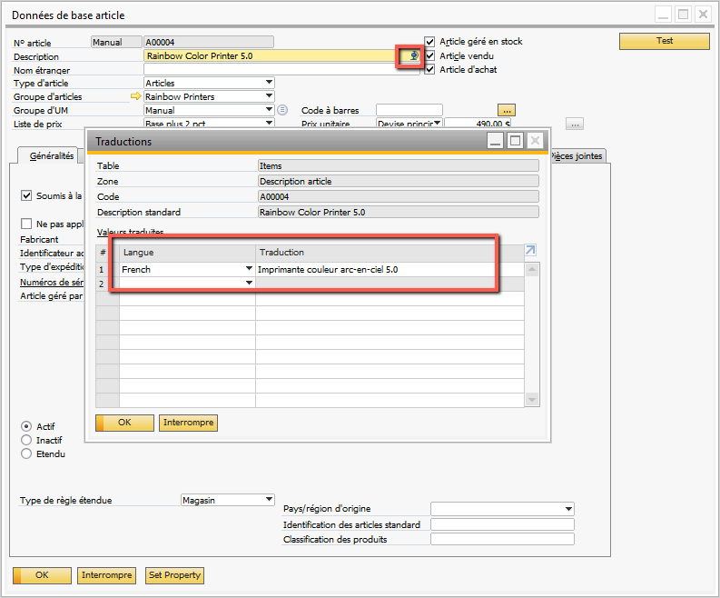

## Figure 1.2 Item Description with French Translation

The sales order printed form needs to be in French for specific customer ship to addresses. I have several customers in Canada and they must have French language documents for at least all ship to locations in Quebec.

I have identified which customers require French by checking the ship to province. If the province where the order is being shipped is ‘Quebec’ (code = ‘QC’), then the form should print in French. When the order is updated or added the ‘language’ code for the order changes to ‘French’ IF the shipping location is Quebec.

If the ‘language code’ for a sales order is set to ‘French’, the standard Boyum ‘Documents.rpt’ Crystal report will also print in French. To switch the language code based on the ship to location (shown in the ‘Logistics’ tab of the sales order form), a B1 Validation is used. Figure 1.4 shows this validation. This logic applies to the ‘Add and Update’ mode for the sales order.

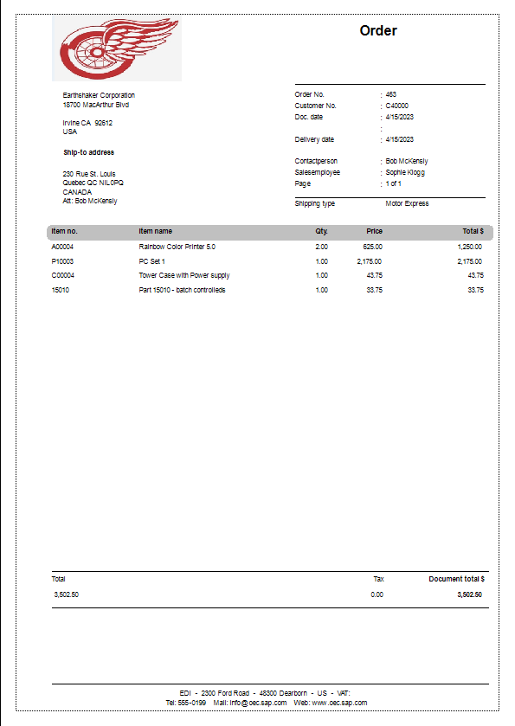

## Figure 1.3 Order Confirmation Document

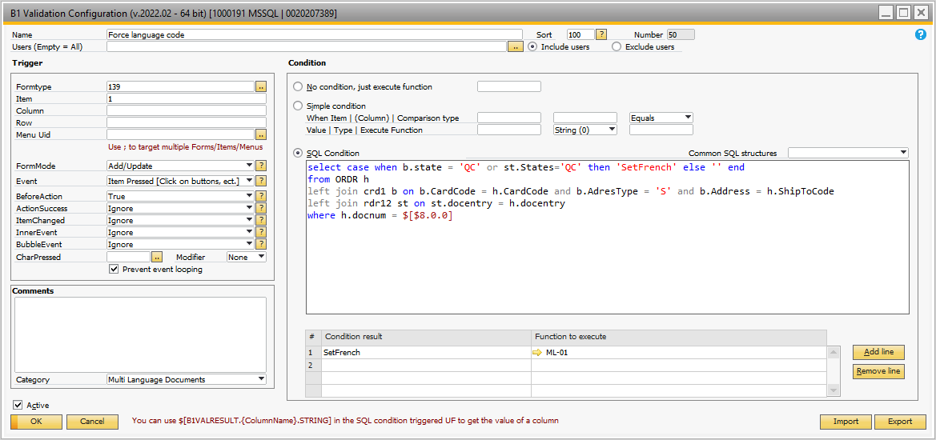

## Figure 1.4 Forcing the Language Based on the Ship to Location

The SQL condition looks first at the ‘state’ for the ship to location. If the CRD1 table does not have a ship to code – i.e. a one-time shipment – then the ship to address is located in the RDR12 table. Assuming the ship to location is ‘QC’, then the Universal Function ML-01 is initiated. Figure 1.5 shows this Universal Function. Figure 1.6 shows the language setting for the order being shipped to Quebec. The end result is the language code is set to ‘French’ if a shipment is being made to the province of Quebec.

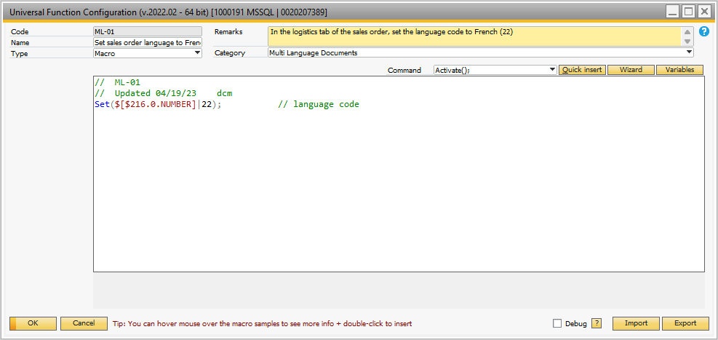

## Figure 1.5 Set the Sales Order Language Code

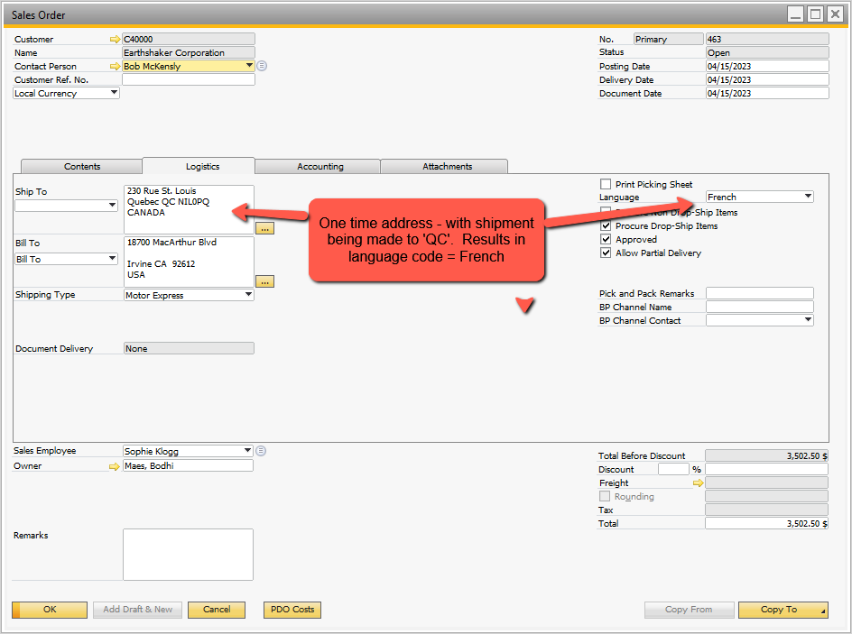

## Figure 1.6 Language Code Set to French

Boyum has a generalized document provided with B1 Print and Delivery ‘Documents.rpt’. When the sales order form is printed using this form and the ‘French’ language sales order the result is Figure 1.7.

The form uses the ‘language code’ to print the form in French. I created ‘French’ translations for 3 of the 4 items on the sales order – item 15010 is the exception and its description is in English.

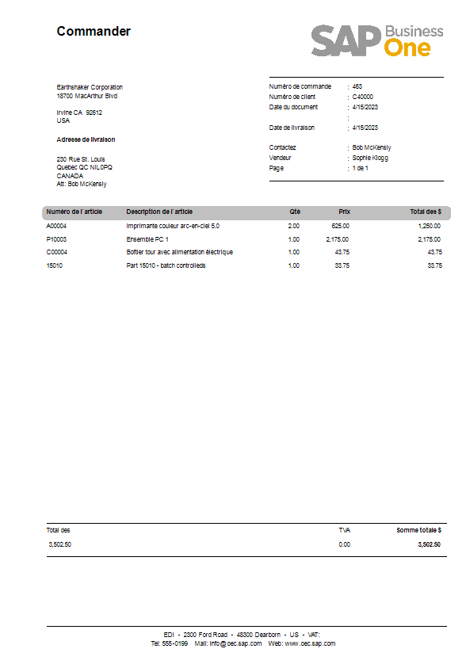

## Figure 1.7 Boyum’s Sales Order Document – French

Here are the processes used to get the French information into the form. We’ll take each field separately.

* Terms codes are also translated into French. (Administration 🡪 Setup 🡪 Business Partners 🡪 Payment Terms). Refer to Figure 1.8 for this translation setup.

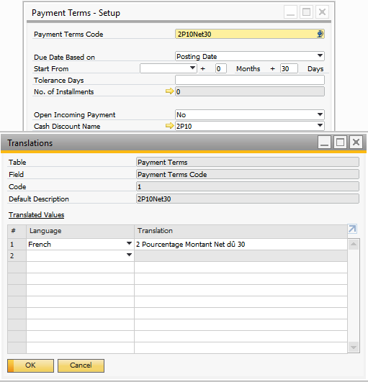

## Figure 1.6 Payment Terms Translation

* Shipping type descriptions are also translated into French. (Administration 🡪 Setup 🡪 Inventory 🡪 Shipping Types). Refer to Figure 1.9 for this translation setup.

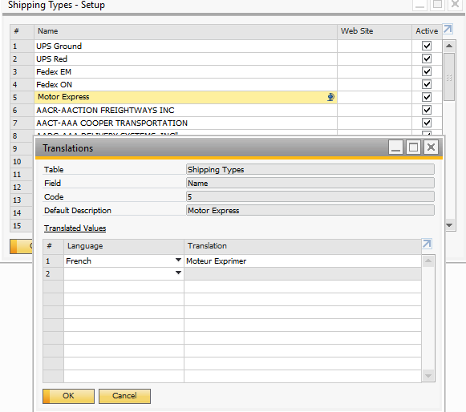

## Figure 1.9 Shipping Types – French Translation

* Item descriptions in French - this is where the hard work begins if you want a ‘French’ description of each of the items being sold. If this is required you must make this a mandatory process when setting up new parts. Figure 1.10 shows the setup required for the item description French description.

The ‘Documents.rpt’ Crystal Report from Boyum did not have the French translation for the shipping type. This Crystal Report uses the ‘Command Line’ technique for the definition of the report. If you access this Crystal Report and click on the menu selection Database 🡪 Database Expert Figure 1.11 displays. The report fields are broken into 3 components: Company Info – containing general information about your company such as name and address; Header – containing the document’s business partner and ship to information; and Lines – containing the item details. Right click on any of these and select ‘Edit’ to change the coding.

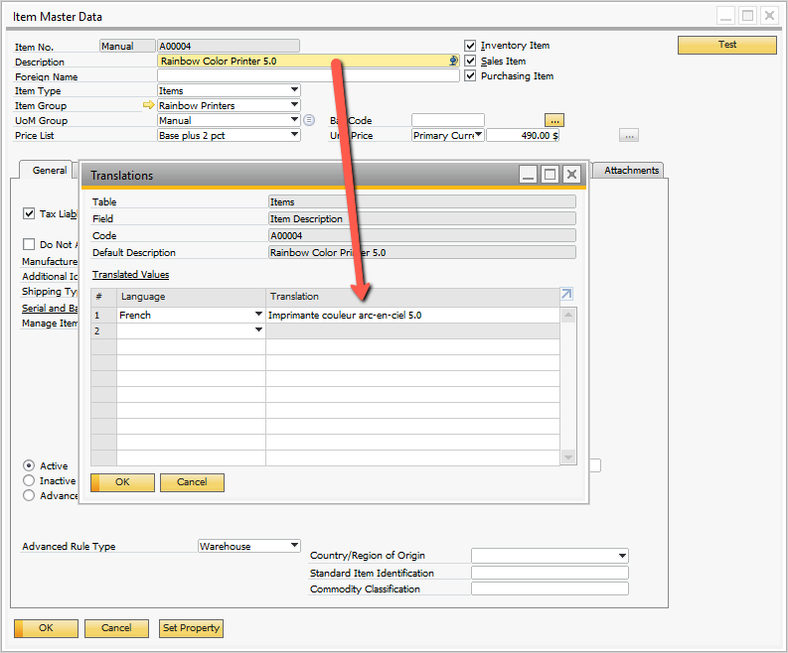

## Figure 1.10 Item Description Defined in French

To add the French translation for the shipping mode I added this line of code to the Header information:

*T4.TrnspName, -- this is the shipping type description*

*ISNULL((SELECT TS1.Trans FROM OMLT TS0 LEFT JOIN MLT1 TS1 ON TS0.TranEntry = TS1.TranEntry WHERE TS0.FieldAlias = ''TrnspName'' AND TS0.TableName = ''OSHP'' AND TS0.PK=T0.TrnspCode AND TS1.LangCode = T0.LangCode),T4.TrnspName) as ShipperTranslated, -- translated shipping type*

The data for the translation is contained in the tables OMLT and MLT1. The ‘T0’ refers to the header table (ORDR for example). I saved this Crystal Report with the changes as ‘Dcouments – Mascidon’. I included the Red Wings logo on the form as well. If you require multi-language forms I suggest you utilize the ‘Documents.rpt’ Crystal report as a basis and make form changes as required by your company documents. Keep the original ‘Documents.rpt’ in case you mess up.

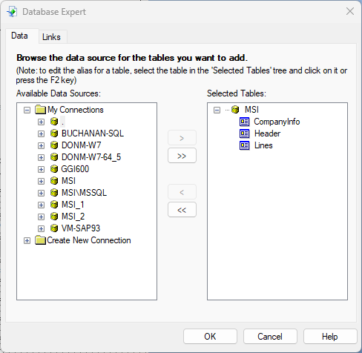

## Figure 1.11 Database Expert for Documents.Rpt Crystal Report

# Videos 1, 2, 3

[https://www.screencast.com/t/g4FYYhwP3](https://www.screencast.com/t/g4FYYhwP3%20)

<https://www.screencast.com/t/vJjjnzSzyj>

<https://www.screencast.com/t/acfvyQ1BV>

# You Tube Video Links

1st of 3: <https://www.youtube.com/watch?v=ukIUtxc84ug>

2nd of 3: <https://www.youtube.com/watch?v=7ml7kF-qM_8&t=6s>

3rd of 3: <https://www.youtube.com/watch?v=pKJKC4MNSLM>

# Short User View

<https://youtu.be/f5dKV84srAc>

# Using B1 Print and Delivery in Multi-Lingual Environment

The first portion of this document discussed how to provide data for SAP forms and documents to get

French and English versions of forms. B1 Print and Delivery can be used to print the sales order form on demand and have it appear in French or English based on the sales order language flag. There is more to the multi-lingual than just the form however. For instance, B1 Print and Delivery can be used to deliver the sales order form via email. After all the work done getting the form into French, the email must also be in French – assuming the order is being shipped to the province of Quebec.

This section describes how to set up the sales order to print and be emailed to customers in the language required. Let’s review the setup of sales orders for B1 Print and Delivery.

1. Use the Crystal report developed for multi-lingual sales orders to create a ‘Crystal Report Definition’ record.

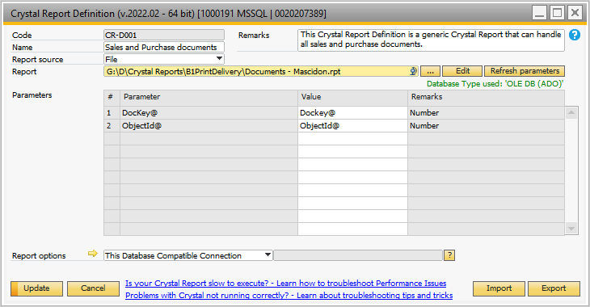

## Figure 2.1 Crystal Report Definition

1. Define the ‘Report Configuration’ for the multi-lingual sales order.

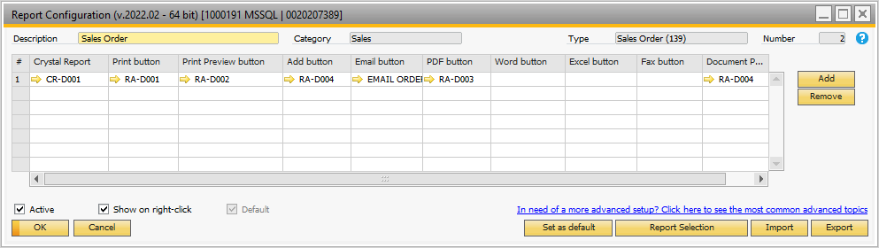

## Figure 2.2 Report Configuration

1. Define the ‘actions’ to take when the sales order is processed. There are choices to make regarding the ‘actions’. The settings are:
   1. Print Button 🡪 RA-D001
   2. Print Preview Button 🡪 RA-D002
   3. Add Button 🡪 RA-D004
   4. Email Button 🡪 Email Order - Conditional
   5. PDF Button 🡪 RA-D003
   6. Document Printing 🡪 RA-D004

I have omitted actions required for pressing the ‘Word’, ‘Excel’ or ‘Fax’ buttons.

The other ‘actions’ are shown below. Let’s review each of these as they relate to ‘multi-lingual’ requirements for the sales order document.

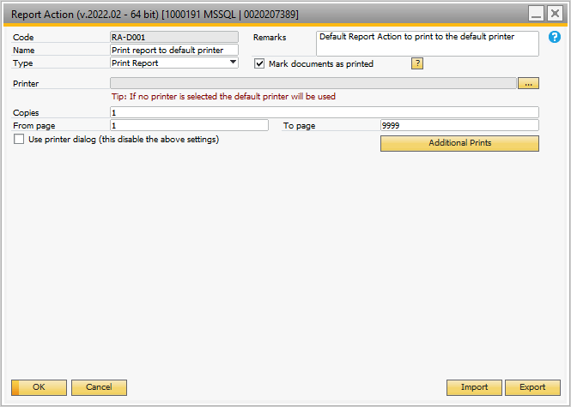

## Figure 2.3 Report Action – Print Report

Referring to Figure 2.3, there are some options the user may want to set. These are:

* + Mark document as printed – check this if B1 Print and Delivery sets the document status to ‘Printed’
  + Printer – if you have a specific printer assigned for sales order, make the selection here.
  + Copies – choose the number of copies
  + Use printer dialog – this option is useful to print to a specific printer chosen by the user.

**NOTE**: Later in this document we’ll discuss how to set up the multi-lingual sales order report if you have multiple order fulfillment locations and need default printers for each location. ‘Location’ could be a location within the same physical building, or locations in different cities.

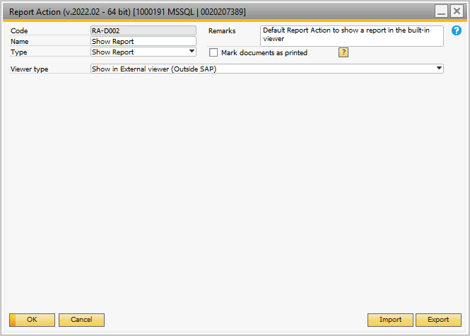

## Figure 2.4 Report Action – Show Report

The ‘Print Preview’ ‘Action’ shows the report on the screen. Not much ambiguity!

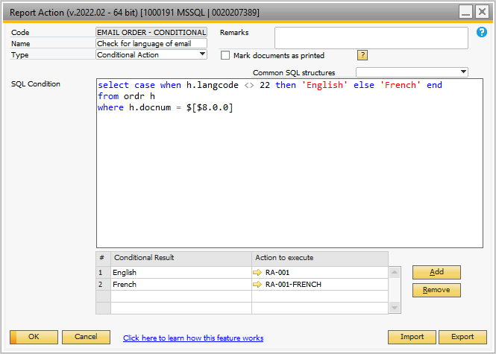

## Figure 2.5 Conditional Action on Email Button

The conditional action when the email button is clicked runs a SQL script to determine if the language code for the sales order is French or English. In turn, this action calls the action RA-001 for English or the action RA-001-French for French.

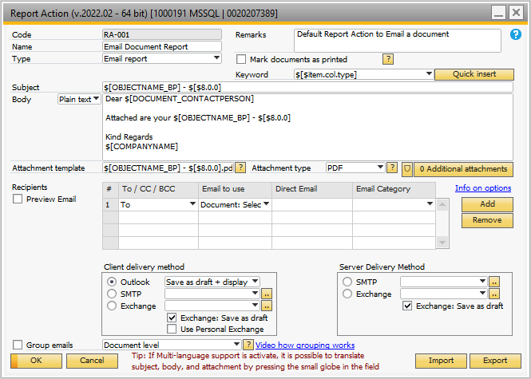

## Figure 2.6 Email in English

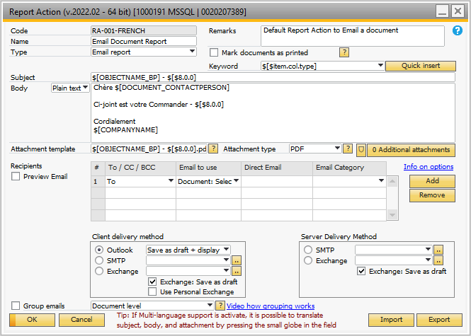

## Figure 2.7 Email in French

Other than the ‘language’, the RA-001 and RA-001-French actions are the same. Figure 2.8 shows a ‘preview’ of the email in French:

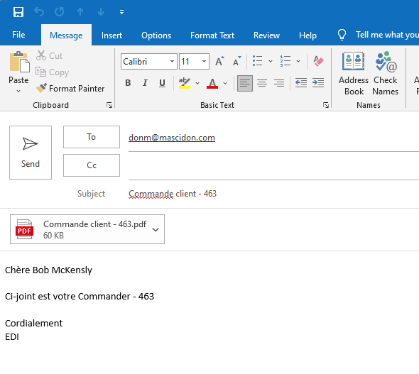

## Figure 2.8 French Version of the Email

Figure 2.9 shows a truncated picture of the attached document – in French.

An English email document is shown in Figure 2.10. The attached document is also in English.

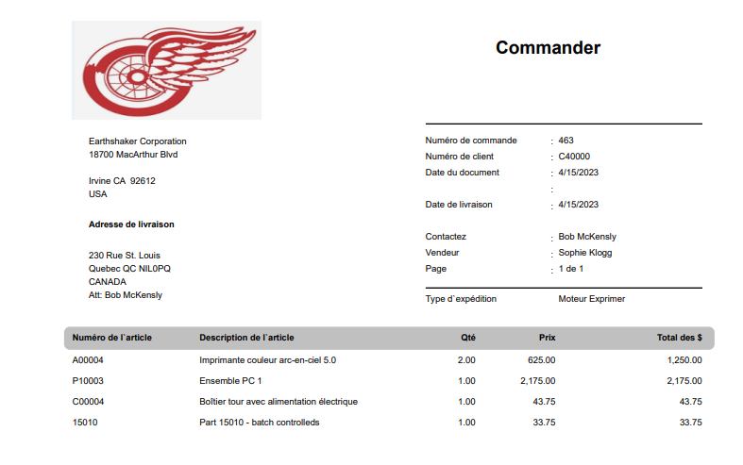

## Figure 2.9 Emailed Form in French (Truncated)

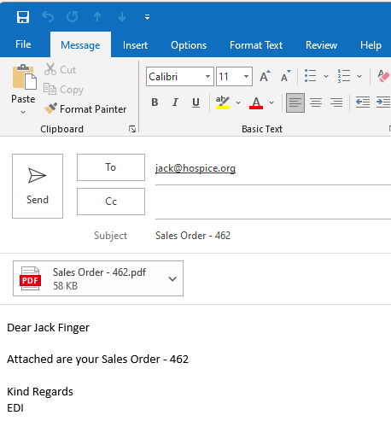

## Figure 2.10 English Version of the Email

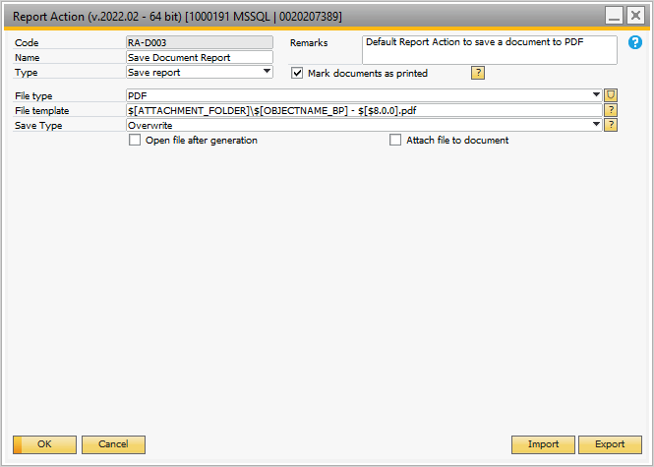

## Figure 2.11 Report Action – Save Report

When the PDF SAP icon is clicked, a digital copy of the sales order report is saved. These options need to be reviewed during setup:

* + Mark document as printed – this changes the document status from open to ‘Open -printed’.
  + File type – there are numerous file types which can be selected. Normally, PDF is the format requested. These are the options available:

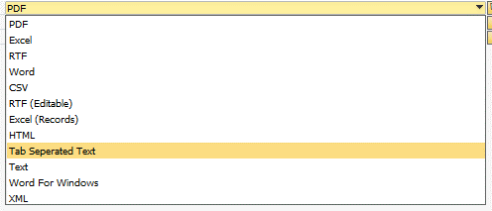

* + The file template can use fields from the document on the screen to ‘name’ the document. The first part of the ‘naming’ is the folder to save the document into. In this instance, the Boyum variable ‘$[ATTACHMENT_FOLDER]’ gets the folder set up in SAP for attachments (Administration 🡪 System Initialization 🡪 General Settings 🡪 Path 🡪 Attachments folder). The second part of the ‘name’ is also a Boyum variable ‘$[OBJECTNAME_BP]’ – which translates to customer code in this instance. This is followed by $[$8.0.0] – which is the sales order document number. The extension is ‘.pdf’. The only limitation is that you do not want the resulting directory / file name to be a duplicate of an existing document. (A popup will appear if this is the case).
  + Unless – the ‘Overwrite’ option is selected.
  + You can have the file display on the screen by checking the ‘Open file after generation’ check box.

**Note**: this action has little ‘multi-lingual’ influence.

The report action RA-D004 is accessed when the ‘Add Button’ or the ‘Document Printing Button’ is clicked. In the standard implementation this action is an ‘Email’ action. i.e. you click the sales order ‘add’ button and an email with this sales order document is sent to the customer. This is likely not a good practice. Let me tell you why not to use this.

Let’s say you routinely get sales orders that need to be keyed into SAP that have 30 – 50 item lines. If these need to be keyed it may take 30 – 40 minutes to do this. Your entry clerk is in the middle of this and their associate says – ‘let’s go to lunch’. To be safe, the clerk ‘adds’ the document to save what they’ve keyed so far. They go to lunch and the customer receives a partial sales order report. Not good.

My recommendation is that you do ‘nothing’ when the ‘Add Button’ is clicked or the ‘Document Printing’ is clicked. This means that the entry clerk is responsible for actually clicking the ‘Print Button’, the ‘PDF Button’ and the ‘Email Button’.

Let’s say that works. How does the entry clerk know that the email went to the customer? There are several ways of making this happen. The easiest is to include a ‘BCC’ in the email ‘action’ document. The person responsible for client contact is their sales person. Figure 2.12 shows how to send a BCC with the customer email. As shown, you select the ‘BCC’ option and the direct email option. The direct email is defined by the sales person associated with this order. This is derived from the ‘SQL’ under the ‘Direct Email’. This SQL code is:

SQLMulti:select e.email from oslp s inner join ohem e on e.salesPrson = s.SlpCode where s.slpcode = $[$20.0.NUMBER]

The field ‘$[$20.0.Number]’ is the sales person code on the sales order form. As long as the sales order has an employee as the sales person, the BCC ‘direct email’ will process.

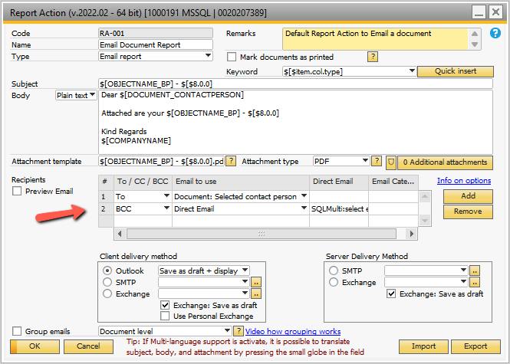

## Figure 2.12 Adding a BCC to the Customer Email

Another means of making certain the email is sent is to include code to add an activity when the clerk clicks the ‘email’ button.

A third way would be to add an ‘email sent’ user defined field for the sales order document and use Boyum to automatically update the date and time the email button was clicked.

I prefer the first method – the ‘BCC’ choice. My reason is that I can go to my emails and look up the time and date sent. If the customer says they never got the email you can review the email address information with them very easily and pinpoint the problem.

## Fax Button

**T**here is a ‘Fax’ button option on the Report Configuration screen. This can be implemented as if it is an email. Figure 2.13 shows a Mascidon customer’s report action coded for fax. This is called by a ‘conditional action’ which checks to make certain that the customer’s fax number is on file.

The ‘To’ email address contains this SQL code:

*SQLMulti:select fax+'@srfax.com' from ocpr p where cardcode = '$[$4.0.0]' and U_BOY_85_ECAT = 'Purchasing' and U_dcm_email in ('Fax','Both')*

Looking at the code, the customer’s fax number is combined with ‘@SRFAX.com’ to define the ‘email’ address to use. This is how the service ‘SRFAX’ is used to send fax information via email.

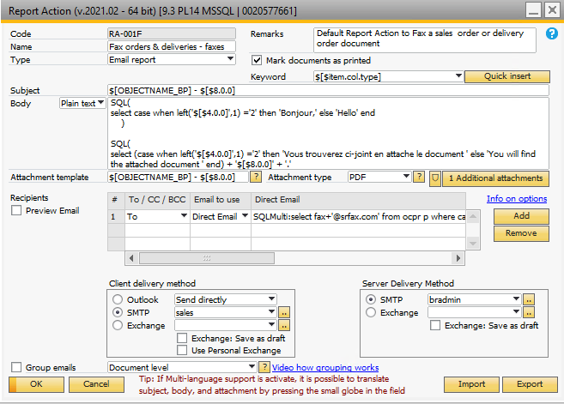

## Figure 2.13 Faxing Instead of Emailing

## Using Email Categories

Another feature of emailing documents is using the ‘Email categories’ defined by Boyum to determine the contact(s) getting the document email. Essentially here is how it would be set up.

* Boyum provides up to 5 different email ‘categories’
* Categories of email are found in the contact person records for each customer

Why use this? Let’s say you have a customer with many contacts. The customer has some ‘vital’ contacts such as who to call if there are A/R problems, or who to call if there are product resolution issues, etc. For example a customer could have an A/R clerk and an A/R manager that both need to get the email. Each of these contacts could have an email category of ‘Accounting’. Then when the email is sent, it is sent not to just the ‘contact’ referenced in the sales order, but all contacts that are ‘Accounting’. Figure 2.14 shows the setup within the customer record.

The ’email’ action is modified from sending the email to the ‘Selected contact’ to the ‘Email Category – as shown in Figure 2.15. Use the drop down to select the ‘Email Category’ option and in the ‘Email Category field select the ‘Accounting’ option.

Emails will then be sent to all contacts with that email category for this customer.

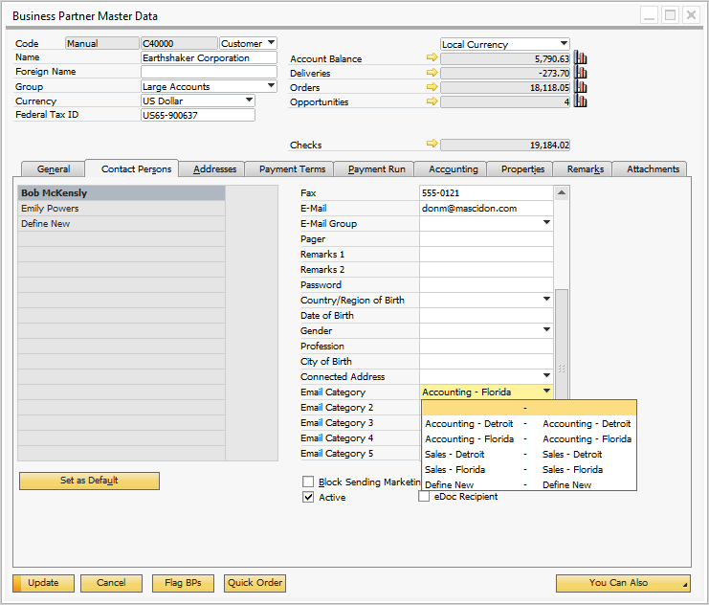

## Figure 2.14 Using the Email Category

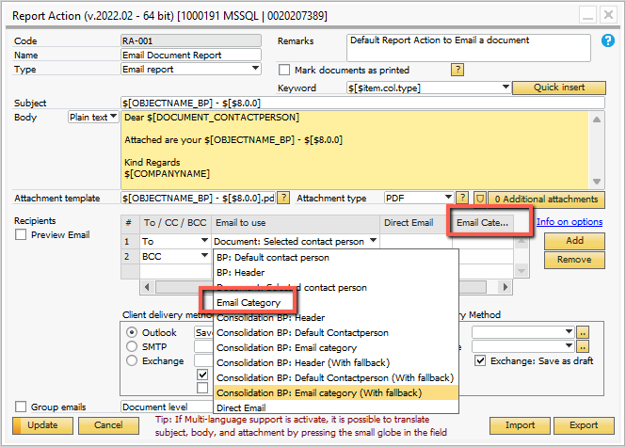

## Figure 2.15 Using the Email Category to Send Emails

**Note**: there are additional Boyum options for handling emails to ‘parent customers’.

# Multi-Location B1 Print & Delivery

The B1 print and delivery for multi-lingual shown in this document is straightforward to implement. Let’s take this a step further with 2 physical locations in different parts of the country. What is different about this?

* Each location would have a separate warehouse that they ship from
* Printing documents needs to be done locally
* Documents shared outside your company may need the address of the location where product was / is shipped
* Perhaps each location has a different company name and logo
* Emails may have different connections within SAP (SMTP, Exchange or Outlook).

I am going to use the warehouse as the determining factor for the ‘location’. If you have implemented SAP using ‘Branches’, you could use the Branch id as the determining factor.

Let’s address each of these issues.

In my test database I have warehouse ‘01’ set up with an address in Detroit, and warehouse ‘10’ with an address in Wildwood, Florida. These are the 2 locations for which we will set up B1 Print and Delivery. Each of the two warehouses have addresses from their area. Refer to Figure 3.1. There is a similar setup for warehouse 01 with a Detroit address.

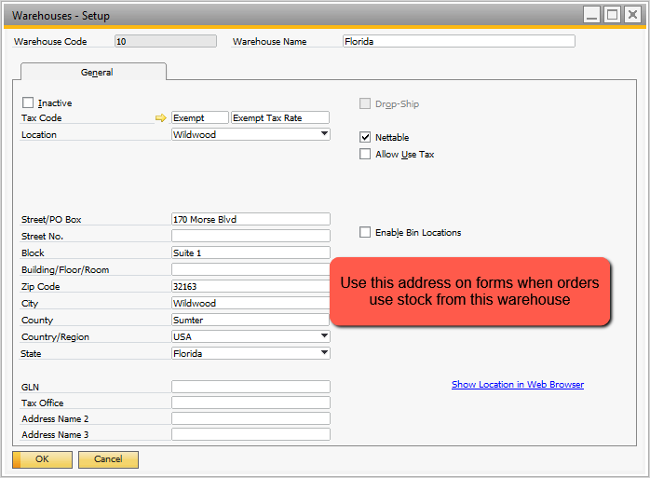

## Figure 3.1 Florida Warehouse Location – with Address

When printing documents, the forms need to use the warehouse to get the company’s location address. The ‘Documents – Mascidon.rpt’ Crystal report needs to be modified to accommodate this change. The ‘Command’ SQL in the Crystal report for the ‘CompanyInfo’ needs to be modified. I left the basic SQL for CompanyInfo intact and added the following:

I added 2 left joins to include the location information for warehouses 01 and 10:

left join OWHS W01 on W01.WhsCode = '01'

left join OWHS W10 on W10.WhsCode = '10'

I added this code to pick up the address information for these warehouses:

, w01.street as Location01_Street

, w01.block as Location01_block

, w01.ZipCode as Location01_zipcode

, w01.city as Location01_City

, w01.country as Location01_Country

, w01.State as Location01_State

, w01.Address3 as Location01_CompanyName

, w10.street as Location10_Street

, w10.block as Location10_block

, w10.ZipCode as Location10_zipcode

, w10.city as Location10_City

, w10.country as Location10_Country

, w10.State as Location10_State

, w10.Address3 as Location10_CompanyName

**Note**: I am using Address3 of the warehouse for the name of the company at each location.

I altered the ‘Header’ Command SQL in Crystal Reports to include the definition of the ‘location’ (=1st whs on a line item for the sales order).

The ‘Header’ SQL contains this added code:

After the ‘@table’ declare I added this:

declare @tabledet as varchar(20)

select @tabledet = substring(@table,2,19) + '1'

This defines the line item table where the items are stored. i.e. if @table = ‘ORDR’, then @tabledet = ‘RDR1’.

Then I added this code just before the ‘From’ clause in the SQL:

, isnull((select top 1 whscode from '+@tabledet+' where docentry = '+@docentry + '),''01'') as Locationwhs

This gets the first warehouse code in the line items and we use this as the ‘locationwhs’.

Using the new data, Crystal can be modified to include the new fields. At the bottom of the Crystal Report your company information is shown. Prior to defining the report as ‘Multi-location’, the information was shown in Figure 1.7. Just this portion is shown in Figure 3.2.



## Figure 3.2 Footer Showing Your Company Name

This information comes from the Crystal formula: CompanyInfo_Style3. Note: there are 2 other styles for this as well. They could be used in place of this formula.

This formula was modified as shown in Figure 3.3. Note: the new ‘Header’ field ‘Locationwhs’ is used to determine which address to use.

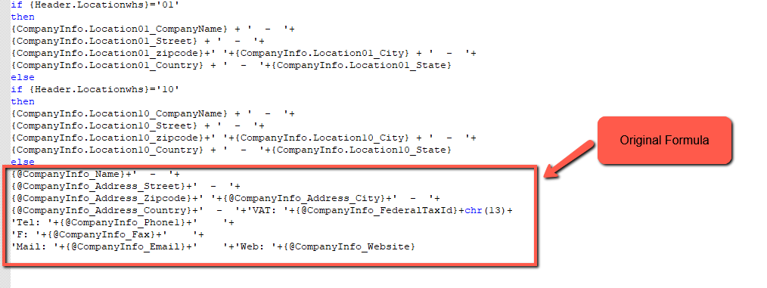

## Figure 3.3 Modified Company Information

Each location may have a different company logo. The logo in the report will have a Detroit Red Wings logo for the Detroit location and a Tampa Bay Lightning logo for the Wildwood Florida location. I have stored ‘png’ versions of these 2 logos.

Here is how the logo is set as a variable in Crystal Reports. The first step is to insert a graphic in the Crystal Report in the location where the logo belongs. It doesn’t matter what graphic is used, but it will be the default in our example if the location warehouse is not ‘01’ or ‘10’.

Within Crystal, right click on the logo and select ‘Format Graphic’. Then select the ‘Picture Tab’ and then the ‘Graphic Location’. Click on the X-2 box . Modify the graphic location as shown in Figure 3.4. The path shown must exist as a network path that is accessible by SAP users. I suggest the ‘Picture’ SAP directory.

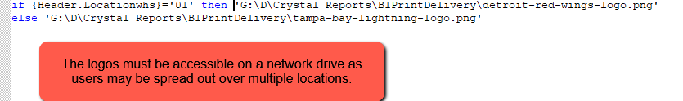

## Figure 3.4 Defining Location of Crystal Logo PNG File

## Printer Selection

The prior steps take care of the changes required to the Crystal Report to support the multi-location functionality. The next step is to direct the printing of the Crystal report to the printer that is connected at the physical location – Florida or Detroit in our example.

One solution to printing to a specific printer is to turn on the ‘Printer Dialog’. Refer to Figure 3.5, a ‘Report Action’ we saw earlier.

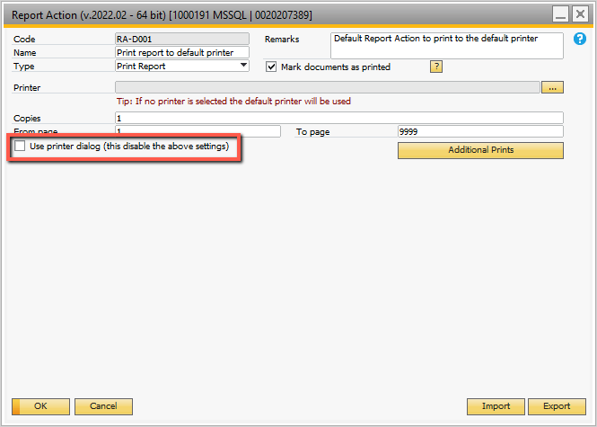

## Figure 3.5 Report Action to Print Report

The problem with this solution is that from time to time your personnel will make a mistake and inadvertently print the sales order document in Florida instead of Detroit.

This problem can be avoided by checking for documents using inventory warehouse ‘01’ or ‘10’. Let’s replace the ‘RA-D001’ report action in the report configuration with a ‘Conditional’ report action. I’ve defined a ‘conditional’ print option – RA-002 and added it to the Report Configuration. This is shown in Figures 3.6 and 3.7.

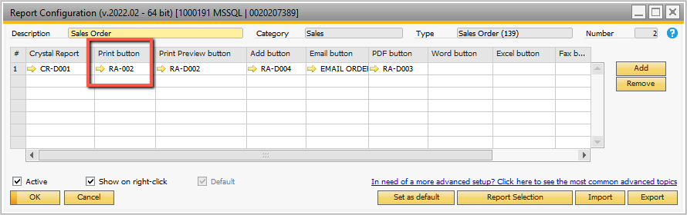

## Figure 3.6 Report Configuration with a Conditional ‘Print’ Button’

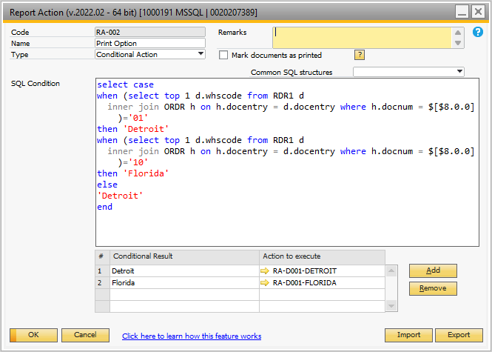

## Figure 3.7 Use SQL to Define Which Print Report Action to Call

I defined 2 new ‘print’ report actions – RA-D001-Detroit and RA-D001-Florida. These do not point to a ‘default’ printer, but to a specific network printer located in the appropriate ‘location’.

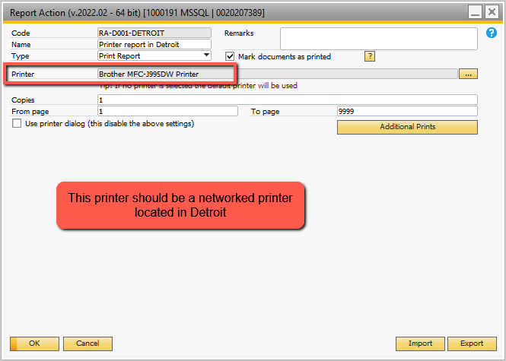

## Figure 3.8 Defining a Location Specific Printer

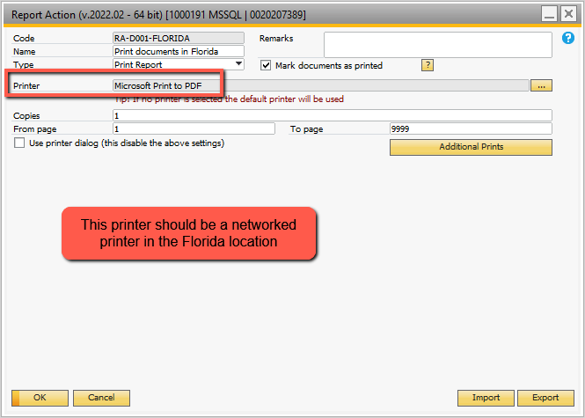

## Figure 3.9 Defining a Second Location Specific Printer

Are there other ways to implement B1Print and Delivery for multi-locations – YES. For instance, you could define 2 Crystal reports – one for Detroit and one for Florida. Then the Crystal report definitions would point to 2 different Crystal reports. Then each of the buttons on the Sales Report Configuration would have conditional report actions. There would be 2 lines on the Report Configuration – CR-D0001 and CR-D002. The ‘conditional’ actions for each of the ‘buttons’ (print, preview, add, etc.) would be true for one of the reports and not the other so that when a button was clicked by the user one or the other of the reports would print (form instance).

Are there other considerations for multi-location implementations? Yes – the emails being sent to the customers (in our example of a sales order) may go out with differing information in the email. For instance, let’s review the ‘email’ in more detail. Figure 3.10 shows an email format.

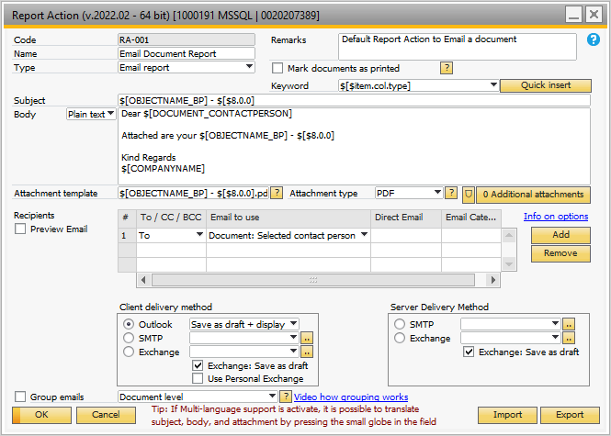

## Figure 3.10 Standard Email Format

In this instance, the information following ‘Kind Regards’ may vary depending on the location. You may want to place the ‘whs company name’ which we stored in the warehouse table as ‘Address3’ after the ‘Kind Regards’. You can use SQL code within the Body of the email to determine which ‘Address3’ company name to use for this email. One location could have radically different ‘body’ text – depending on what you want to say.

In the ‘Client Delivery’ method at the bottom of the email ‘action’ you could have different SMTP or Exchange data. Let’s look at SMTP. If you click on the icon next to the SMTP the window shown in Figure 3.11 opens.

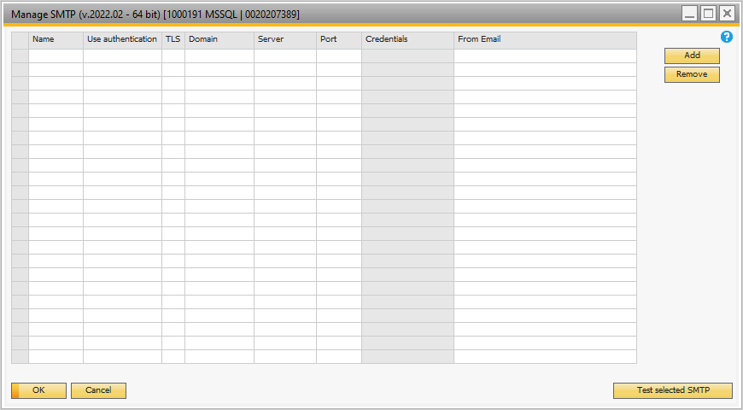

## Figure 3.11 Manage SMTP

You can define multiple rows of SMTP information. You will need to get with your IT people to define most of the rows, but from a ‘Multi-location’ view, you can change the ‘From Email’. If your 2 locations have different ‘sales@xxxx.com’ sales email addresses you would want your customer to use the correct email address if they have questions or problems with the sales order form emailed to them. This provides that capability.